Lecture 13:

Segmentation and Attention



Fei-Fei Li & Andrej Karpathy & Justin Johnson Lecture 1 24 Feb 2016

**Administrative**



* Assignment 3 due tonight!
* We are reading your milestones



Fei-Fei Li & Andrej Karpathy & Justin Johnson Lecture 13 2 24 Feb 2016

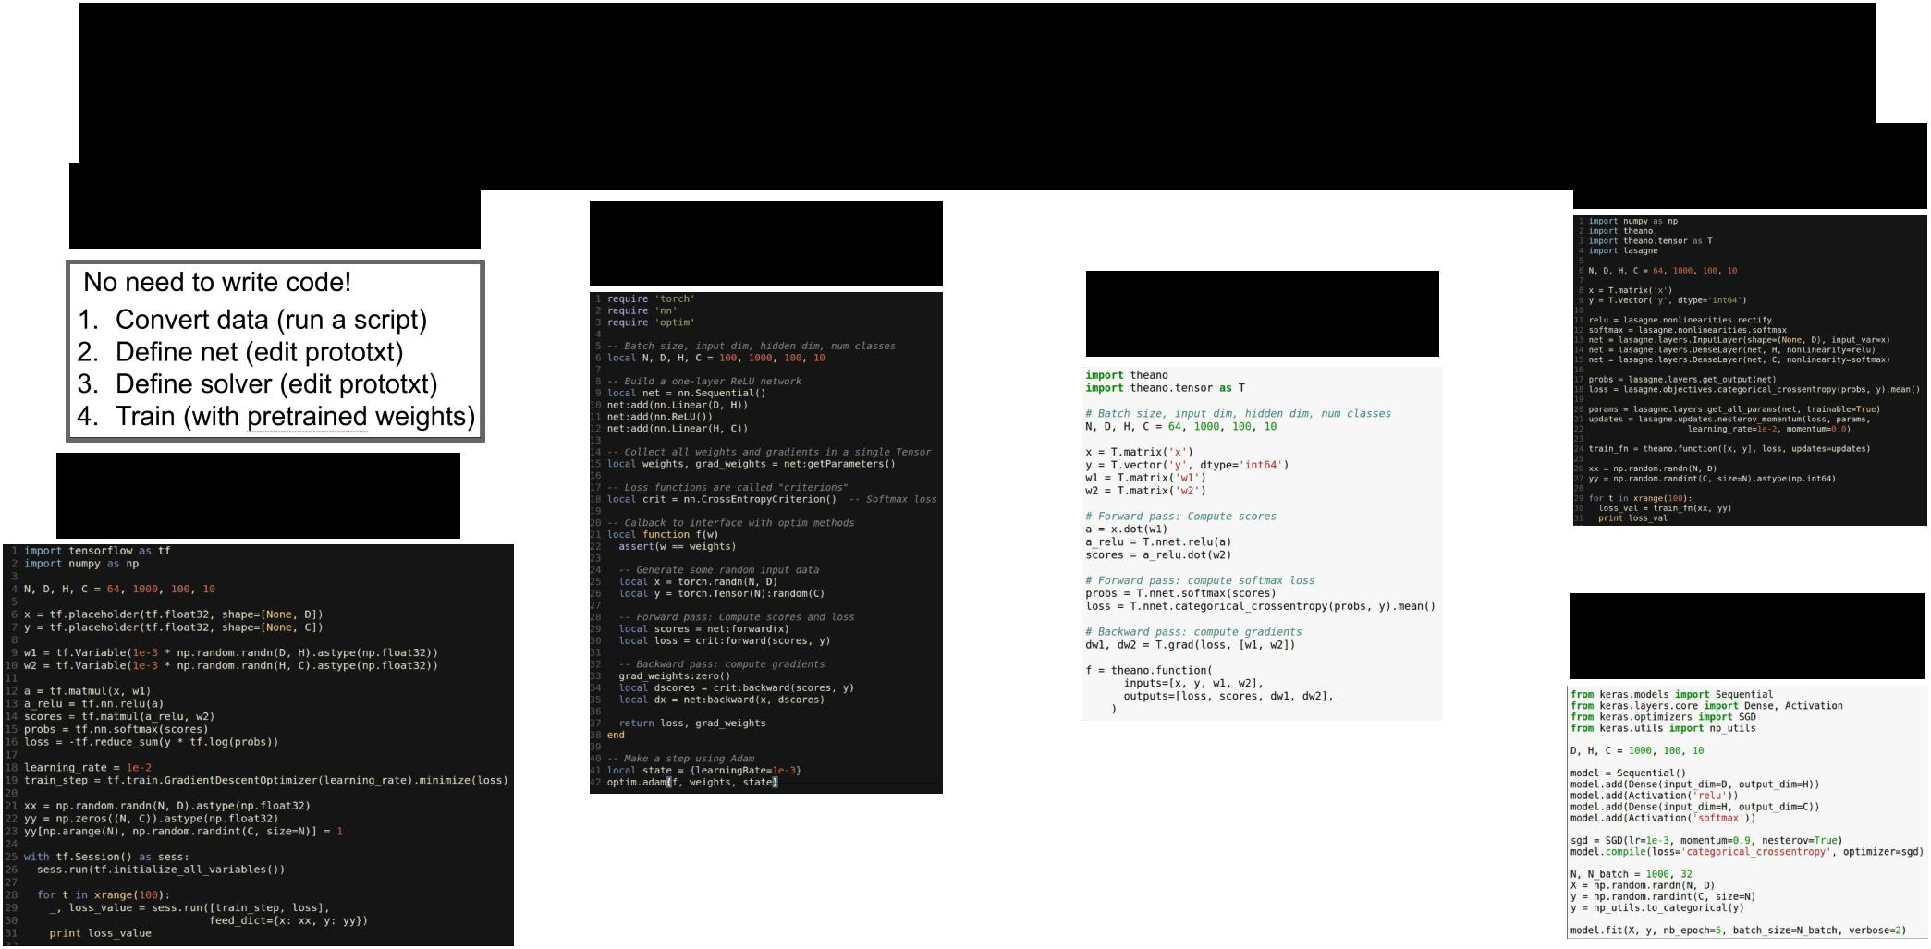Last time: Software Packages

**Caffe**

**Lasagne**

**Torch**

**Theano**

**TensorFlow**

**Keras**



Fei-Fei Li & Andrej Karpathy & Justin Johnson Lecture 13 3 24 Feb 2016

Today



* Segmentation
  + Semantic Segmentation
  + Instance Segmentation
* (Soft) Attention
  + Discrete locations
  + Continuous locations (Spatial Transformers)



Fei-Fei Li & Andrej Karpathy & Justin Johnson Lecture 13 4 24 Feb 2016

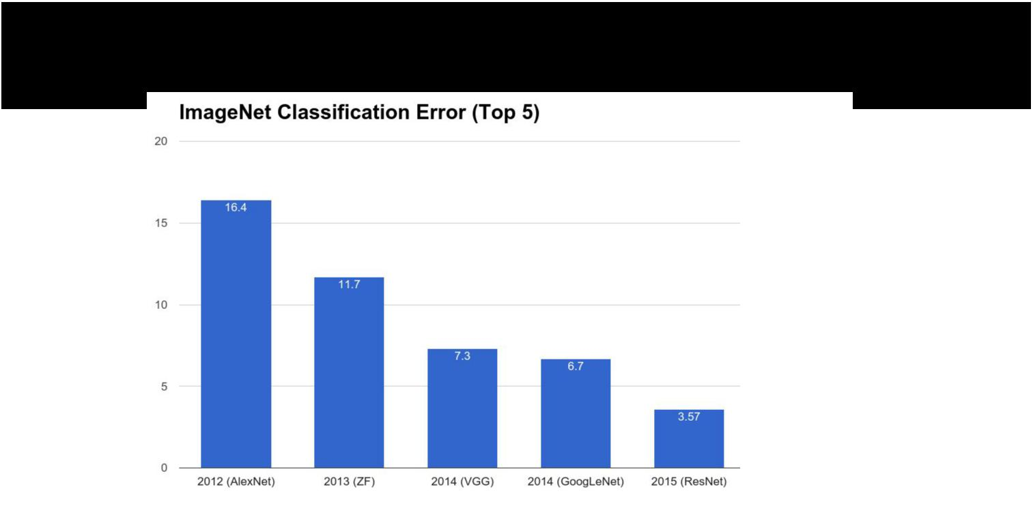But first….



Fei-Fei Li & Andrej Karpathy & Justin Johnson Lecture 13 5 24 Feb 2016

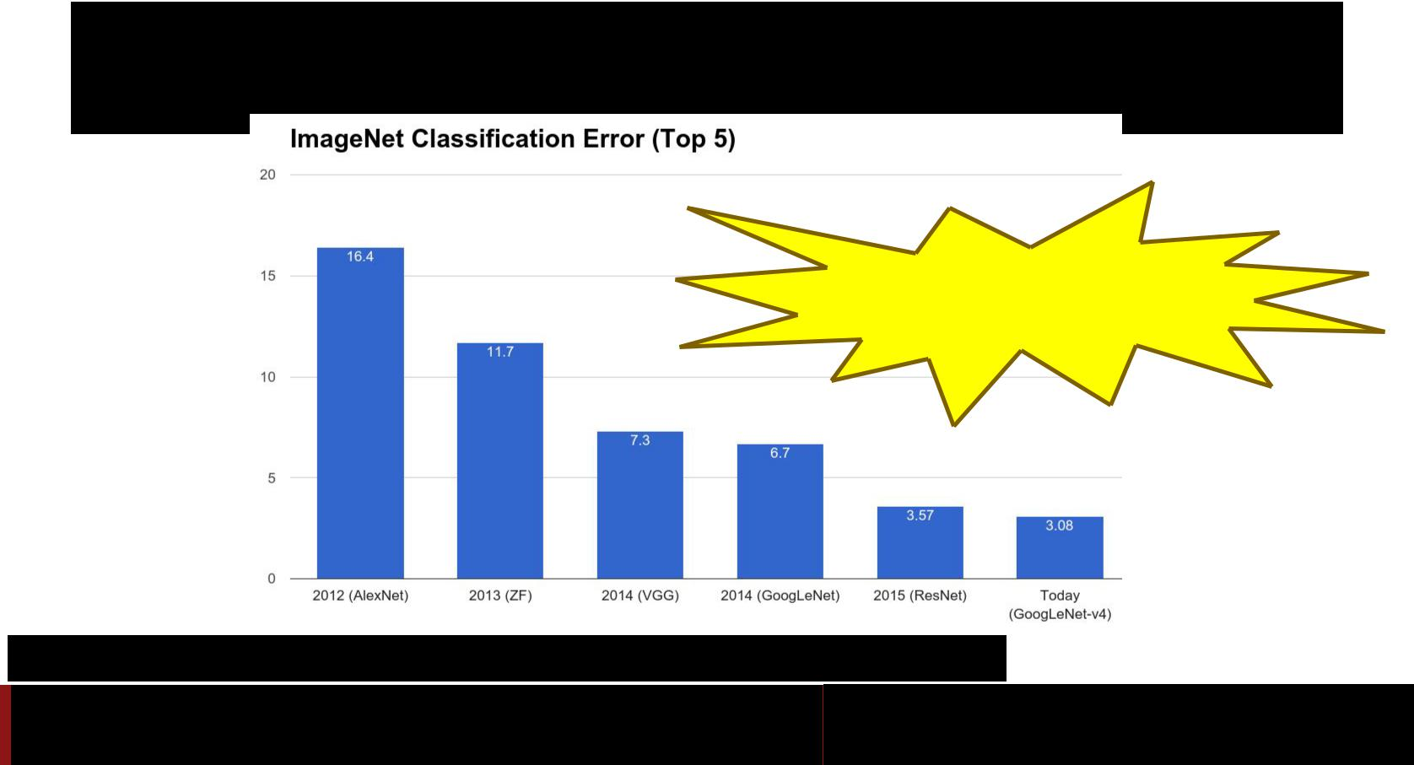But first….

New ImageNet Record today!

Szegedy et al, Inception-v4, Inception-ResNet and the Impact of Residual Connections on Learning, arXiv 2016

Fei-Fei Li & Andrej Karpathy & Justin Johnson Lecture 13 6 24 Feb 2016

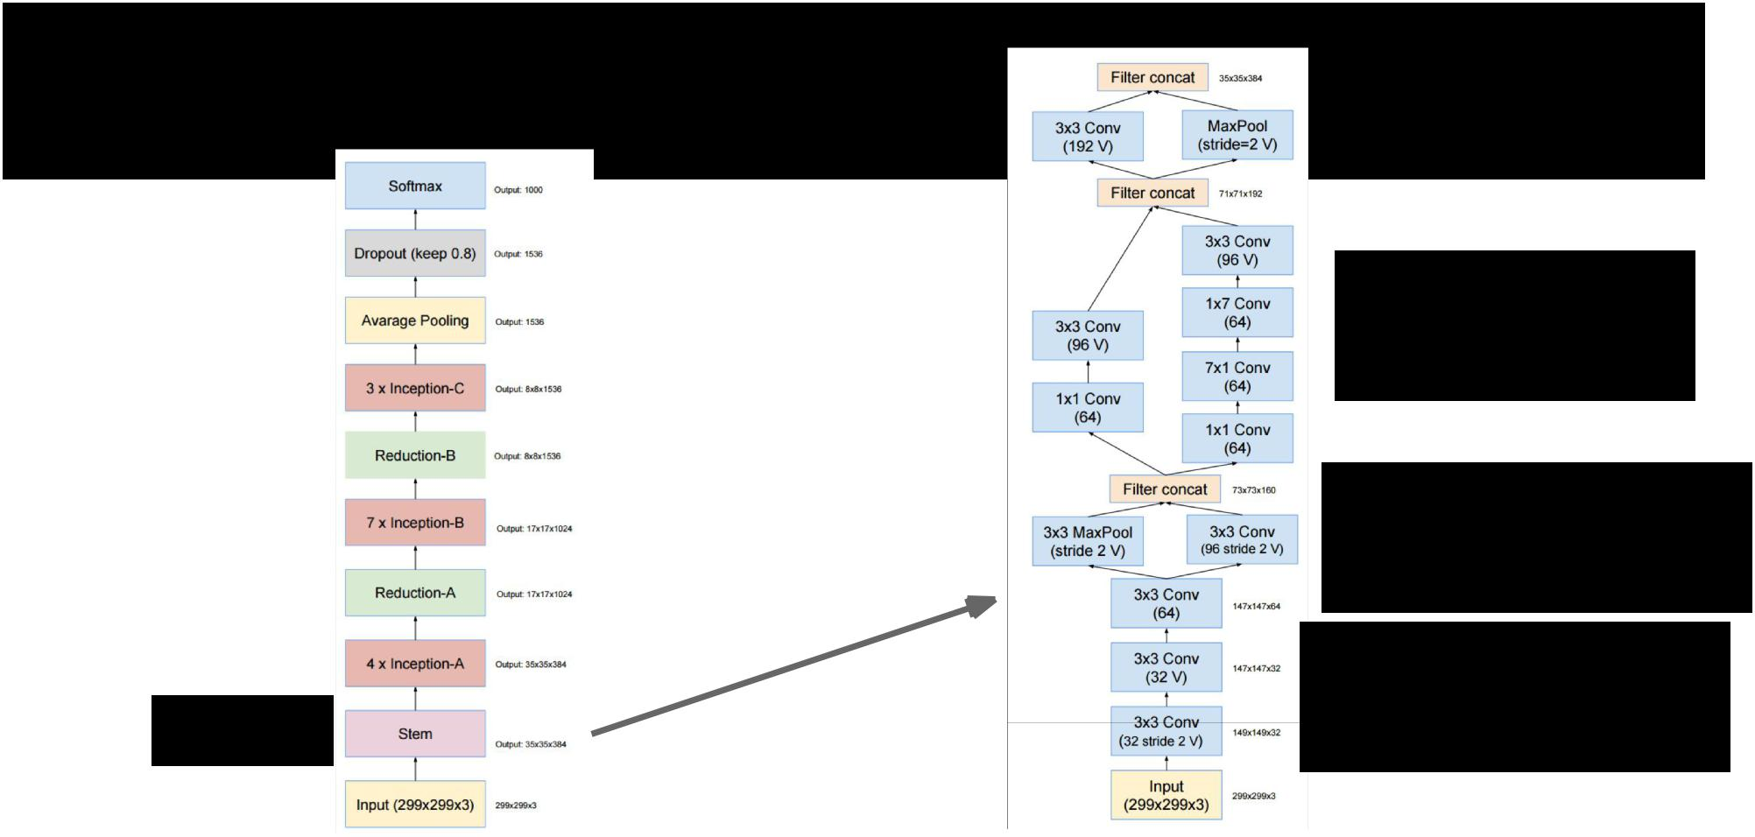Inception-v4

1x7, 7x1 filters

Strided convolution AND max pooling

V = Valid convolutions (no padding)

9 layers



Szegedy et al, Inception-v4, Inception-ResNet and the Impact of Residual Connections on Learning, arXiv 2016

Fei-Fei Li & Andrej Karpathy & Justin Johnson Lecture 13 7 24 Feb 2016

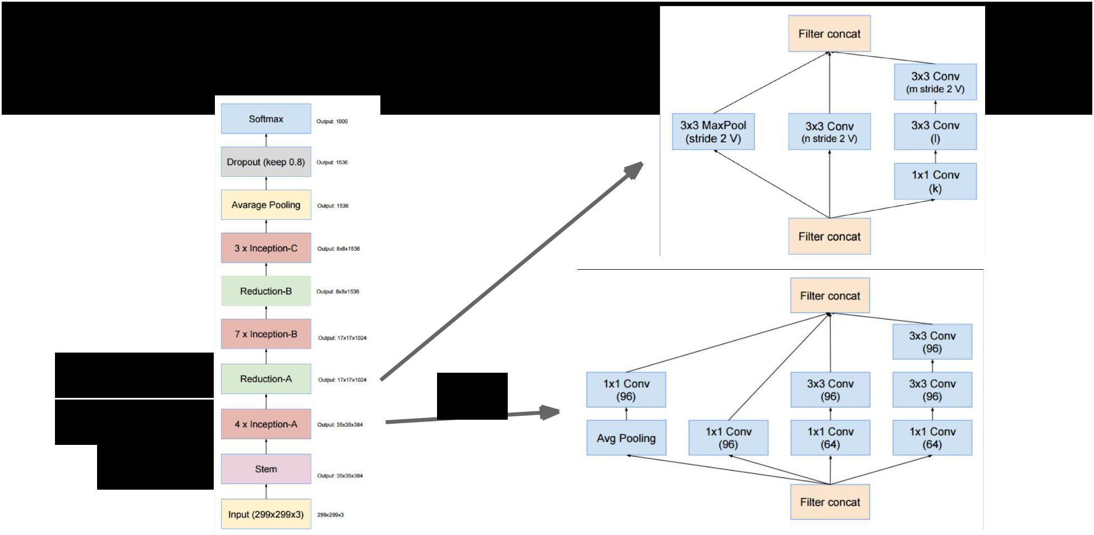Inception-v4

3 layers

x4

4 x 3 layers

9 layers



Szegedy et al, Inception-v4, Inception-ResNet and the Impact of Residual Connections on Learning, arXiv 2016

Fei-Fei Li & Andrej Karpathy & Justin Johnson Lecture 13 8 24 Feb 2016

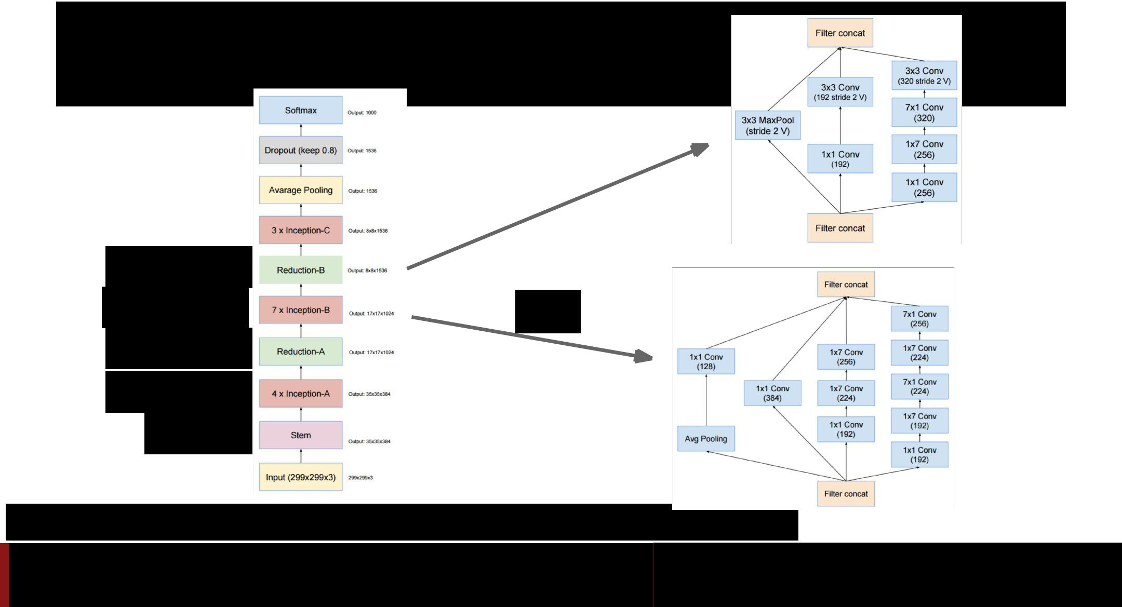Inception-v4

4 layers

|  |  |
| --- | --- |
| 5 x 7 layers | x7 |

3 layers

4 x 3 layers

9 layers

Szegedy et al, Inception-v4, Inception-ResNet and the Impact of Residual Connections on Learning, arXiv 2016

Fei-Fei Li & Andrej Karpathy & Justin Johnson Lecture 13 9 24 Feb 2016

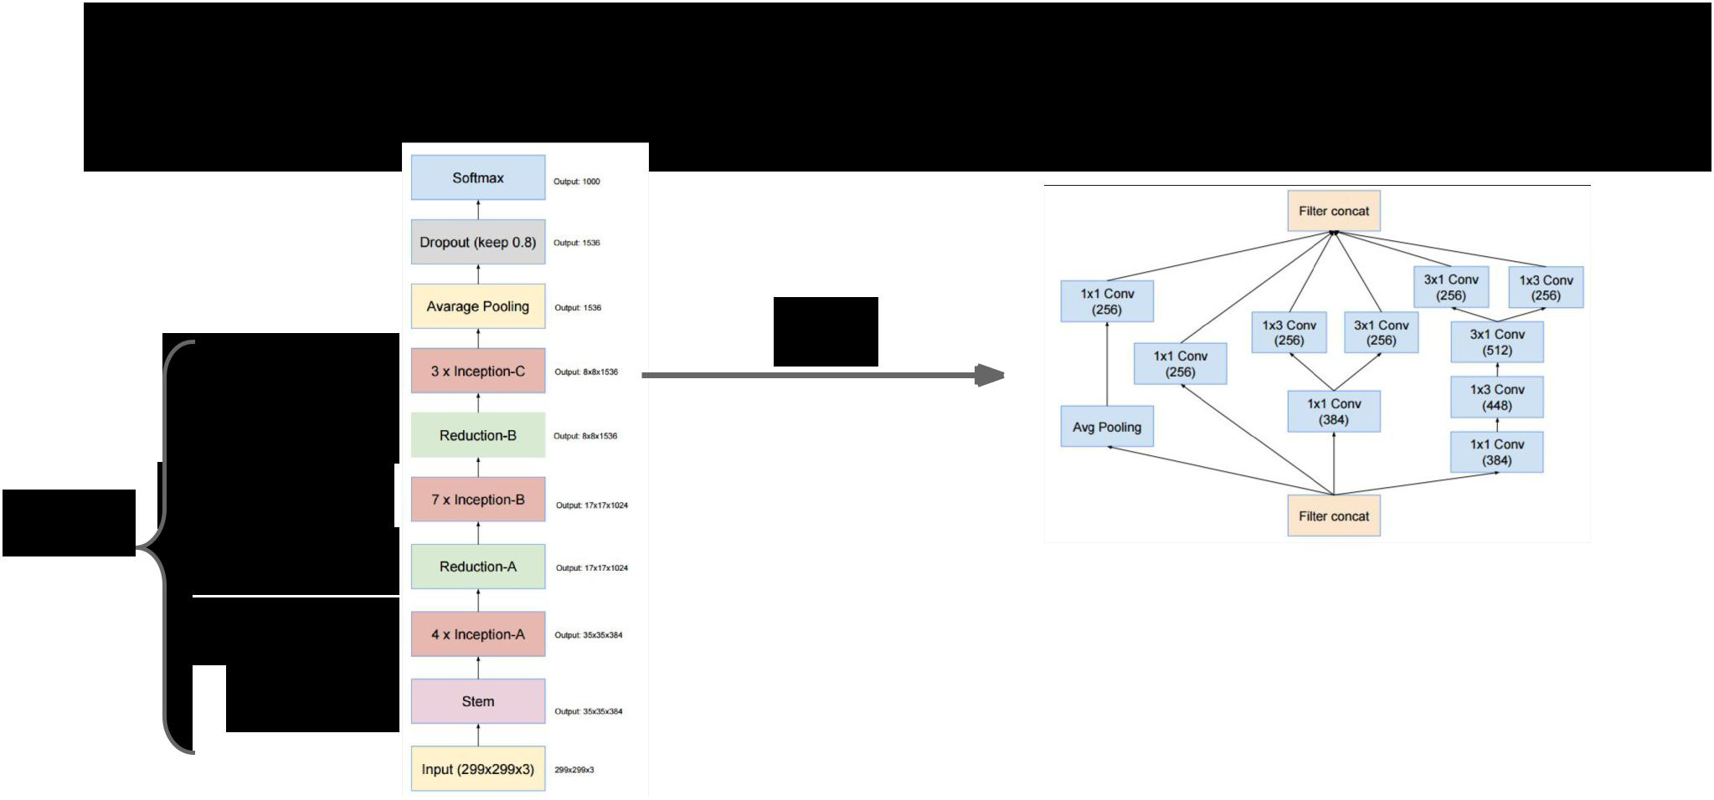Inception-v4

x3

|  |  |  |
| --- | --- | --- |
|  | 3 x 4 layers |  |
|  | 4 layers |  |
| 75 | 5 x 7 layers |  |
| 3 layers |  |
| layers |  |
|  | 4 x 3 layers |  |
|  | 9 layers |  |



Szegedy et al, Inception-v4, Inception-ResNet and the Impact of Residual Connections on Learning, arXiv 2016

Fei-Fei Li & Andrej Karpathy & Justin Johnson Lecture 13 10 24 Feb 2016

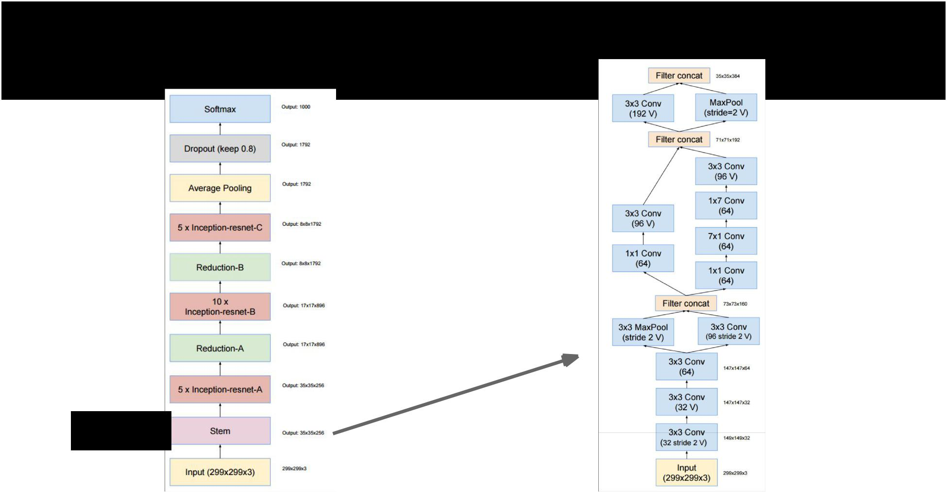Inception-ResNet-v2

9 layers



Fei-Fei Li & Andrej Karpathy & Justin Johnson Lecture 13 11 24 Feb 2016

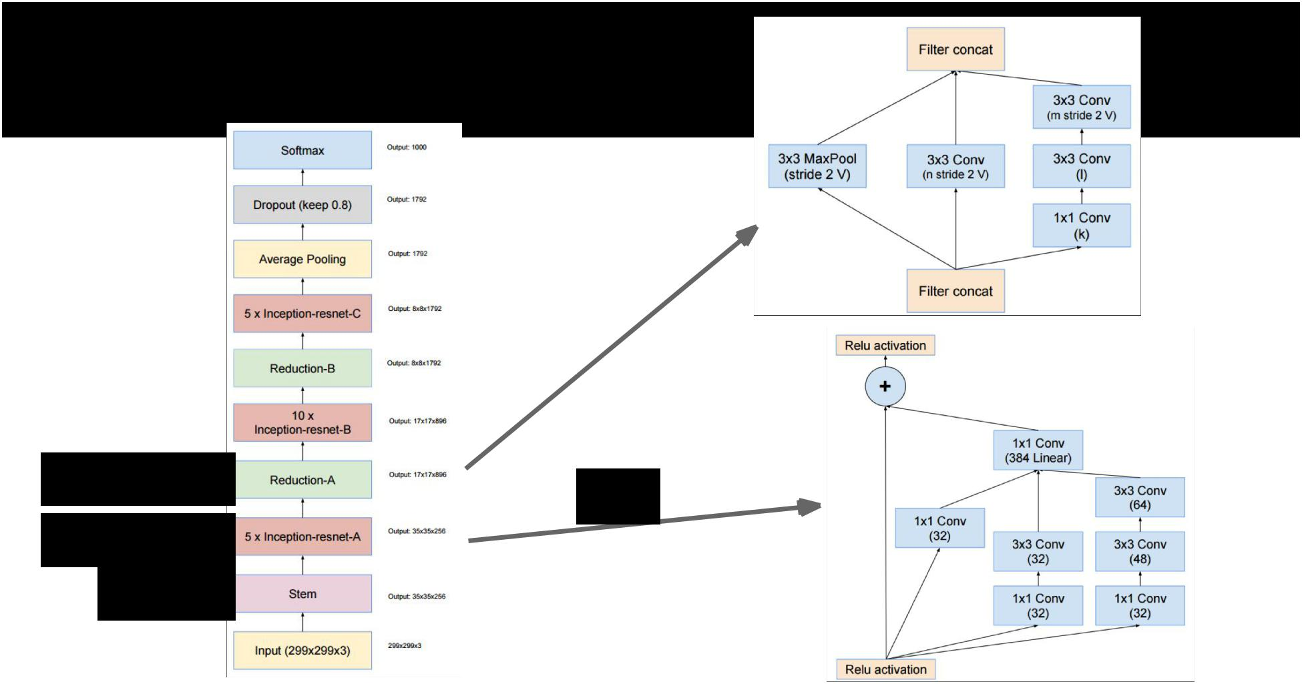Inception-ResNet-v2

3 layers

5 x 4 layers

9 layers

x7



Fei-Fei Li & Andrej Karpathy & Justin Johnson Lecture 13 12 24 Feb 2016

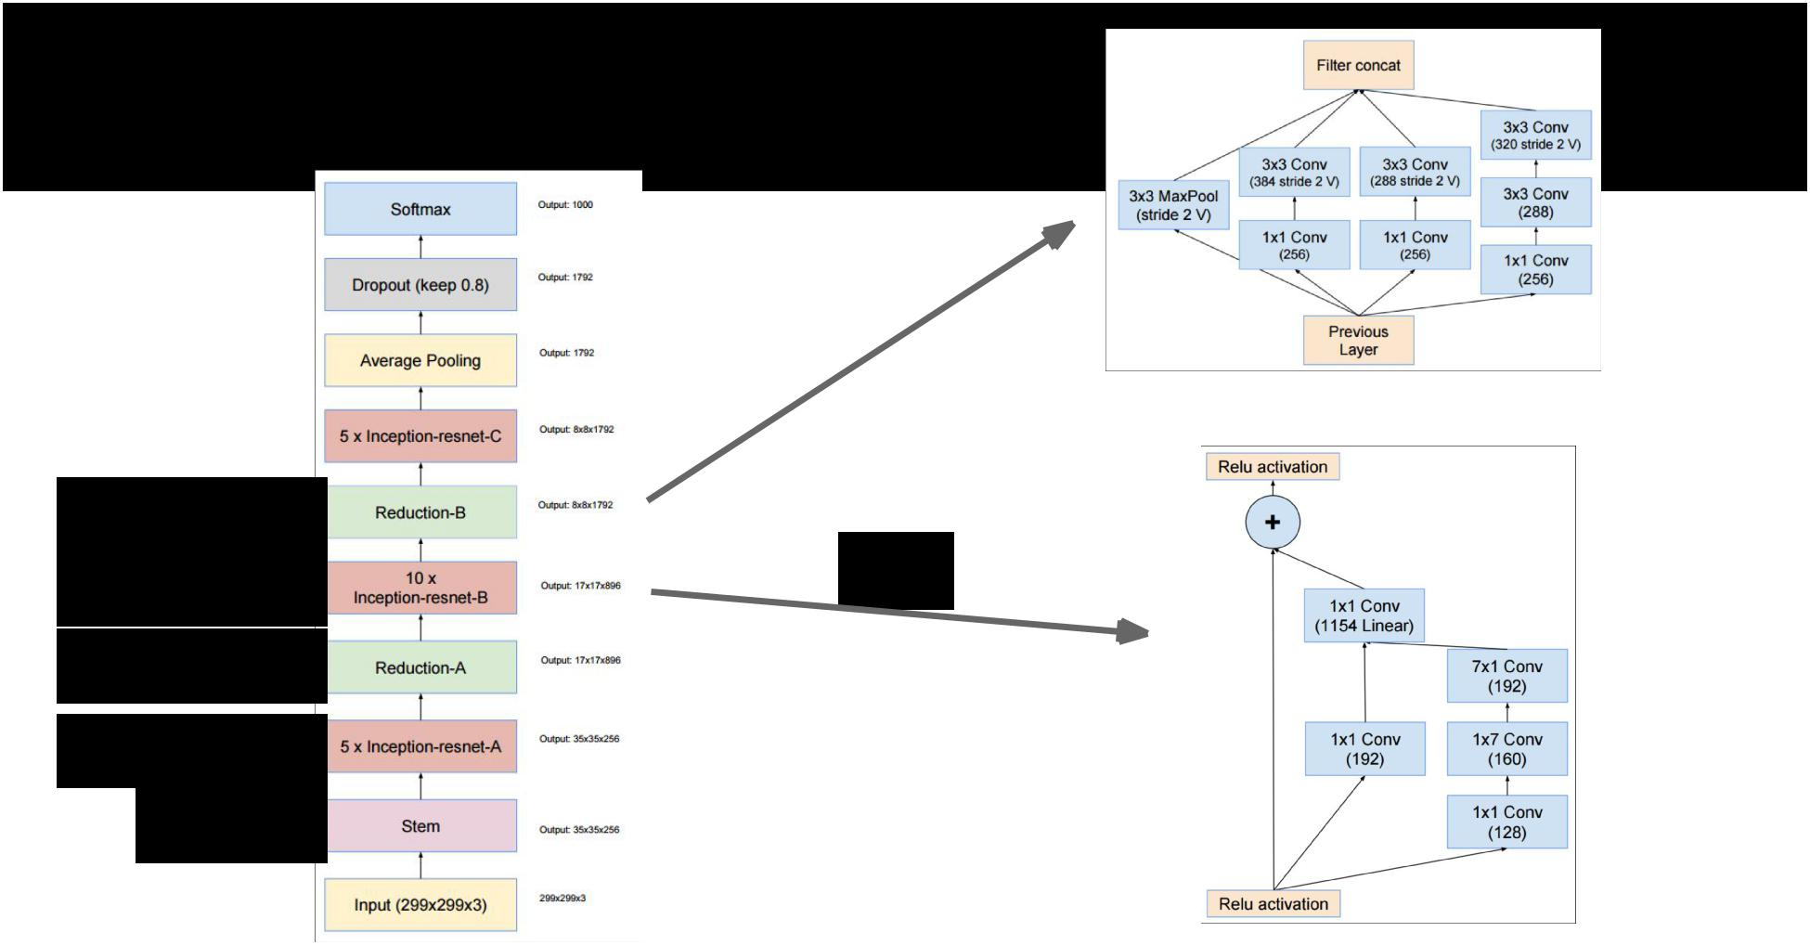Inception-ResNet-v2

3 layers

|  |  |  |
| --- | --- | --- |
| 10 x 4 layers | x10 |  |
|  |  |
| 3 layers |  |  |

5 x 4 layers

9 layers



Fei-Fei Li & Andrej Karpathy & Justin Johnson Lecture 13 13 24 Feb 2016

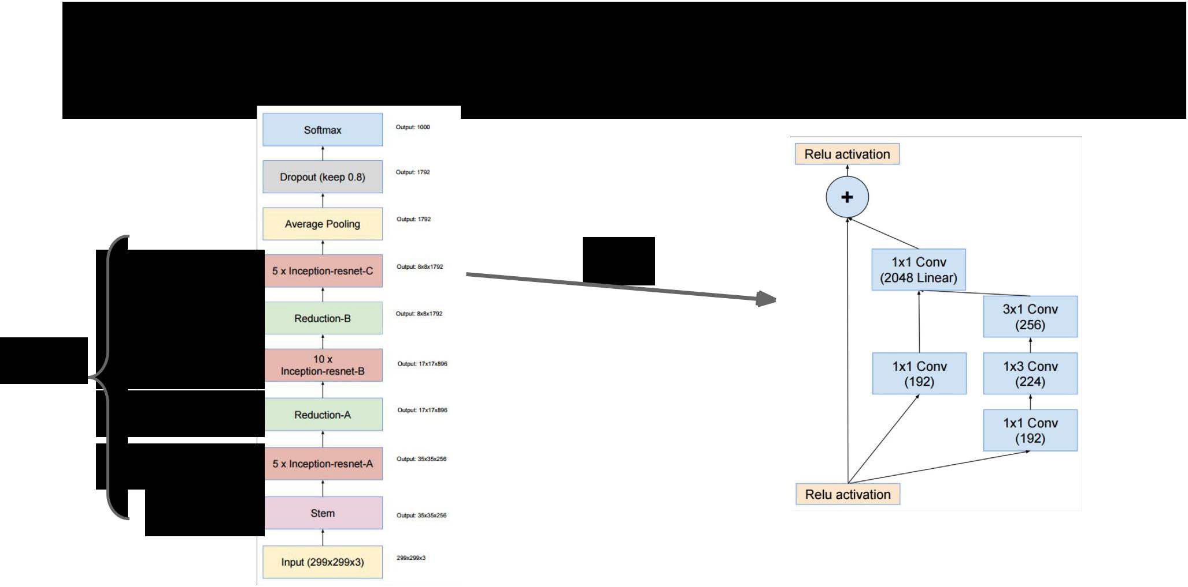Inception-ResNet-v2

|  |  |  |
| --- | --- | --- |
| 5 x 4 layers | x 5 |  |
|  |  |
| 3 layers |  |  |
| 75 10 x 4 layers |  |  |

layers

3 layers

5 x 3 layers

9 layers



Fei-Fei Li & Andrej Karpathy & Justin Johnson Lecture 13 14 24 Feb 2016

Inception-ResNet-v2

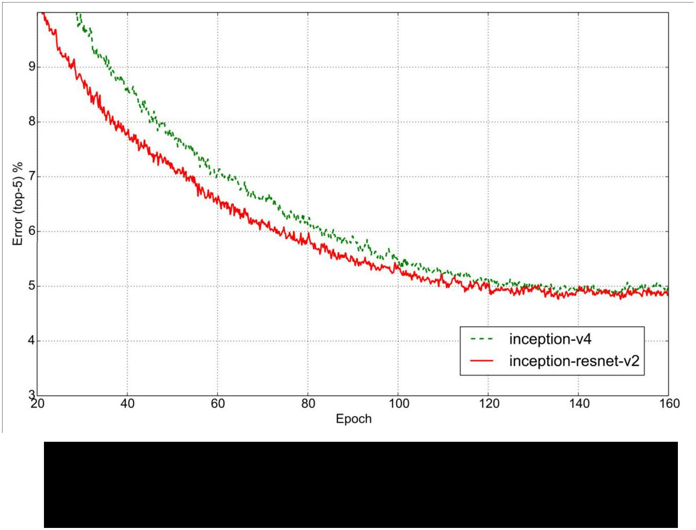

Residual and non-residual converge to

similar value, but residual learns faster



Fei-Fei Li & Andrej Karpathy & Justin Johnson Lecture 13 15 24 Feb 2016

Today



* Segmentation
  + Semantic Segmentation
  + Instance Segmentation
* (Soft) Attention
  + Discrete locations
  + Continuous locations (Spatial Transformers)



Fei-Fei Li & Andrej Karpathy & Justin Johnson Lecture 13 16 24 Feb 2016



Segmentation



Fei-Fei Li & Andrej Karpathy & Justin Johnson Lecture 13 17 24 Feb 2016

Computer Vision Tasks

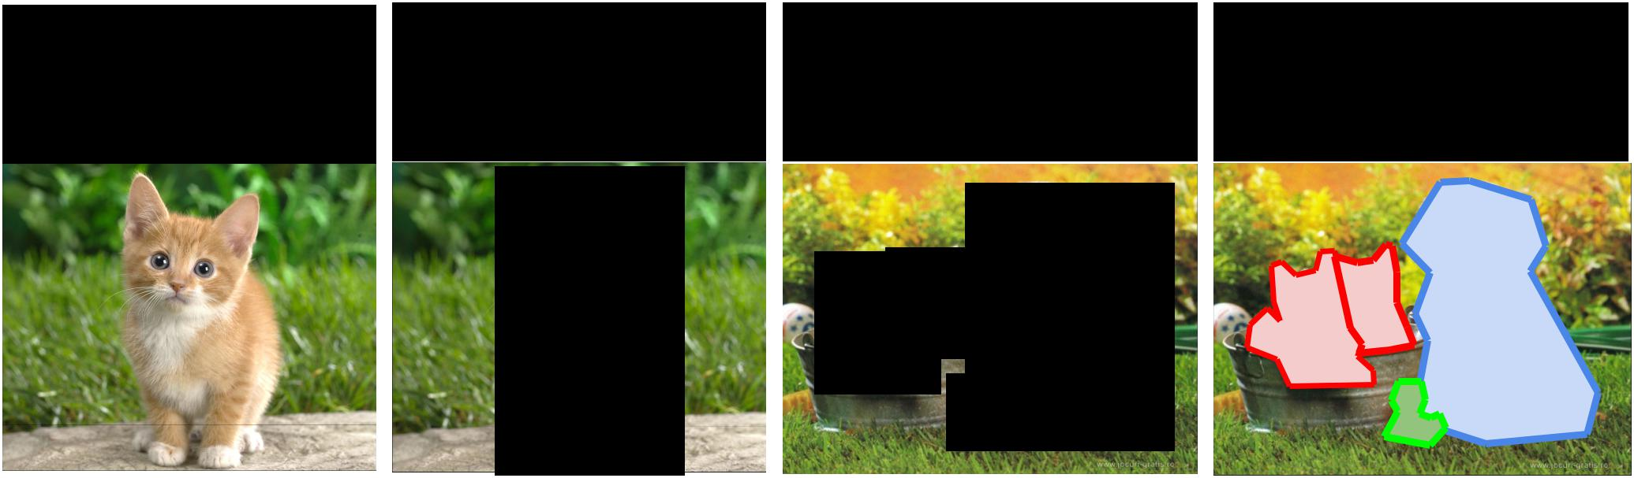

|  |  |  |  |  |  |  |  |  |  |  |  |  |  |  |
| --- | --- | --- | --- | --- | --- | --- | --- | --- | --- | --- | --- | --- | --- | --- |
| **Classification** | **Classification** | | | | | **Object Detection** | | | | | | | **Segmentation** |  |
| **+ Localization** | | | | |  |
|  |  |  |  |  |  |  |  |  |  |
|  |  |  |  |  |  |  |  |  |  |  |  |  |  |  |
|  |  |  |  |  |  |  |  |  |  |  |  |  |  |  |
|  |  |  |  |  |  |  |  |  |  |  |  |  |  |  |
|  |  |  |  |  |  |  |  |  |  |  |  |  |  |  |
|  |  |  |  |  |  |  |  |  |  |  |  |  |  |  |
|  |  |  |  |  |  |  |  |  |  |  |  |  |  |  |
|  |  |  |  |  |  |  |  |  |  |  |  |  |  |  |
|  |  |  |  |  |  |  |  |  |  |  |  |  |  |  |
|  |  |  |  |  |  |  |  |  |  |  |  |  |  |  |
|  |  |  |  |  |  |  |  |  |  |  |  |  |  |  |



CAT CAT CAT, DOG, DUCK CAT, DOG, DUCK



Single object Multiple objects

Fei-Fei Li & Andrej Karpathy & Justin Johnson Lecture 13 1818 24 Feb 2016

Computer Vision Tasks

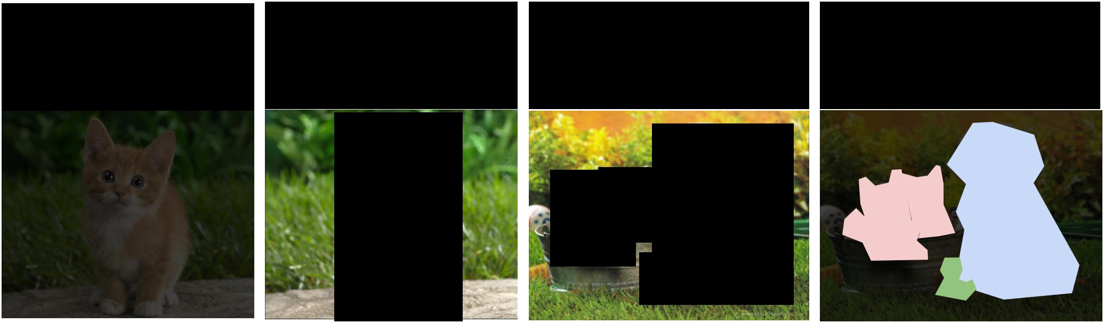

|  |  |  |  |  |  |  |  |  |  |  |  |  |  |  |
| --- | --- | --- | --- | --- | --- | --- | --- | --- | --- | --- | --- | --- | --- | --- |
| **Classification** | **Classification** | | | | | **Object Detection** | | | | | | | **Segmentation** |  |
| **+ Localization** | | | | |  |
|  |  |  |  |  |  |  |  |  |  |
|  |  |  |  |  |  |  |  |  |  |  |  |  |  |  |
|  |  |  |  |  |  |  |  |  |  |  |  |  |  |  |
|  |  |  |  |  |  |  |  |  |  |  |  |  |  |  |
|  |  |  |  |  |  |  |  |  |  |  |  |  |  |  |
|  |  |  |  |  |  |  |  |  |  |  |  |  |  |  |
|  |  |  |  |  |  |  |  |  |  |  |  |  |  |  |
|  |  |  |  |  |  |  |  |  |  |  |  |  |  |  |
|  |  |  |  |  |  |  |  |  |  |  |  |  |  |  |
|  |  |  |  |  |  |  |  |  |  |  |  |  |  |  |
|  |  |  |  |  |  |  |  |  |  |  |  |  |  |  |



Lecture 8



Fei-Fei Li & Andrej Karpathy & Justin Johnson Lecture 13 1919 24 Feb 2016

Computer Vision Tasks

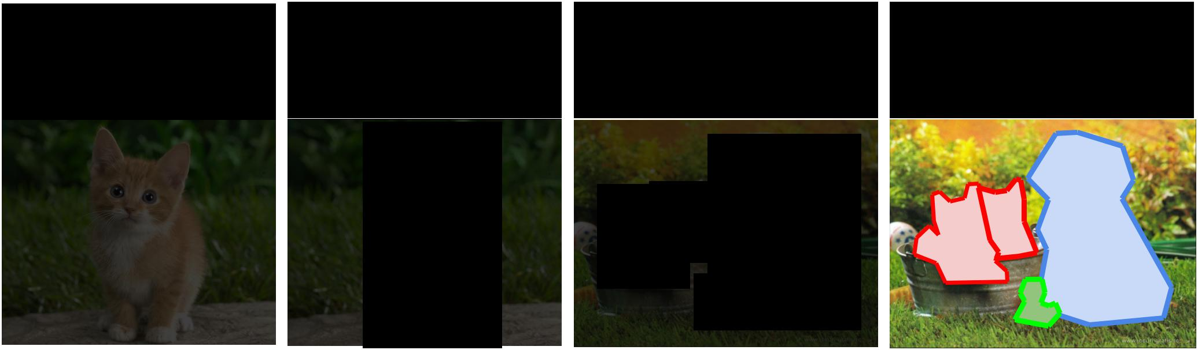

|  |  |  |  |  |  |  |  |  |  |  |  |  |  |  |
| --- | --- | --- | --- | --- | --- | --- | --- | --- | --- | --- | --- | --- | --- | --- |
| **Classification** | **Classification** | | | | | **Object Detection** | | | | | | | **Segmentation** |  |
| **+ Localization** | | | | |  |
|  |  |  |  |  |  |  |  |  |  |
|  |  |  |  |  |  |  |  |  |  |  |  |  |  |  |
|  |  |  |  |  |  |  |  |  |  |  |  |  |  |  |
|  |  |  |  |  |  |  |  |  |  |  |  |  |  |  |
|  |  |  |  |  |  |  |  |  |  |  |  |  |  |  |
|  |  |  |  |  |  |  |  |  |  |  |  |  |  |  |
|  |  |  |  |  |  |  |  |  |  |  |  |  |  |  |
|  |  |  |  |  |  |  |  |  |  |  |  |  |  |  |
|  |  |  |  |  |  |  |  |  |  |  |  |  |  |  |
|  |  |  |  |  |  |  |  |  |  |  |  |  |  |  |
|  |  |  |  |  |  |  |  |  |  |  |  |  |  |  |



Today



Fei-Fei Li & Andrej Karpathy & Justin Johnson Lecture 13 2020 24 Feb 2016

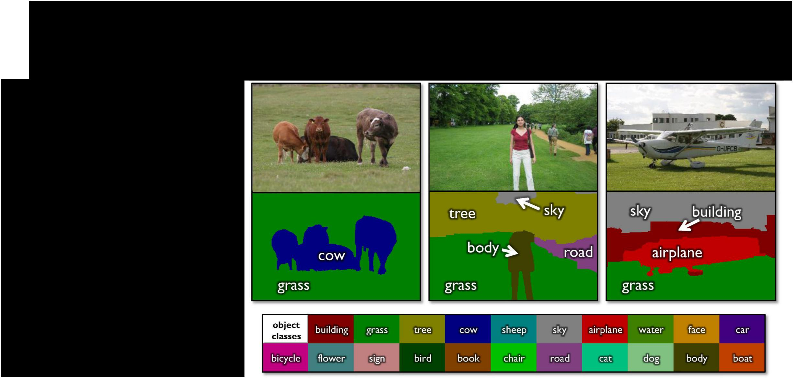Semantic Segmentation

Label every pixel!

Don’t differentiate instances (cows)

Classic computer vision problem



Figure credit: Shotton et al, “TextonBoost for Image Understanding: Multi-Class Object Recognition and Segmentation by Jointly Modeling Texture, Layout, and Context”, IJCV 2007

Fei-Fei Li & Andrej Karpathy & Justin Johnson Lecture 13 21 24 Feb 2016

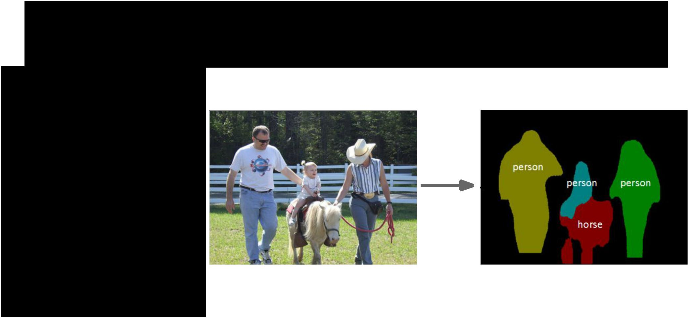Instance Segmentation

Detect instances, give category, label pixels

“simultaneous detection and segmentation” (SDS)



Lots of recent work

(MS-COCO)



Figure credit: Dai et al, “Instance-aware Semantic Segmentation via Multi-task Network Cascades”, arXiv 2015

Fei-Fei Li & Andrej Karpathy & Justin Johnson Lecture 13 22 24 Feb 2016



Semantic Segmentation



Fei-Fei Li & Andrej Karpathy & Justin Johnson Lecture 13 23 24 Feb 2016

Semantic Segmentation

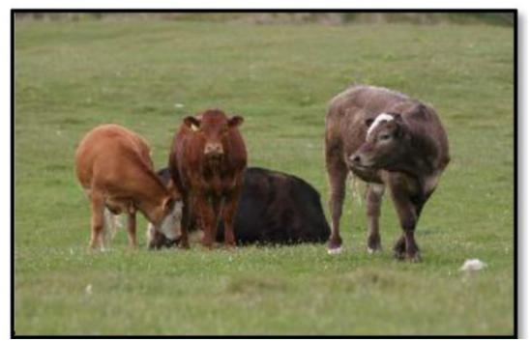

Fei-Fei Li & Andrej Karpathy & Justin Johnson Lecture 13 24 24 Feb 2016

Semantic Segmentation



Extract

patch

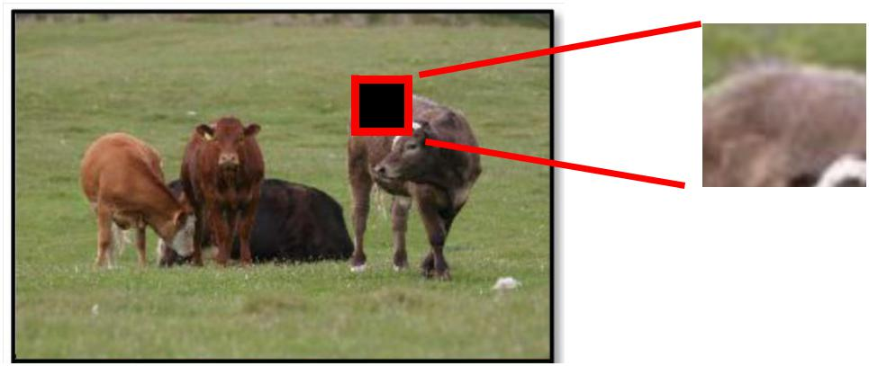

Fei-Fei Li & Andrej Karpathy & Justin Johnson Lecture 13 25 24 Feb 2016

Semantic Segmentation



Extract Run through

patch a CNN

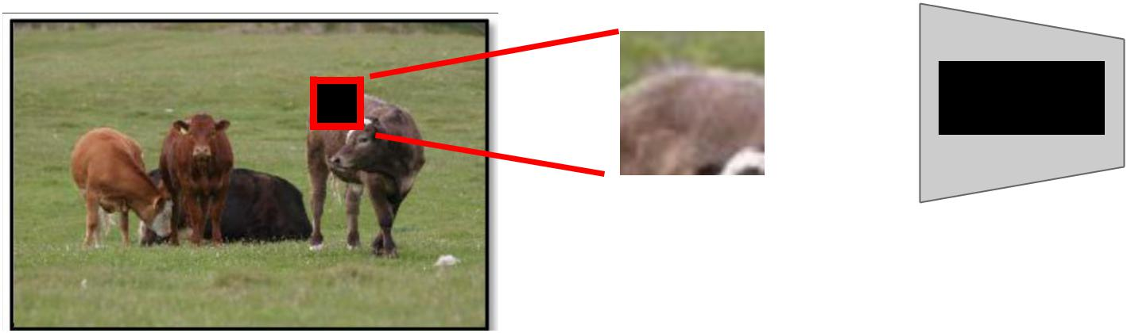

CNN



Fei-Fei Li & Andrej Karpathy & Justin Johnson Lecture 13 26 24 Feb 2016

Semantic Segmentation



Extract Run through Classify

patch a CNN center pixel

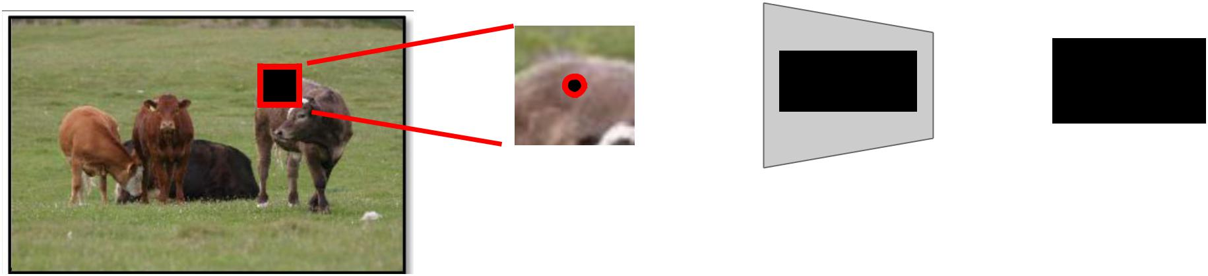

CNN  COW



Fei-Fei Li & Andrej Karpathy & Justin Johnson Lecture 13 27 24 Feb 2016

Semantic Segmentation



Extract Run through Classify

patch a CNN center pixel

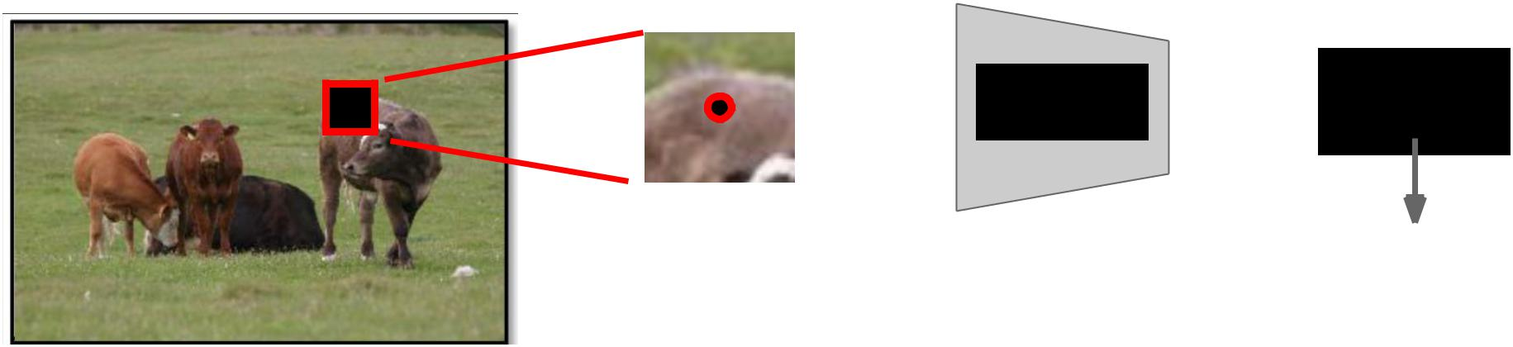

CNN  COW

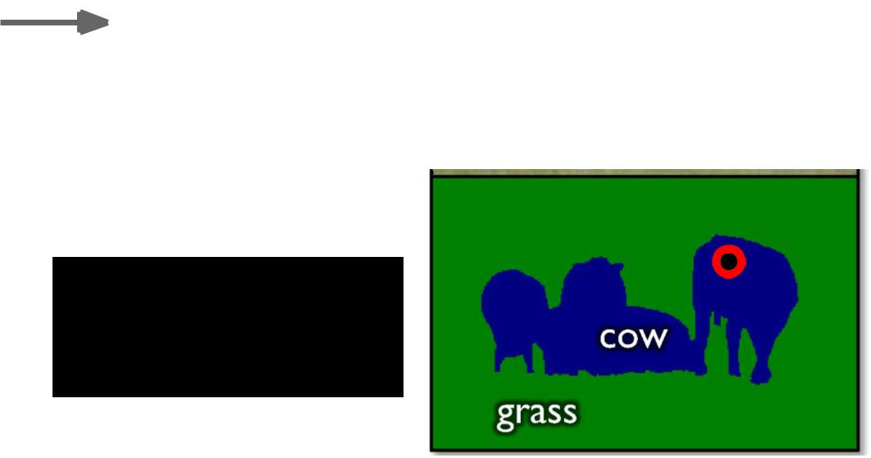

Repeat for

every pixel



Fei-Fei Li & Andrej Karpathy & Justin Johnson Lecture 13 28 24 Feb 2016

Semantic Segmentation



Run “fully convolutional” network

to get all pixels at once

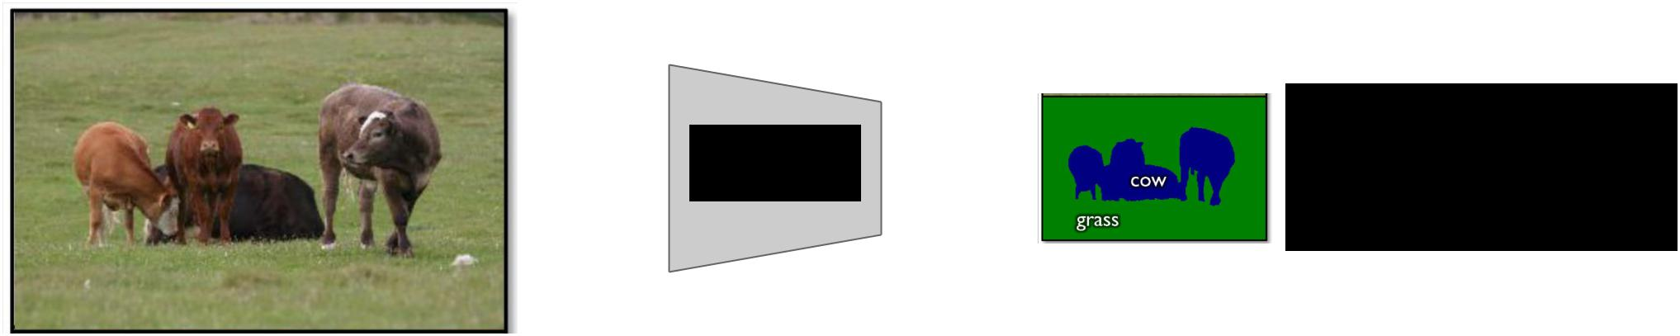

Smaller output

|  |  |  |
| --- | --- | --- |
| CNN | due to pooling |  |
|  |  |



Fei-Fei Li & Andrej Karpathy & Justin Johnson Lecture 13 29 24 Feb 2016

Semantic Segmentation: Multi-Scale

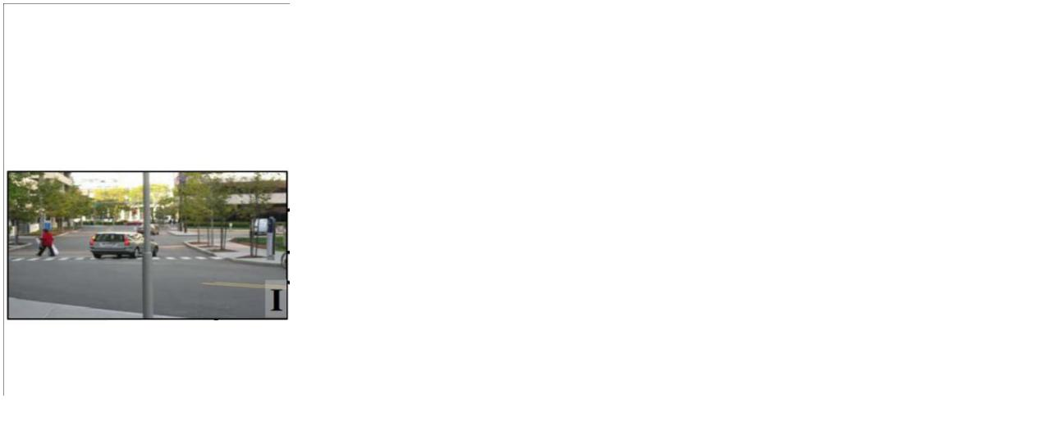

Farabet et al, “Learning Hierarchical Features for Scene Labeling,” TPAMI 2013

Fei-Fei Li & Andrej Karpathy & Justin Johnson Lecture 13 30 24 Feb 2016

Semantic Segmentation: Multi-Scale

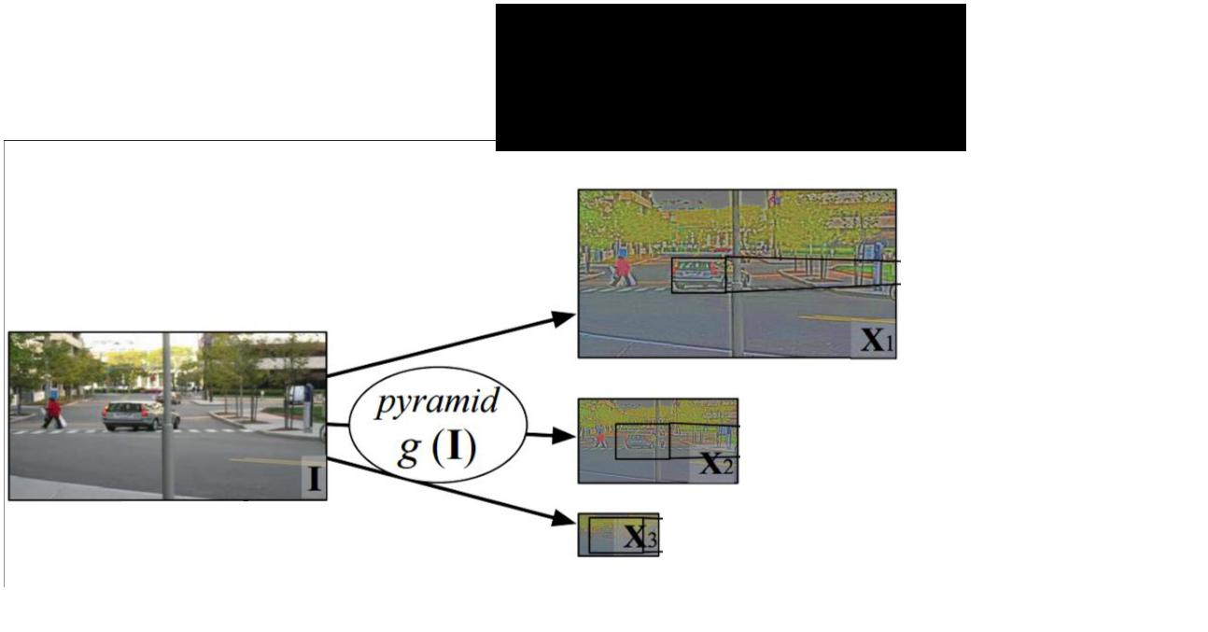

Resize image to

multiple scales



Farabet et al, “Learning Hierarchical Features for Scene Labeling,” TPAMI 2013

Fei-Fei Li & Andrej Karpathy & Justin Johnson Lecture 13 31 24 Feb 2016

Semantic Segmentation: Multi-Scale

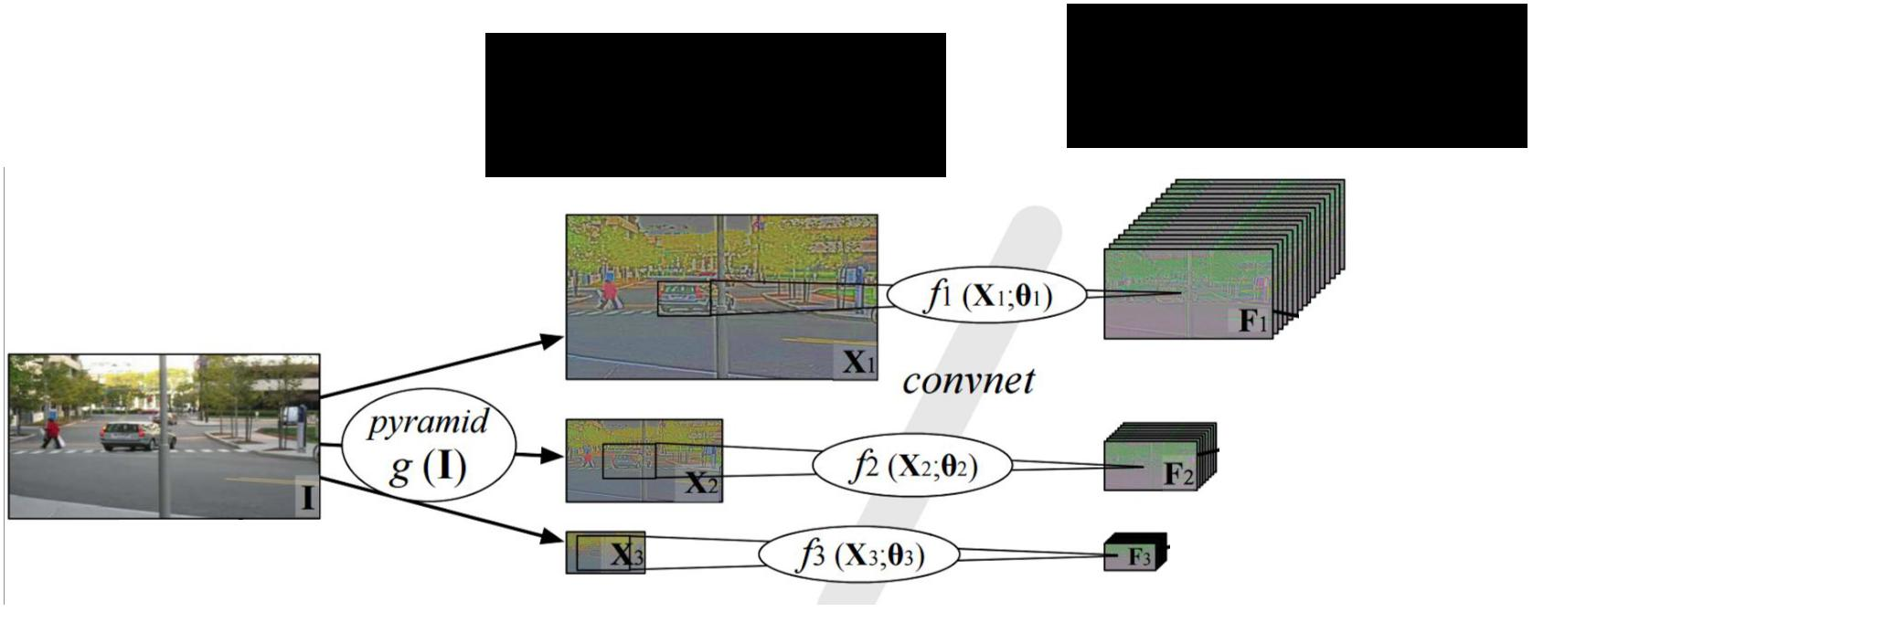

|  |  |  |
| --- | --- | --- |
| Resize image to | Run one CNN |  |
| per scale |  |
| multiple scales |  |
|  |  |



Farabet et al, “Learning Hierarchical Features for Scene Labeling,” TPAMI 2013

Fei-Fei Li & Andrej Karpathy & Justin Johnson Lecture 13 32 24 Feb 2016

Semantic Segmentation: Multi-Scale

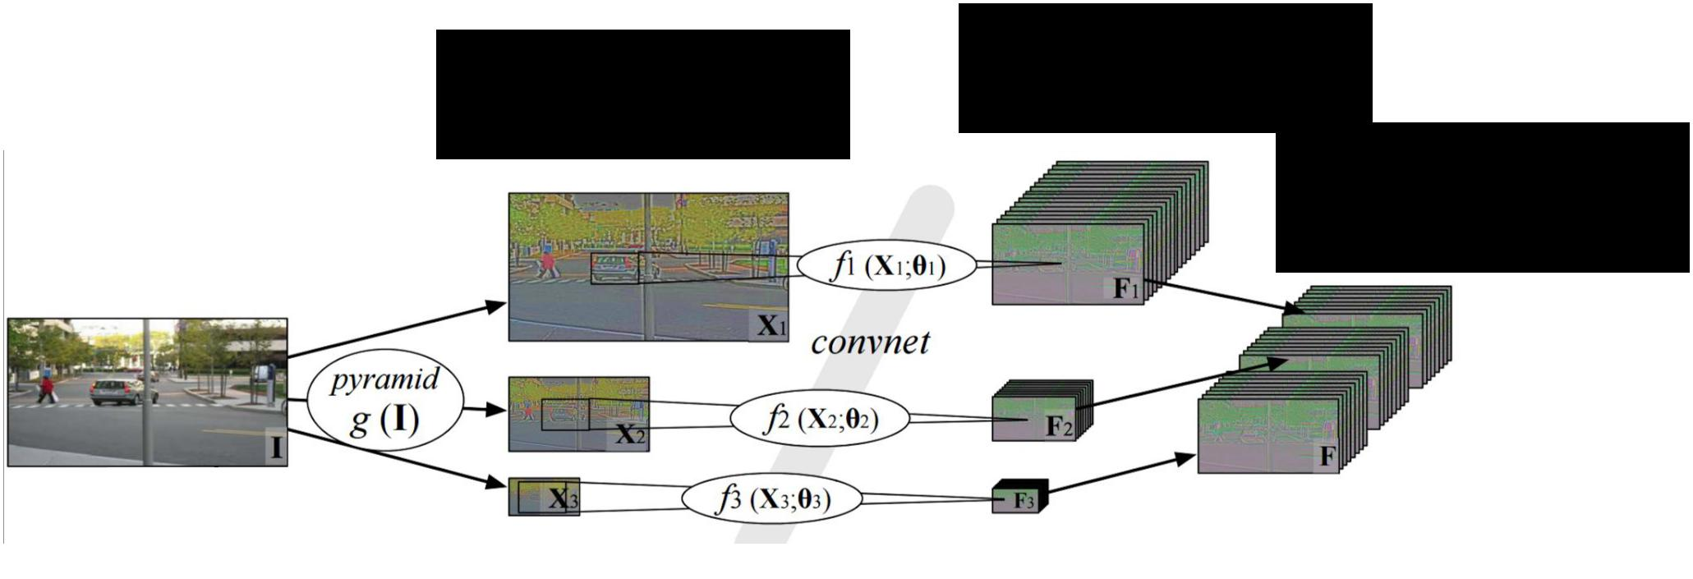

|  |  |  |
| --- | --- | --- |
| Resize image to | Run one CNN |  |
| per scale |  |
| multiple scales |  |
| Upscale outputs |  |
|  |  |
|  | and concatenate |  |



Farabet et al, “Learning Hierarchical Features for Scene Labeling,” TPAMI 2013

Fei-Fei Li & Andrej Karpathy & Justin Johnson Lecture 13 33 24 Feb 2016

Semantic Segmentation: Multi-Scale

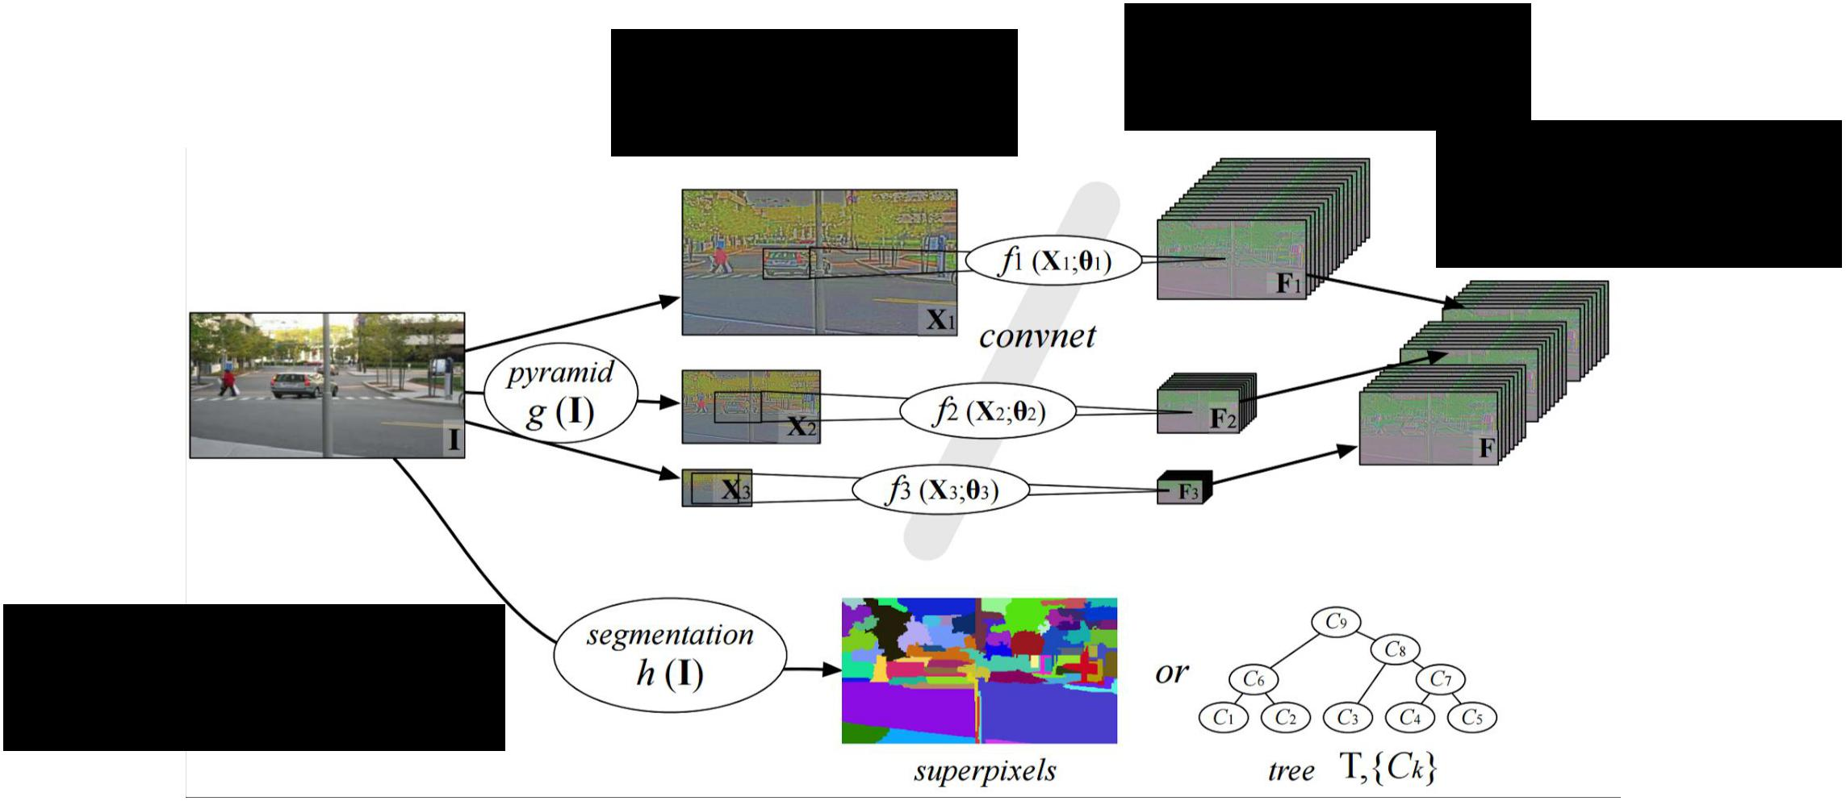

|  |  |  |
| --- | --- | --- |
| Resize image to | Run one CNN |  |
| per scale |  |
| multiple scales |  |
| Upscale outputs |  |
|  |  |
|  | and concatenate |  |

External “bottom-up”

segmentation



Farabet et al, “Learning Hierarchical Features for Scene Labeling,” TPAMI 2013

Fei-Fei Li & Andrej Karpathy & Justin Johnson Lecture 13 34 24 Feb 2016

Semantic Segmentation: Multi-Scale

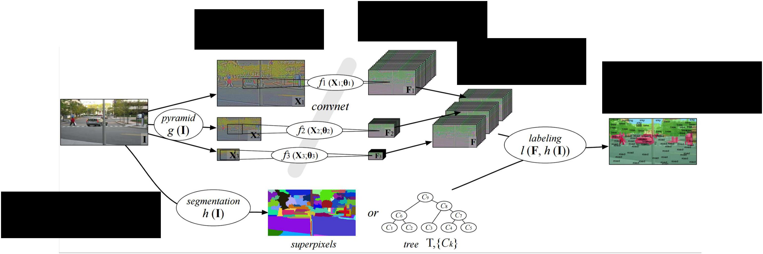

|  |  |  |  |
| --- | --- | --- | --- |
| Resize image to | Run one CNN |  |  |
| per scale |  |  |
| multiple scales |  |  |
| Upscale outputs |  |  |
|  |  |  |
|  | and concatenate | Combine everything |  |
|  |  | for final outputs |  |

External “bottom-up”

segmentation



Farabet et al, “Learning Hierarchical Features for Scene Labeling,” TPAMI 2013

Fei-Fei Li & Andrej Karpathy & Justin Johnson Lecture 13 35 24 Feb 2016

Semantic Segmentation: Refinement

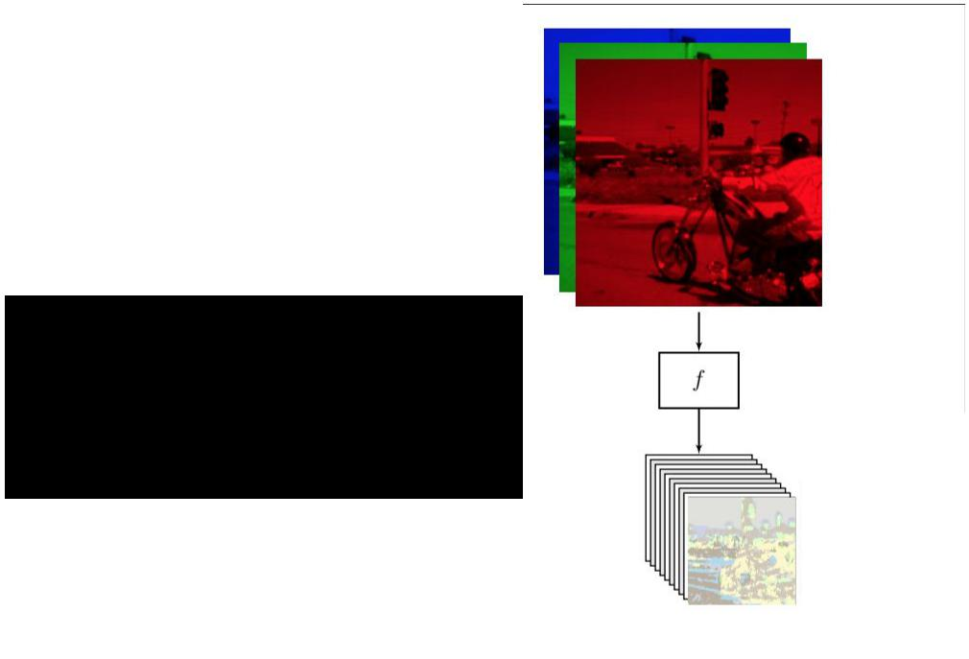

Apply CNN once to get labels



Pinheiro and Collobert, “Recurrent Convolutional Neural Networks for Scene Labeling”, ICML 2014

Fei-Fei Li & Andrej Karpathy & Justin Johnson Lecture 13 36 24 Feb 2016

Semantic Segmentation: Refinement

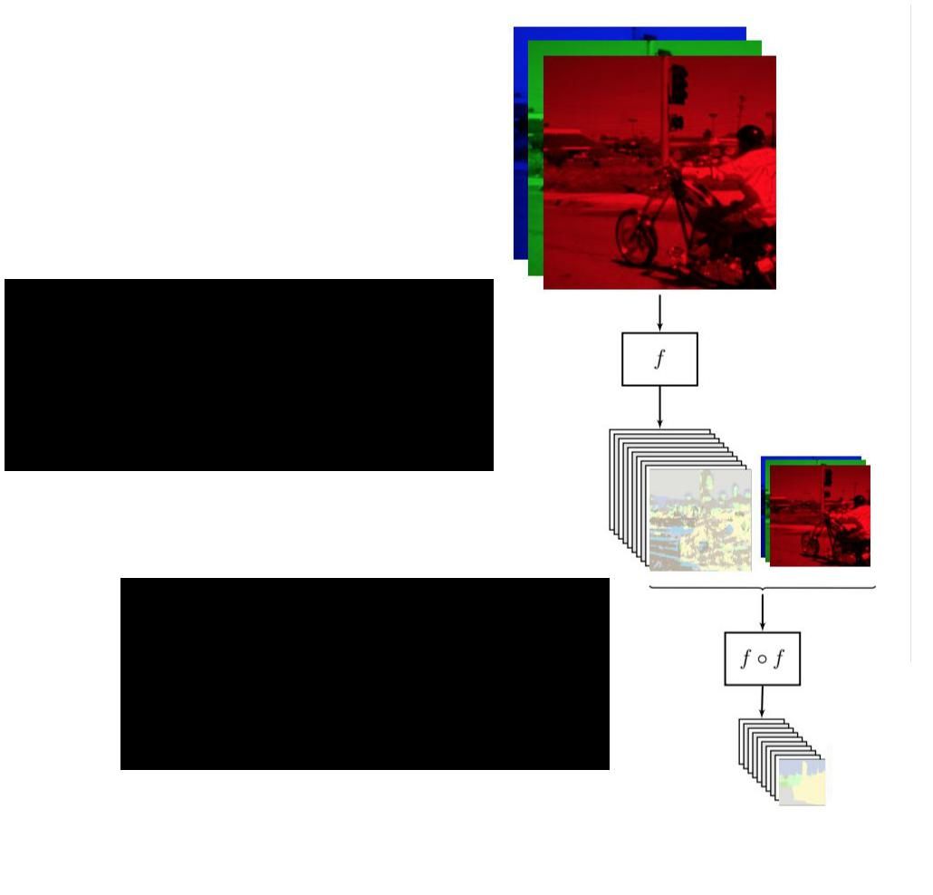

Apply CNN once to get labels

Apply AGAIN to

refine labels



Pinheiro and Collobert, “Recurrent Convolutional Neural Networks for Scene Labeling”, ICML 2014

Fei-Fei Li & Andrej Karpathy & Justin Johnson Lecture 13 37 24 Feb 2016

Semantic Segmentation: Refinement

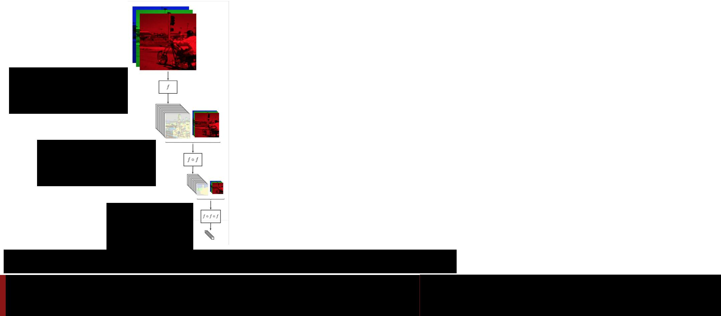

Apply CNN once to get labels

Apply AGAIN to

refine labels

And again!

Pinheiro and Collobert, “Recurrent Convolutional Neural Networks for Scene Labeling”, ICML 2014

Fei-Fei Li & Andrej Karpathy & Justin Johnson Lecture 13 38 24 Feb 2016

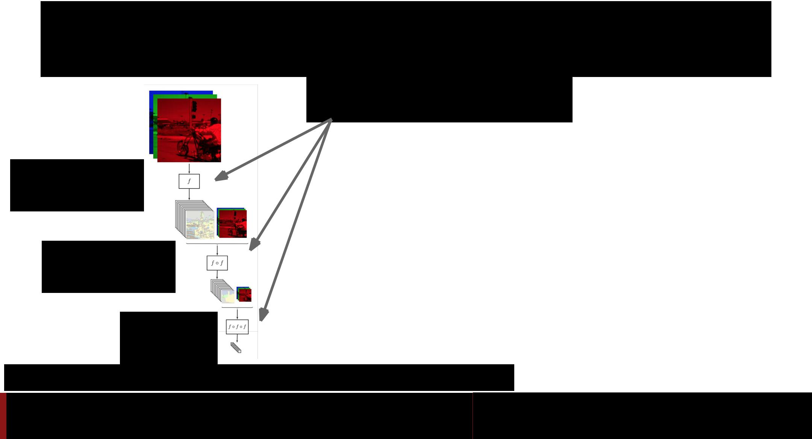Semantic Segmentation: Refinement

Same CNN weights:

**recurrent convolutional network**

Apply CNN once to get labels

Apply AGAIN to

refine labels

And again!

Pinheiro and Collobert, “Recurrent Convolutional Neural Networks for Scene Labeling”, ICML 2014

Fei-Fei Li & Andrej Karpathy & Justin Johnson Lecture 13 39 24 Feb 2016

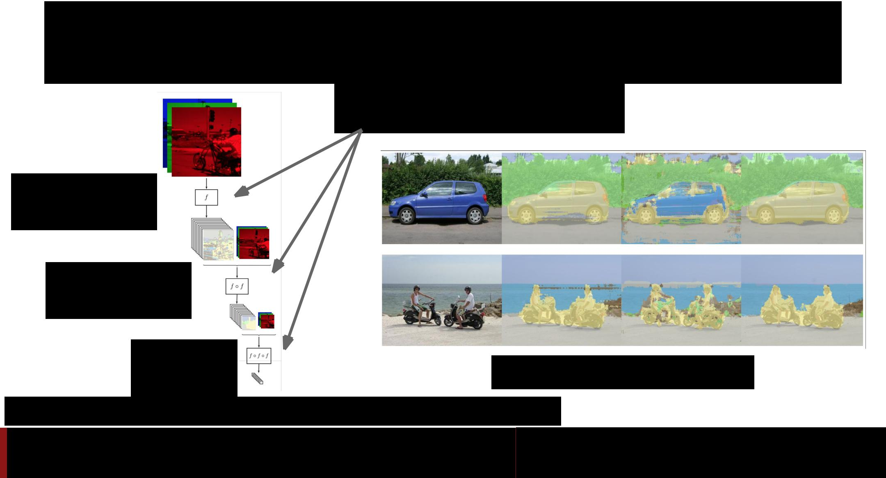Semantic Segmentation: Refinement

Same CNN weights:

**recurrent convolutional network**

Apply CNN once to get labels

Apply AGAIN to

refine labels

And again!  More iterations improve results



Pinheiro and Collobert, “Recurrent Convolutional Neural Networks for Scene Labeling”, ICML 2014

Fei-Fei Li & Andrej Karpathy & Justin Johnson Lecture 13 40 24 Feb 2016

Semantic Segmentation: Upsampling

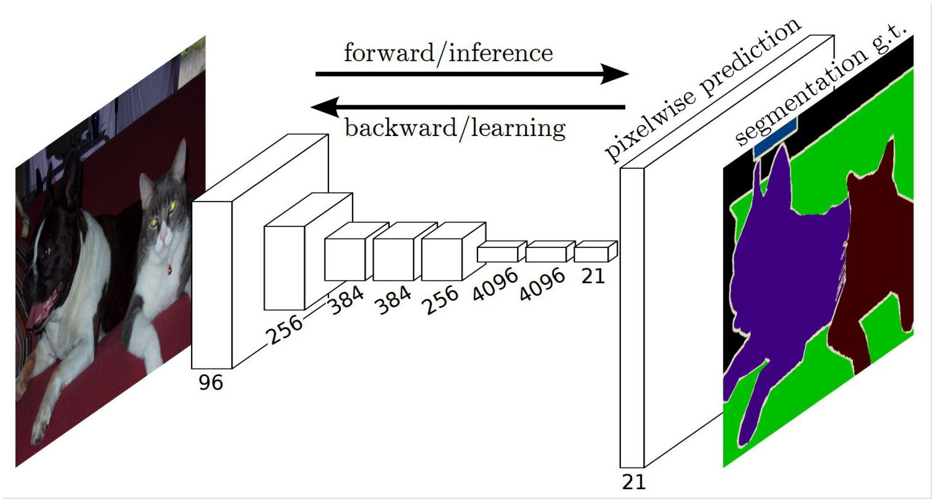

Long, Shelhamer, and Darrell, “Fully Convolutional Networks for Semantic Segmentation”, CVPR 2015

Fei-Fei Li & Andrej Karpathy & Justin Johnson Lecture 13 41 24 Feb 2016

Semantic Segmentation: Upsampling

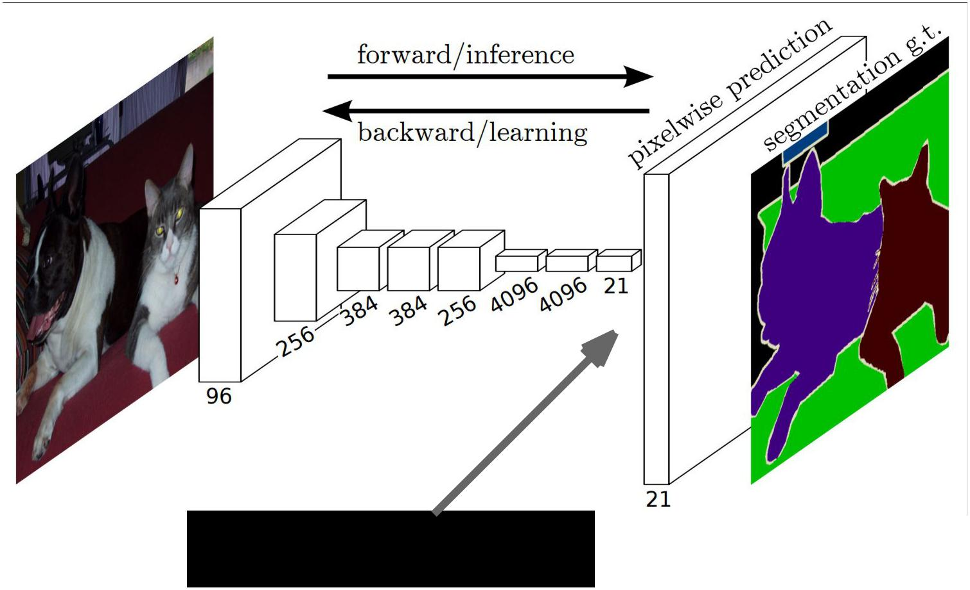

Learnable upsampling!



Long, Shelhamer, and Darrell, “Fully Convolutional Networks for Semantic Segmentation”, CVPR 2015

Fei-Fei Li & Andrej Karpathy & Justin Johnson Lecture 13 42 24 Feb 2016

Semantic Segmentation: Upsampling

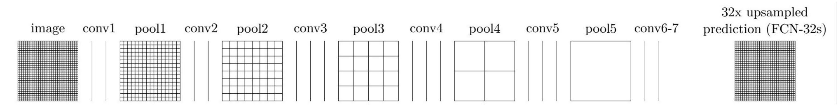

Long, Shelhamer, and Darrell, “Fully Convolutional Networks for Semantic Segmentation”, CVPR 2015

Fei-Fei Li & Andrej Karpathy & Justin Johnson Lecture 13 43 24 Feb 2016

Semantic Segmentation: Upsampling

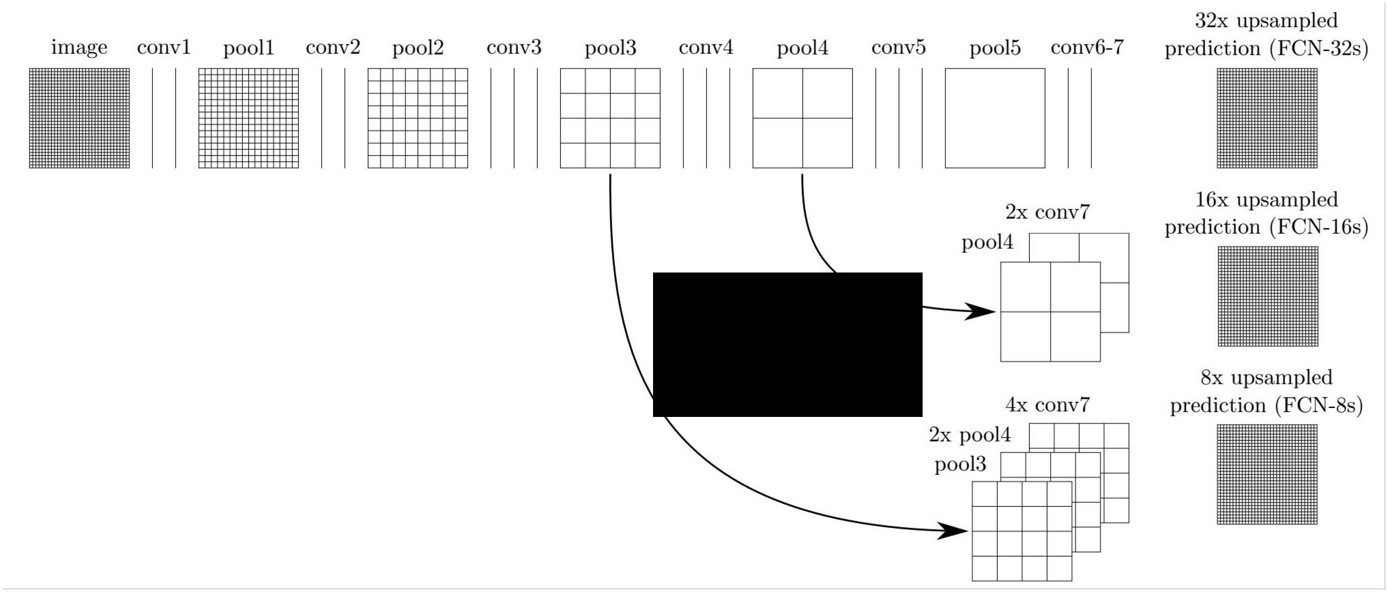

“skip

connections”



Long, Shelhamer, and Darrell, “Fully Convolutional Networks for Semantic Segmentation”, CVPR 2015

Fei-Fei Li & Andrej Karpathy & Justin Johnson Lecture 13 44 24 Feb 2016

Semantic Segmentation: Upsampling

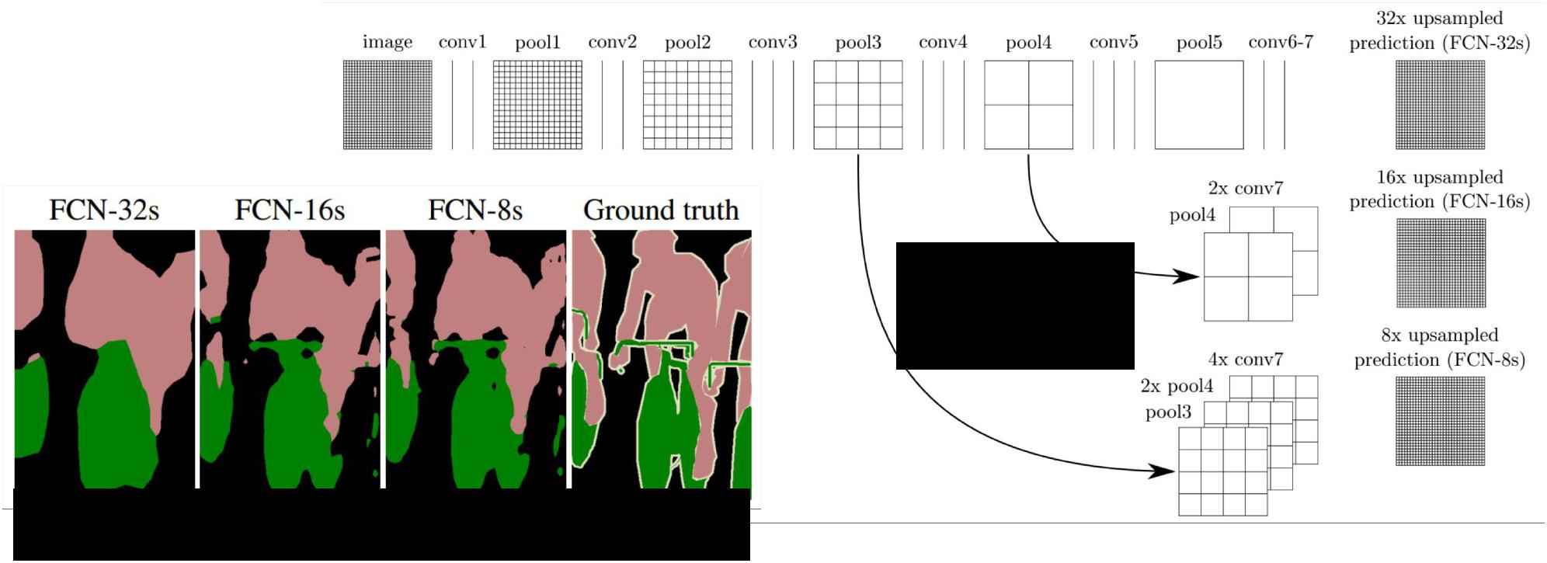

“skip

connections”

Skip connections = Better results



Long, Shelhamer, and Darrell, “Fully Convolutional Networks for Semantic Segmentation”, CVPR 2015

Fei-Fei Li & Andrej Karpathy & Justin Johnson Lecture 13 45 24 Feb 2016

Learnable Upsampling: “Deconvolution”

Typical 3 x 3 convolution, stride 1 pad 1

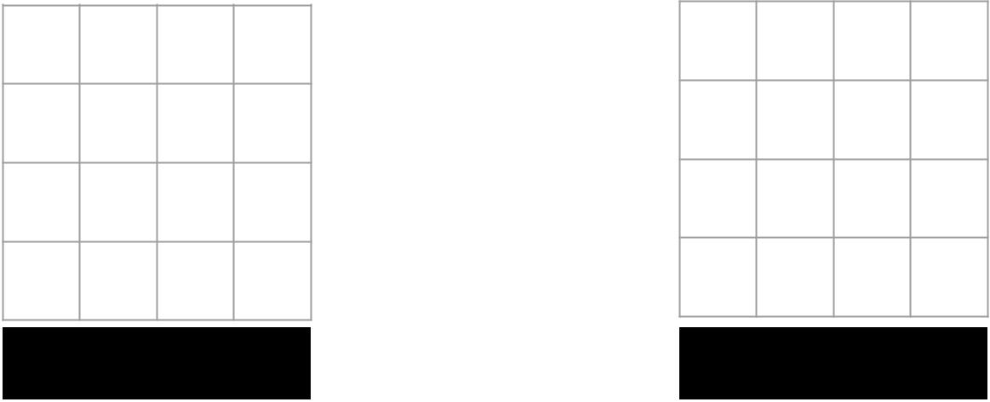

Input: 4 x 4 Output: 4 x 4



Fei-Fei Li & Andrej Karpathy & Justin Johnson Lecture 13 46 24 Feb 2016

Learnable Upsampling: “Deconvolution”

Typical 3 x 3 convolution, stride 1 pad 1

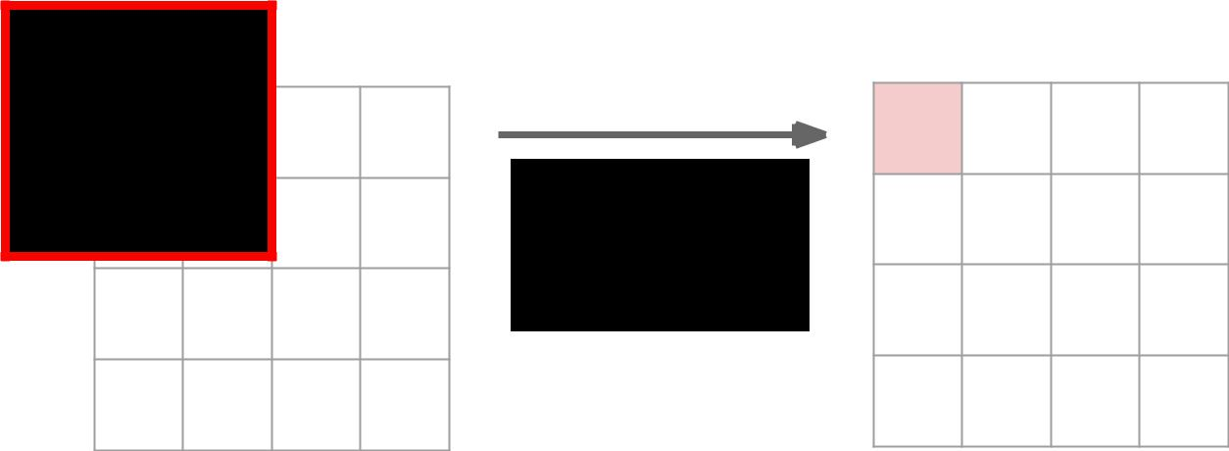

Dot product

between filter

and input



Input: 4 x 4 Output: 4 x 4



Fei-Fei Li & Andrej Karpathy & Justin Johnson Lecture 13 47 24 Feb 2016

Learnable Upsampling: “Deconvolution”

Typical 3 x 3 convolution, stride 1 pad 1

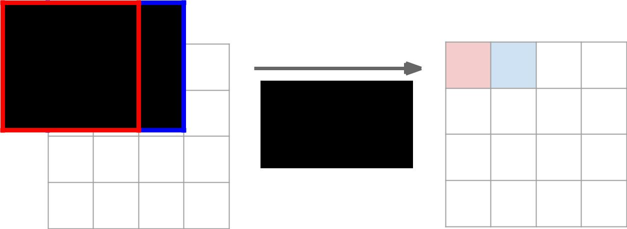

Dot product

between filter

and input



Input: 4 x 4 Output: 4 x 4



Fei-Fei Li & Andrej Karpathy & Justin Johnson Lecture 13 48 24 Feb 2016

Learnable Upsampling: “Deconvolution”

Typical 3 x 3 convolution, **stride 2** pad 1

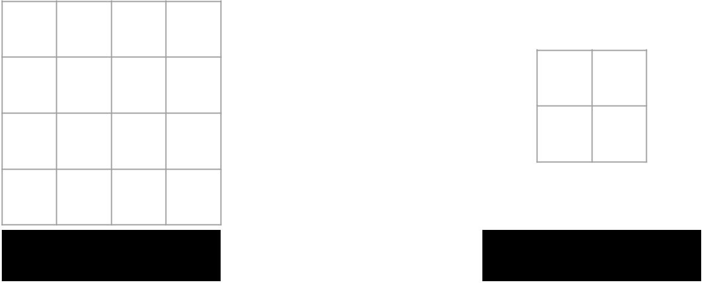

Input: 4 x 4 Output: 2 x 2



Fei-Fei Li & Andrej Karpathy & Justin Johnson Lecture 13 49 24 Feb 2016

Learnable Upsampling: “Deconvolution”

Typical 3 x 3 convolution, stride 2 pad 1

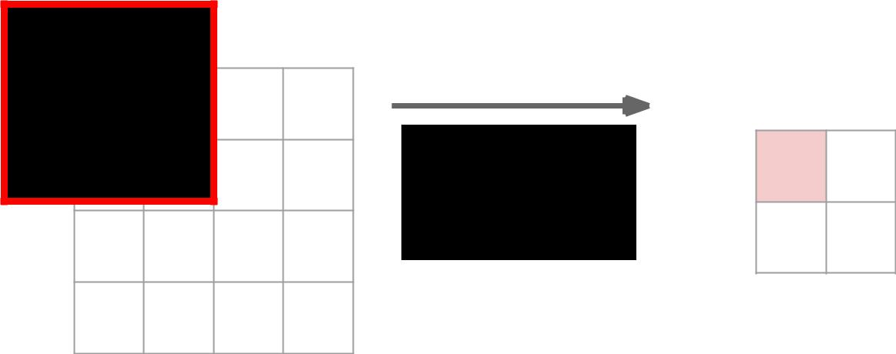

Dot product

between filter

and input



Input: 4 x 4 Output: 2 x 2



Fei-Fei Li & Andrej Karpathy & Justin Johnson Lecture 13 50 24 Feb 2016

Learnable Upsampling: “Deconvolution”

Typical 3 x 3 convolution, stride 2 pad 1

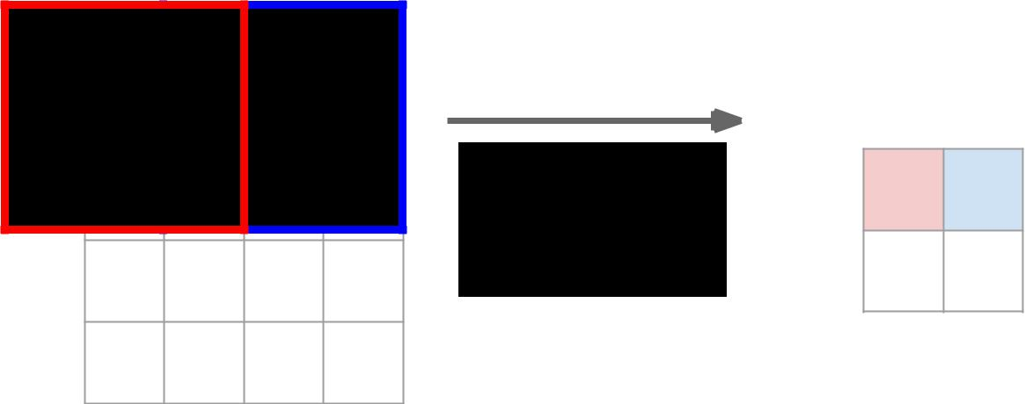

Dot product

between filter

and input



Input: 4 x 4 Output: 2 x 2



Fei-Fei Li & Andrej Karpathy & Justin Johnson Lecture 13 51 24 Feb 2016

Learnable Upsampling: “Deconvolution”

3 x 3 “deconvolution”, stride 2 pad 1

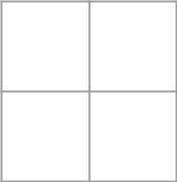

Input: 2 x 2 Output: 4 x 4



Fei-Fei Li & Andrej Karpathy & Justin Johnson Lecture 13 52 24 Feb 2016

Learnable Upsampling: “Deconvolution”

3 x 3 “deconvolution”, stride 2 pad 1

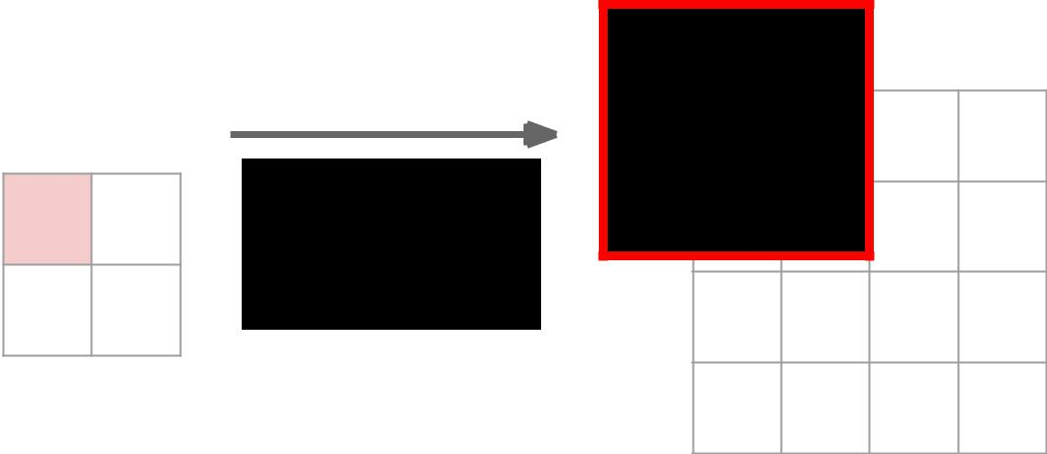

Input gives

weight for

filter



Input: 2 x 2 Output: 4 x 4



Fei-Fei Li & Andrej Karpathy & Justin Johnson Lecture 13 53 24 Feb 2016

Learnable Upsampling: “Deconvolution”

3 x 3 “deconvolution”, stride 2 pad 1

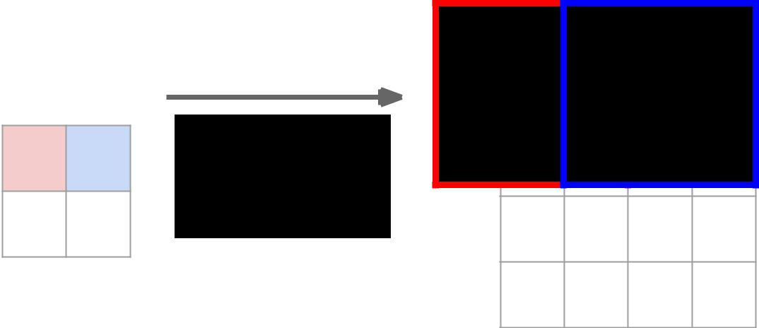

Input gives

weight for

filter



Input: 2 x 2 Output: 4 x 4



Fei-Fei Li & Andrej Karpathy & Justin Johnson Lecture 13 54 24 Feb 2016

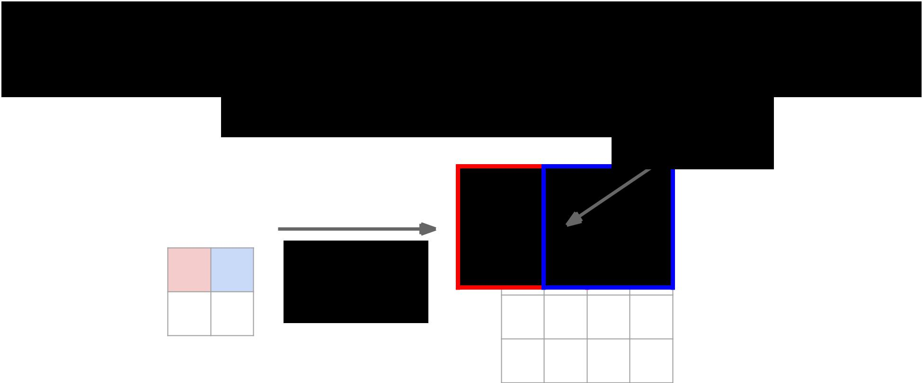Learnable Upsampling: “Deconvolution”

|  |  |  |
| --- | --- | --- |
| 3 x 3 “deconvolution”, stride 2 pad 1 | Sum where |  |
| output overlaps |  |
|  |  |



Input gives

weight for

filter



Input: 2 x 2 Output: 4 x 4



Fei-Fei Li & Andrej Karpathy & Justin Johnson Lecture 13 55 24 Feb 2016

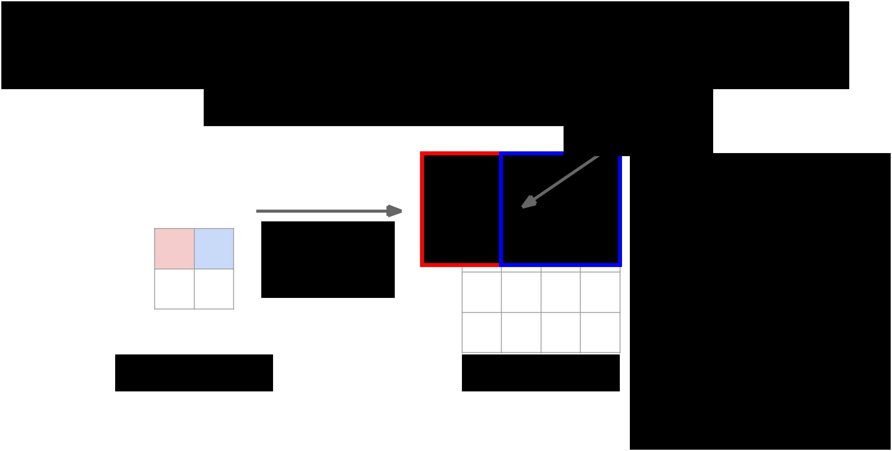Learnable Upsampling: “Deconvolution”

|  |  |  |
| --- | --- | --- |
| 3 x 3 “deconvolution”, stride 2 pad 1 | Sum where |  |
| output overlaps |  |
|  |  |

Same as backward pass for

normal convolution!



Input gives

weight for

filter

Input: 2 x 2 Output: 4 x 4



Fei-Fei Li & Andrej Karpathy & Justin Johnson Lecture 13 56 24 Feb 2016

Learnable Upsampling: “Deconvolution”

|  |  |  |  |  |  |  |  |  |  |  |  |  |
| --- | --- | --- | --- | --- | --- | --- | --- | --- | --- | --- | --- | --- |
|  |  | 3 x 3 “deconvolution”, stride 2 pad 1 | | | | | | | Sum where | | |  |
|  |  | output overlaps | | |  |
|  |  |  |  |  |  |  |  |  |  |
|  |  |  |  |  |  |  |  |  |  |  | Same as backward pass for |  |
|  |  |  |  |  |  |  |  |  |  |  |  |
|  |  |  |  |  |  |  |  |  |  |  | normal convolution! |  |
|  |  |  |  |  |  |  |  |  |  |  |  |
|  |  |  |  |  |  |  |  |  |  |  | “Deconvolution” is a bad |  |
|  |  |  |  | Input gives | |  |  |  |  |  |  |
|  |  |  |  |  |  |  |  |  |  |
|  |  |  |  | weight for | |  |  |  |  |  | name, already defined as |  |
|  |  |  |  | filter | | |  |  |  |  | “inverse of convolution” |  |
|  |  |  |  |  |  |  |  |  |  |  | **Better names:** |  |
|  |  |  |  |  |  |  |  |  |  |  |  |
|  |  |  |  |  |  |  |  |  |  |  |  |
|  |  |  |  |  |  |  |  |  |  |  | convolution transpose, |  |
| Input: 2 x 2 | | | | | | | Output: 4 x 4 | | | | backward strided convolution, |  |
|  |  |



1/2 strided convolution,

upconvolution



Fei-Fei Li & Andrej Karpathy & Justin Johnson Lecture 13 57 24 Feb 2016

Learnable Upsampling: “Deconvolution”

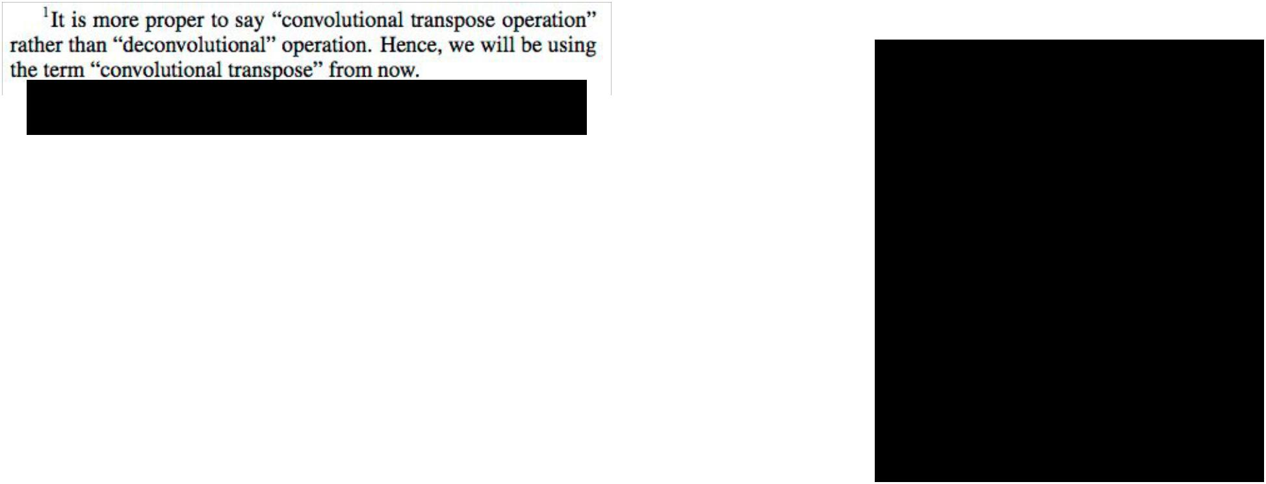

Im et al, “Generating images with recurrent adversarial networks”, arXiv 2016

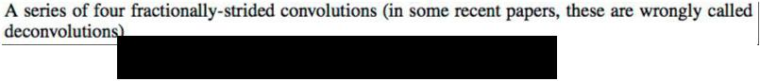

Radford et al, “Unsupervised Representation Learning with Deep

Convolutional Generative Adversarial Networks”, ICLR 2016



“Deconvolution” is a bad name, already defined as “inverse of convolution”

**Better names:** convolution transpose, backward strided convolution, 1/2 strided convolution, upconvolution

Fei-Fei Li & Andrej Karpathy & Justin Johnson Lecture 13 58 24 Feb 2016

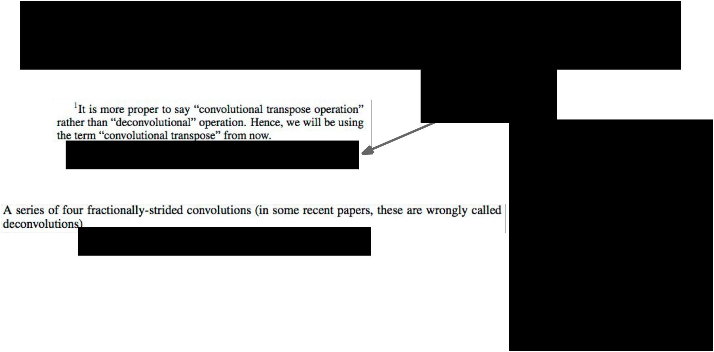Learnable Upsampling: “Deconvolution”

Im et al, “Generating images with recurrent adversarial networks”, arXiv 2016

Radford et al, “Unsupervised Representation Learning with Deep Convolutional Generative Adversarial Networks”, ICLR 2016



Great explanation

in appendix

“Deconvolution” is a bad name, already defined as “inverse of convolution”

**Better names:** convolution transpose, backward strided convolution, 1/2 strided convolution, upconvolution

Fei-Fei Li & Andrej Karpathy & Justin Johnson Lecture 13 59 24 Feb 2016

Semantic Segmentation: Upsampling

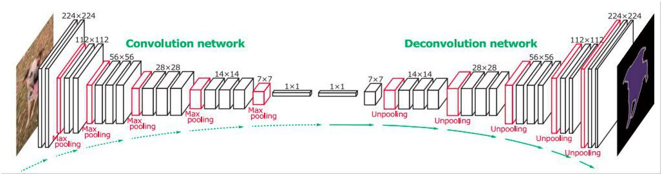

Noh et al, “Learning Deconvolution Network for Semantic Segmentation”, ICCV 2015

Fei-Fei Li & Andrej Karpathy & Justin Johnson Lecture 13 60 24 Feb 2016

Semantic Segmentation: Upsampling

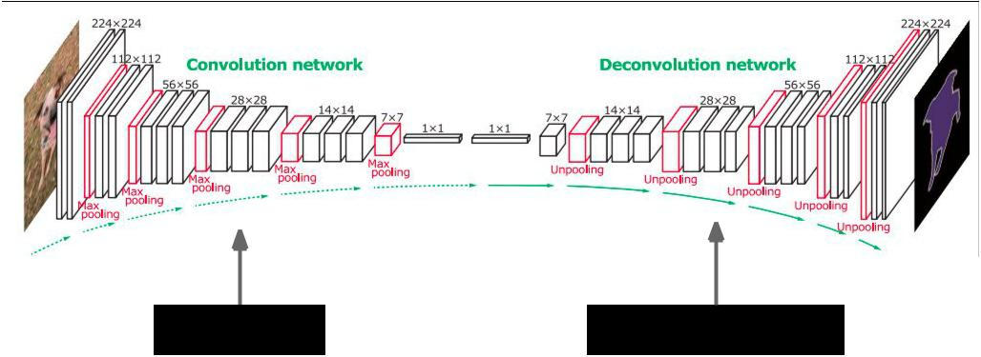

Normal VGG “Upside down” VGG



Noh et al, “Learning Deconvolution Network for Semantic Segmentation”, ICCV 2015

6 days of training on Titan X…

Fei-Fei Li & Andrej Karpathy & Justin Johnson Lecture 13 61 24 Feb 2016



Instance Segmentation



Fei-Fei Li & Andrej Karpathy & Justin Johnson Lecture 13 62 24 Feb 2016

Instance Segmentation

Detect instances, give category, label pixels

“simultaneous detection and segmentation” (SDS)



Lots of recent work

(MS-COCO)



Figure credit: Dai et al, “Instance-aware Semantic Segmentation via Multi-task Network Cascades”, arXiv 2015

Fei-Fei Li & Andrej Karpathy & Justin Johnson Lecture 13 63 24 Feb 2016

Instance Segmentation

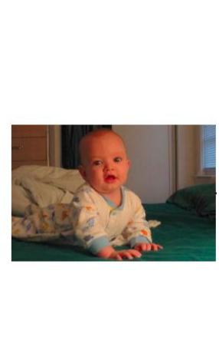

Similar to R-CNN, but

with segments

Hariharan et al, “Simultaneous Detection and Segmentation”, ECCV 2014

Fei-Fei Li & Andrej Karpathy & Justin Johnson Lecture 13 64 24 Feb 2016

|  |  |
| --- | --- |
| Instance Segmentation | with segments |
|  | Similar to R-CNN, but |

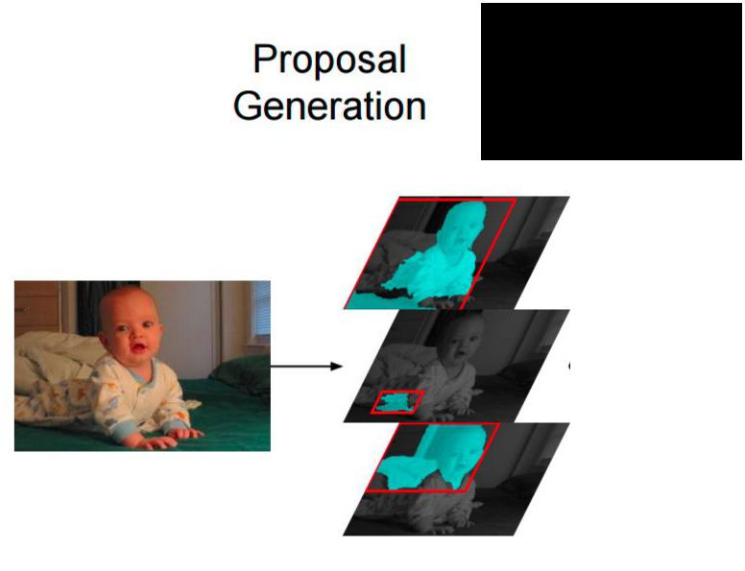

External

Segment

proposals



Hariharan et al, “Simultaneous Detection and Segmentation”, ECCV 2014

Fei-Fei Li & Andrej Karpathy & Justin Johnson Lecture 13 65 24 Feb 2016

|  |  |
| --- | --- |
| Instance Segmentation | with segments |
|  | Similar to R-CNN, but |

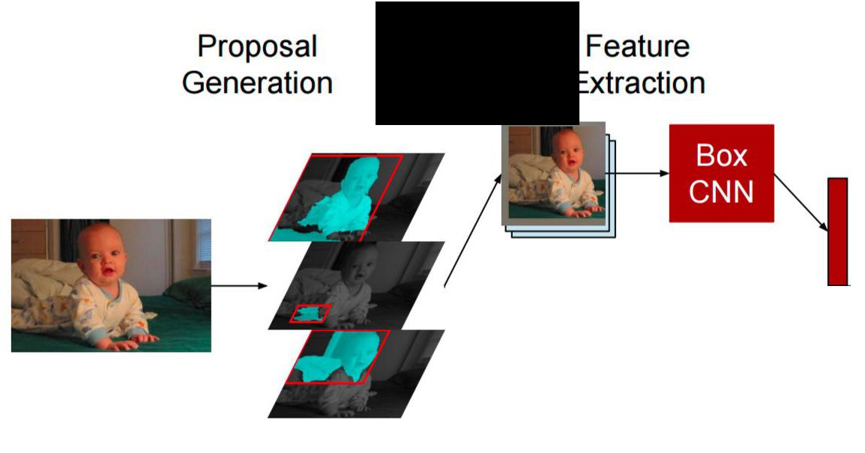

External

Segment

proposals



Hariharan et al, “Simultaneous Detection and Segmentation”, ECCV 2014

Fei-Fei Li & Andrej Karpathy & Justin Johnson Lecture 13 66 24 Feb 2016

|  |  |
| --- | --- |
| Instance Segmentation | with segments |
|  | Similar to R-CNN, but |

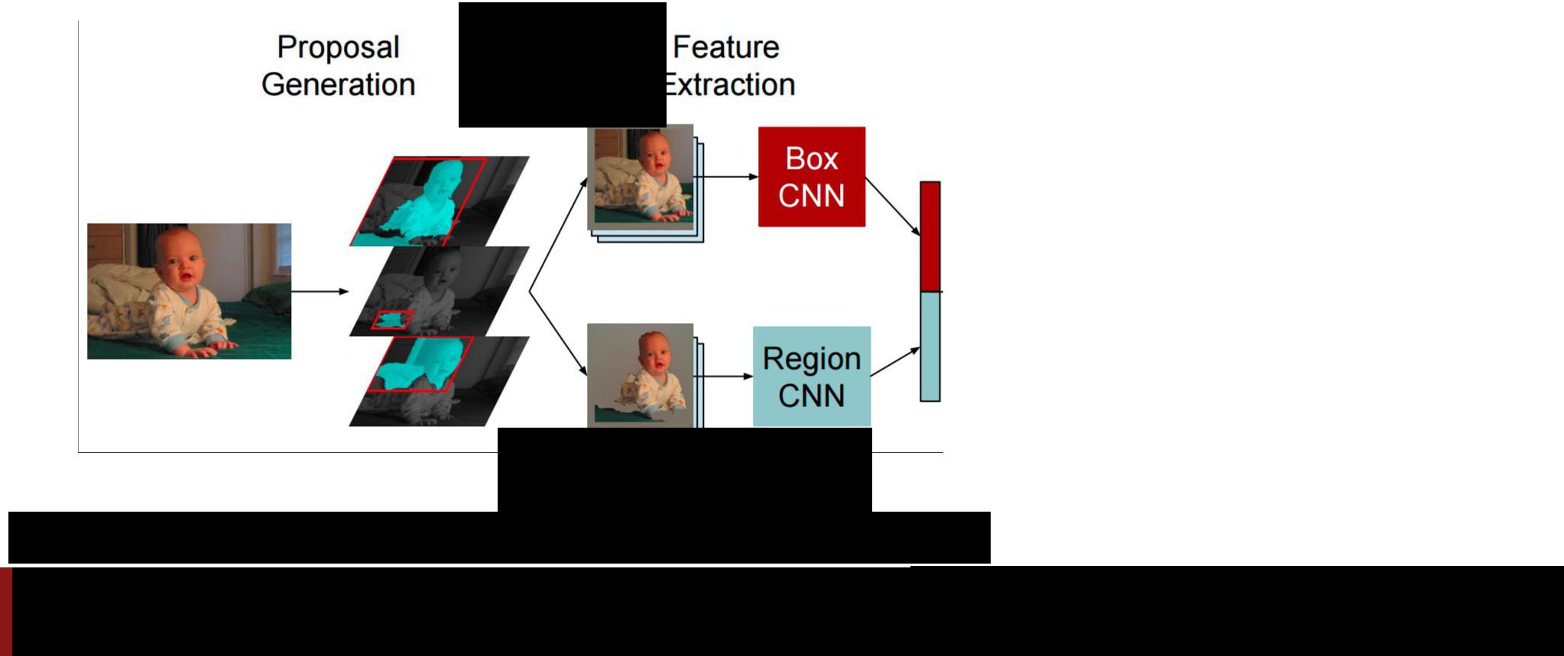

External

Segment

proposals

Mask out background

with mean image

Hariharan et al, “Simultaneous Detection and Segmentation”, ECCV 2014

Fei-Fei Li & Andrej Karpathy & Justin Johnson Lecture 13 67 24 Feb 2016

|  |  |
| --- | --- |
| Instance Segmentation | with segments |
|  | Similar to R-CNN, but |

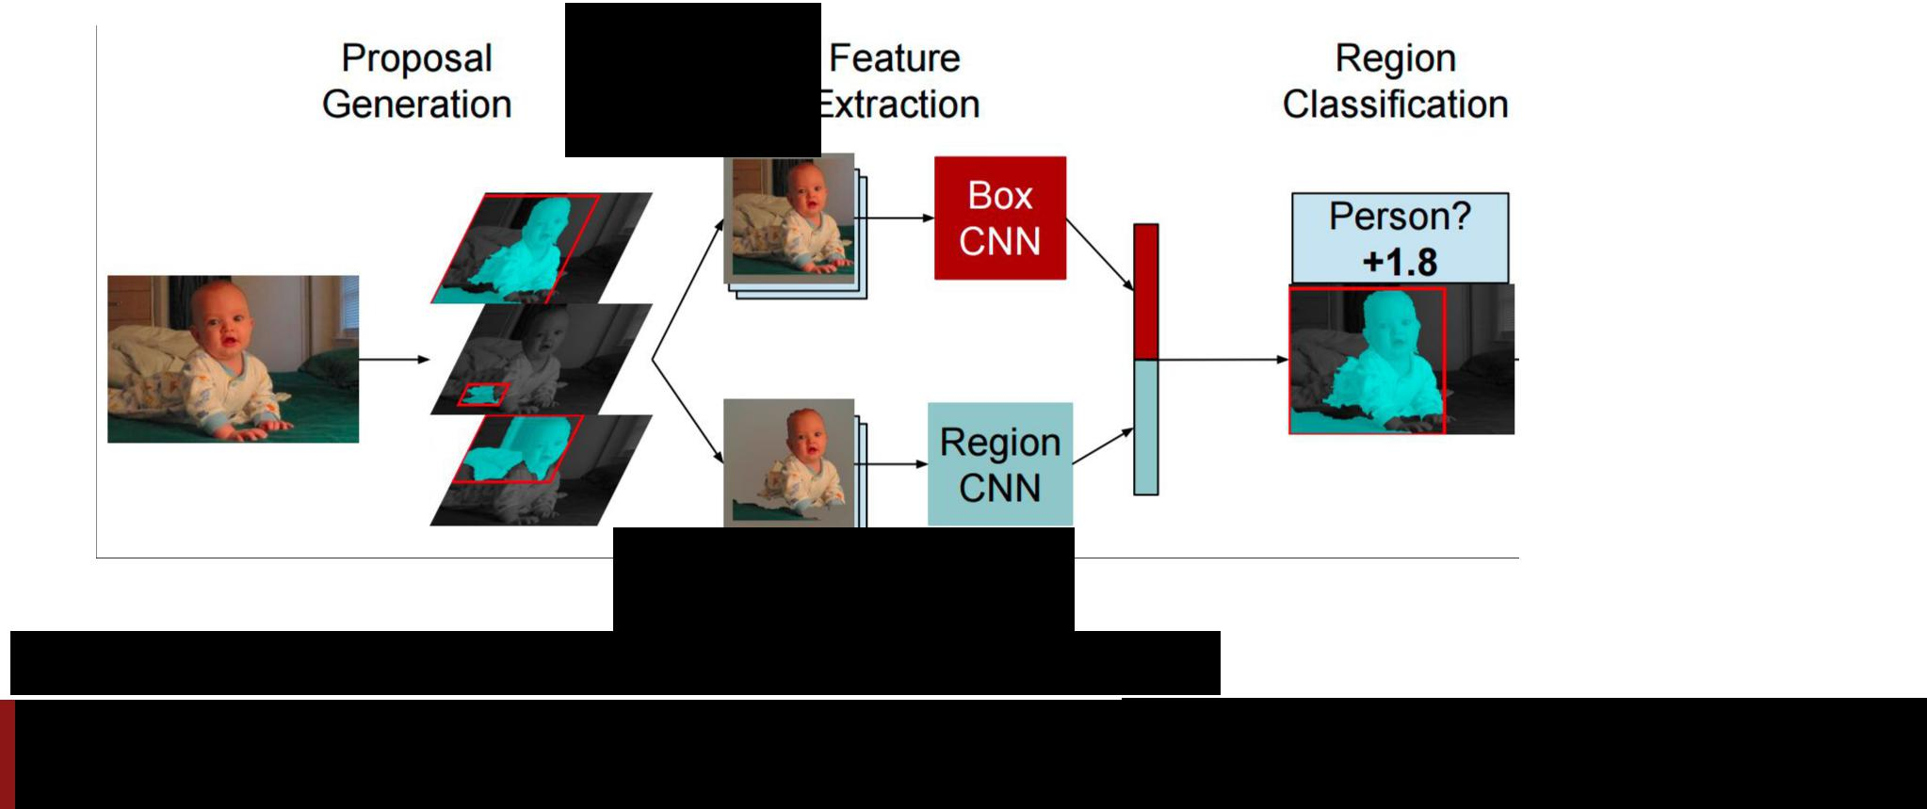

External

Segment

proposals

Mask out background

with mean image

Hariharan et al, “Simultaneous Detection and Segmentation”, ECCV 2014

Fei-Fei Li & Andrej Karpathy & Justin Johnson Lecture 13 68 24 Feb 2016

|  |  |
| --- | --- |
| Instance Segmentation | with segments |
|  | Similar to R-CNN, but |

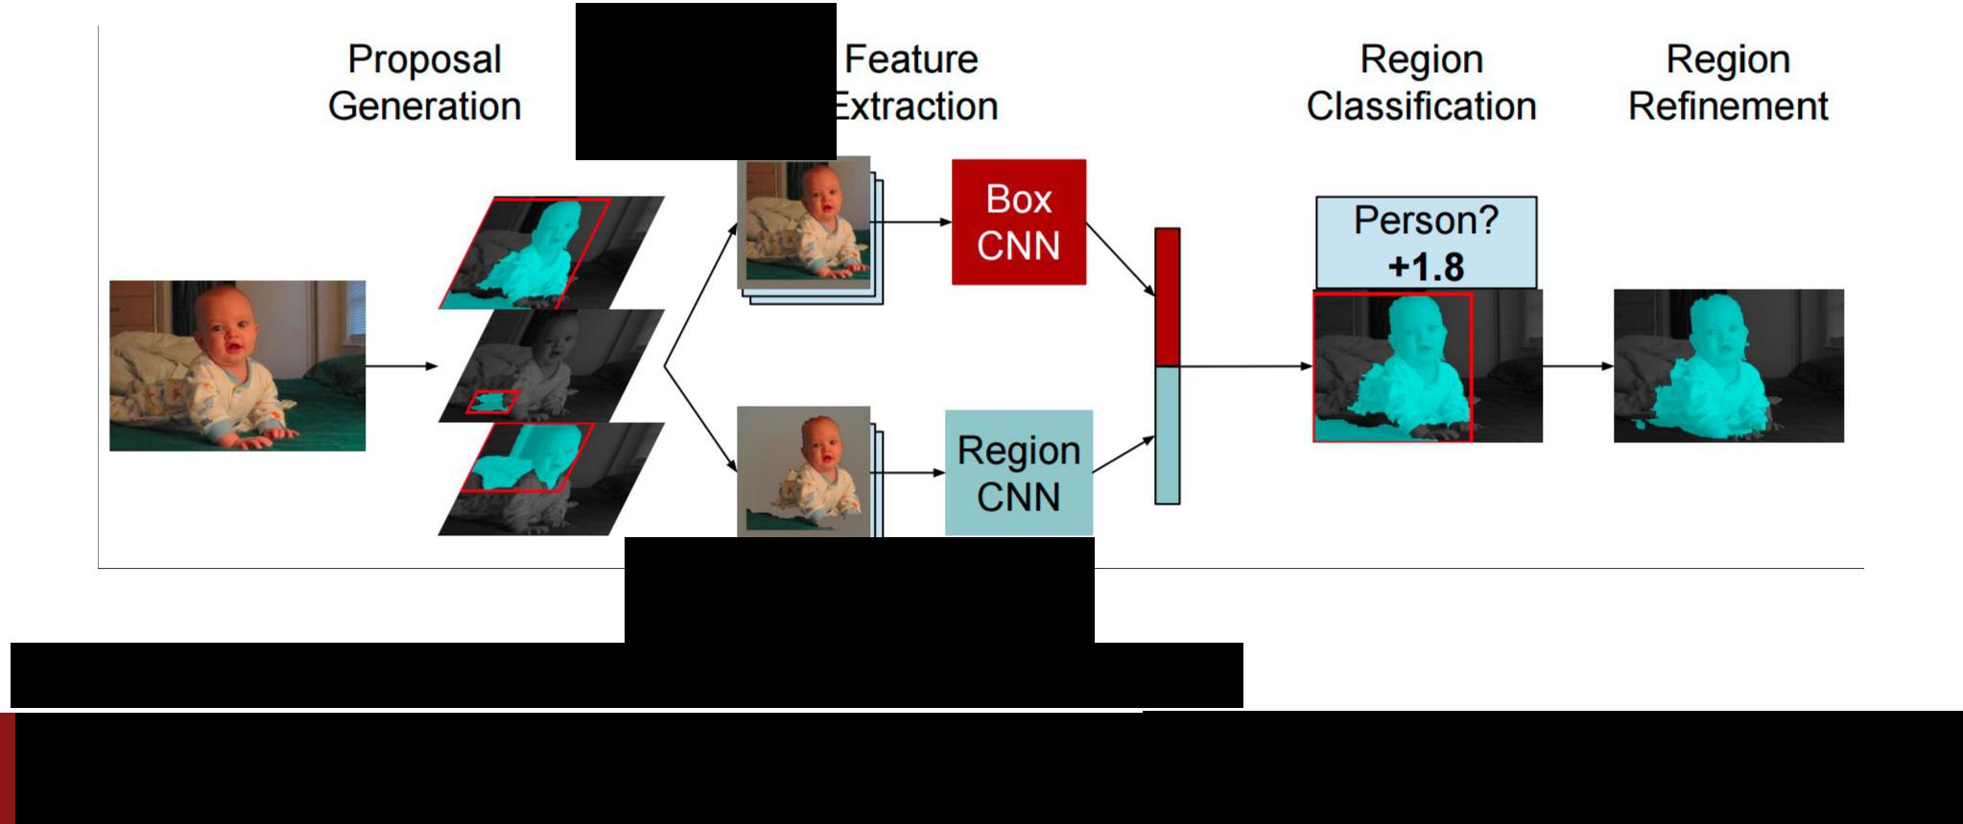

External

Segment

proposals

Mask out background

with mean image

Hariharan et al, “Simultaneous Detection and Segmentation”, ECCV 2014

Fei-Fei Li & Andrej Karpathy & Justin Johnson Lecture 13 69 24 Feb 2016

Instance Segmentation: Hypercolumns

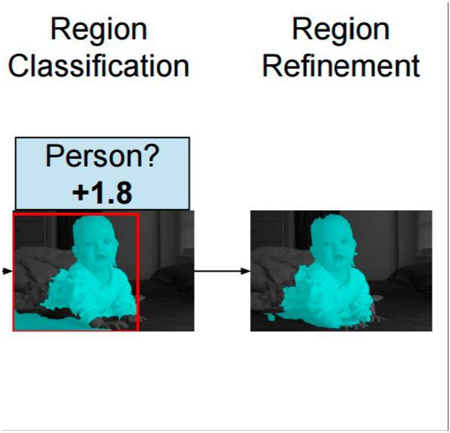

Hariharan et al, “Hypercolumns for Object Segmentation and Fine-grained Localization”, CVPR 2015

Fei-Fei Li & Andrej Karpathy & Justin Johnson Lecture 13 70 24 Feb 2016

Instance Segmentation: Hypercolumns

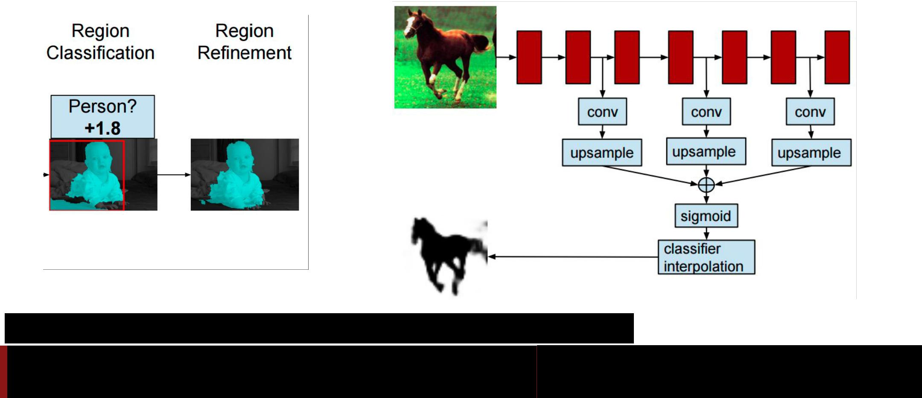

Hariharan et al, “Hypercolumns for Object Segmentation and Fine-grained Localization”, CVPR 2015

Fei-Fei Li & Andrej Karpathy & Justin Johnson Lecture 13 71 24 Feb 2016

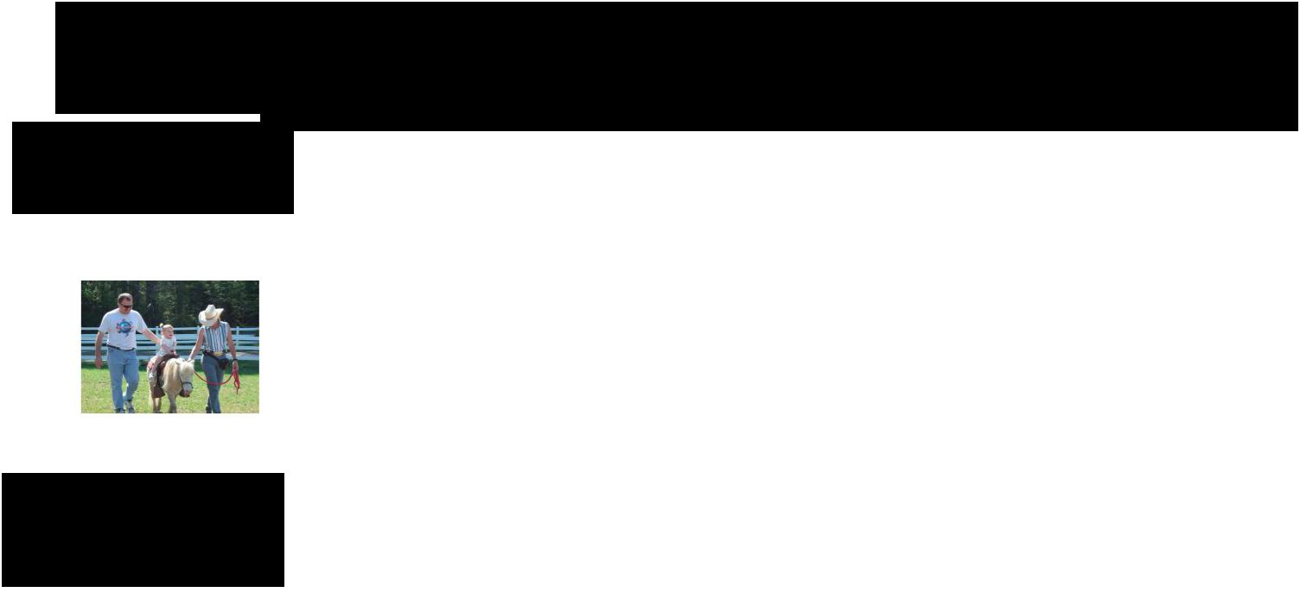Instance Segmentation: Cascades

Similar to

Faster R-CNN

Won COCO 2015

challenge

(with ResNet)



Dai et al, “Instance-aware Semantic Segmentation via Multi-task Network Cascades”, arXiv 2015

Fei-Fei Li & Andrej Karpathy & Justin Johnson Lecture 13 72 24 Feb 2016

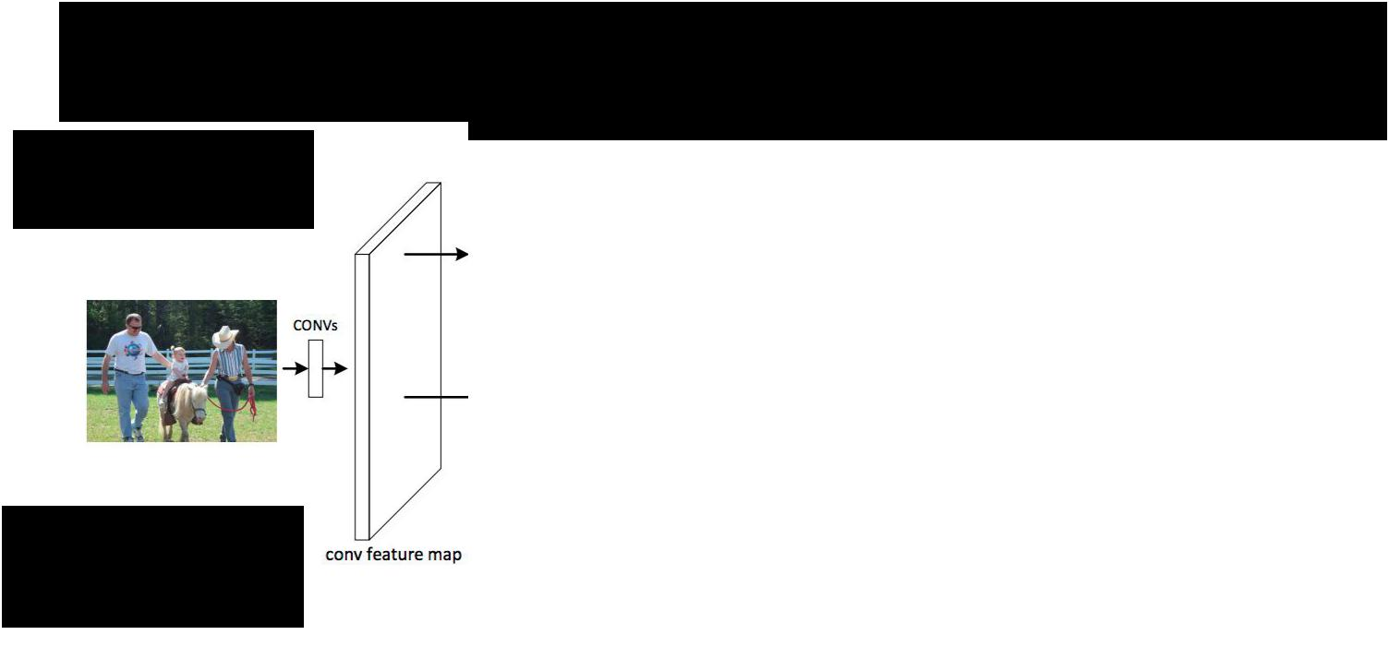Instance Segmentation: Cascades

Similar to

Faster R-CNN

Won COCO 2015

challenge

(with ResNet)



Dai et al, “Instance-aware Semantic Segmentation via Multi-task Network Cascades”, arXiv 2015

Fei-Fei Li & Andrej Karpathy & Justin Johnson Lecture 13 73 24 Feb 2016

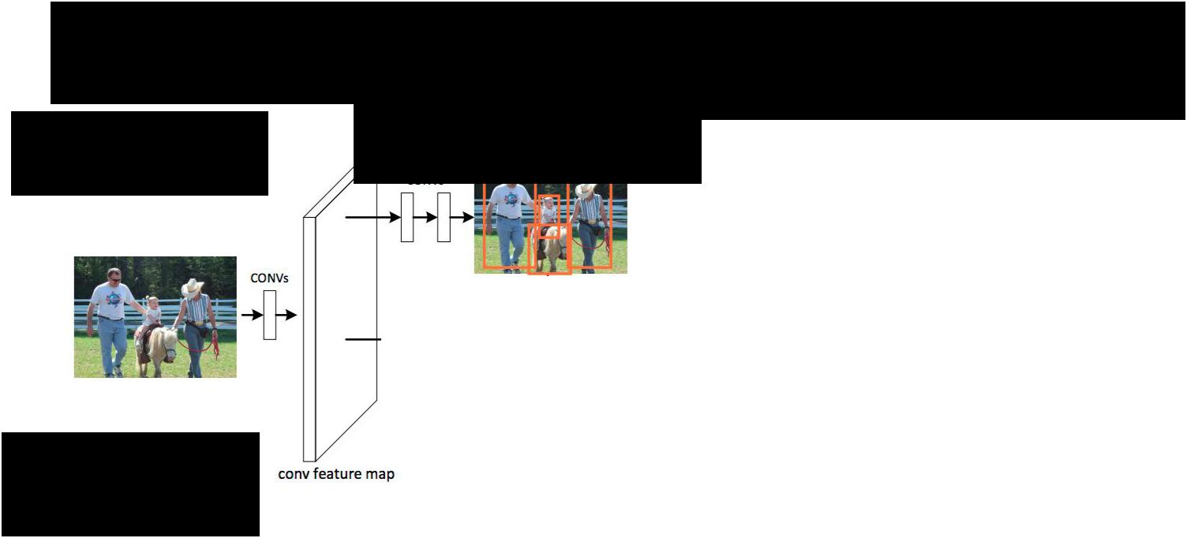Instance Segmentation: Cascades

Similar to

Faster R-CNN

Region proposal network (RPN)

Won COCO 2015

challenge

(with ResNet)



Dai et al, “Instance-aware Semantic Segmentation via Multi-task Network Cascades”, arXiv 2015

Fei-Fei Li & Andrej Karpathy & Justin Johnson Lecture 13 74 24 Feb 2016

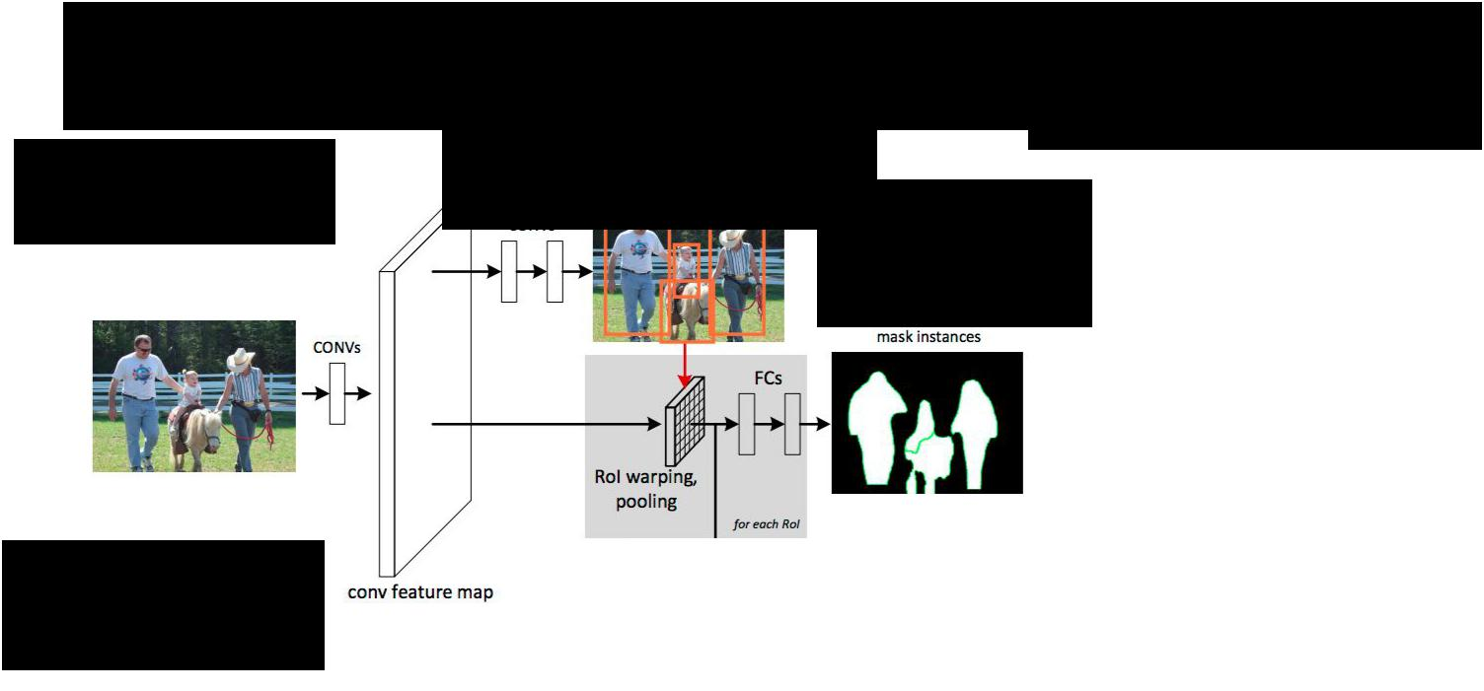Instance Segmentation: Cascades

Similar to

Faster R-CNN

Region proposal network (RPN)

Reshape boxes to

fixed size,

figure / ground

logistic regression

Won COCO 2015

challenge

(with ResNet)



Dai et al, “Instance-aware Semantic Segmentation via Multi-task Network Cascades”, arXiv 2015

Fei-Fei Li & Andrej Karpathy & Justin Johnson Lecture 13 75 24 Feb 2016

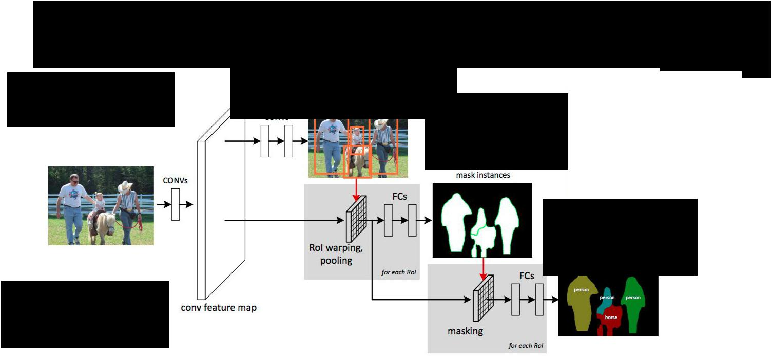Instance Segmentation: Cascades

Similar to

Faster R-CNN

Won COCO 2015 challenge (with ResNet)

Region proposal network (RPN)

Reshape boxes to

fixed size,

figure / ground

logistic regression

Mask out background,

predict object class



Dai et al, “Instance-aware Semantic Segmentation via Multi-task Network Cascades”, arXiv 2015

Fei-Fei Li & Andrej Karpathy & Justin Johnson Lecture 13 76 24 Feb 2016

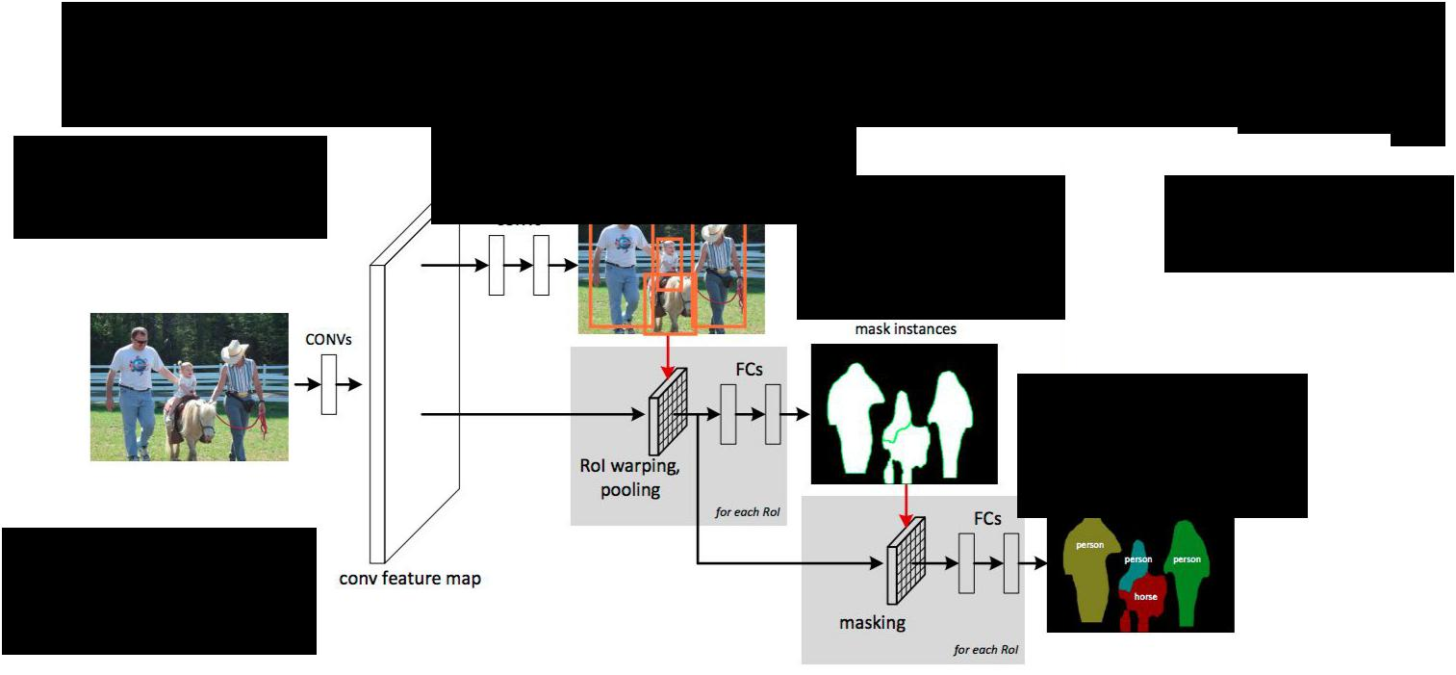Instance Segmentation: Cascades

Similar to

Faster R-CNN

Won COCO 2015 challenge (with ResNet)

Region proposal network (RPN)

Reshape boxes to Learn entire model

fixed size, end-to-end!

figure / ground

logistic regression

Mask out background,

predict object class



Dai et al, “Instance-aware Semantic Segmentation via Multi-task Network Cascades”, arXiv 2015

Fei-Fei Li & Andrej Karpathy & Justin Johnson Lecture 13 77 24 Feb 2016

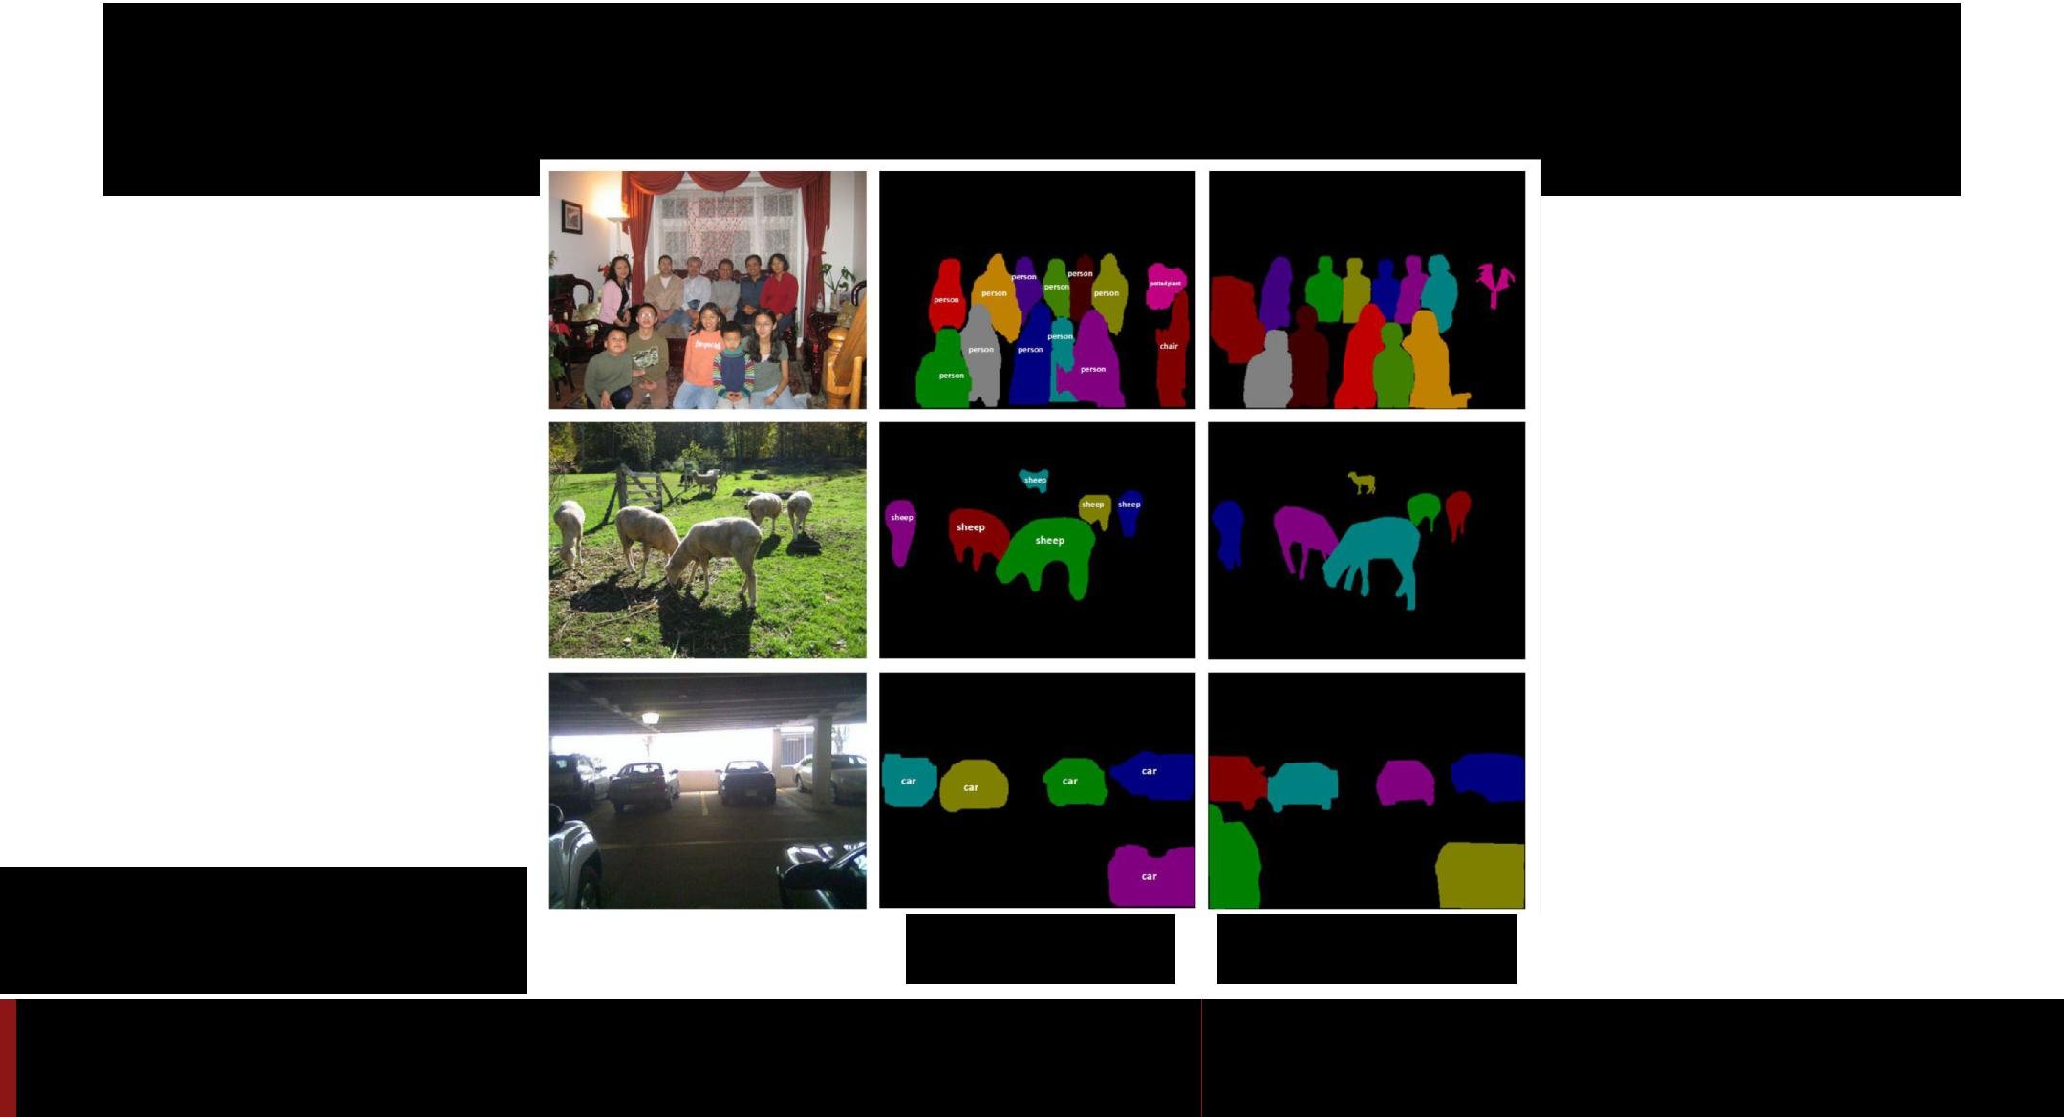Instance Segmentation: Cascades

Dai et al, “Instance-aware Semantic Segmentation via Multi-task Network Cascades”, arXiv 2015

**Predictions** **Ground truth**

Fei-Fei Li & Andrej Karpathy & Justin Johnson Lecture 13 78 24 Feb 2016

Segmentation Overview



* Semantic segmentation
  + Classify all pixels
  + Fully convolutional models, downsample then upsample
  + Learnable upsampling: fractionally strided convolution
  + Skip connections can help
* Instance Segmentation
  + Detect instance, generate mask
  + Similar pipelines to object detection



Fei-Fei Li & Andrej Karpathy & Justin Johnson Lecture 13 79 24 Feb 2016



Attention Models



Fei-Fei Li & Andrej Karpathy & Justin Johnson Lecture 13 80 24 Feb 2016

Recall: RNN for Captioning

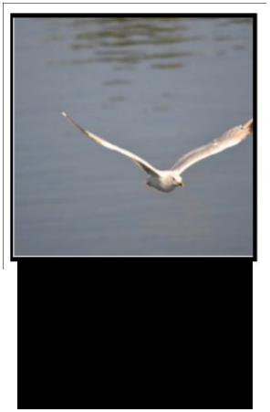

Image:

H x W x 3



Fei-Fei Li & Andrej Karpathy & Justin Johnson Lecture 13 81 24 Feb 2016

Recall: RNN for Captioning

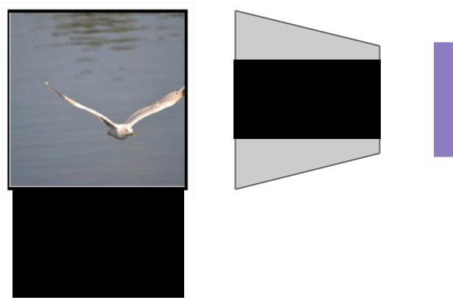

CNN



Image: Features:

H x W x 3 D



Fei-Fei Li & Andrej Karpathy & Justin Johnson Lecture 13 82 24 Feb 2016

Recall: RNN for Captioning

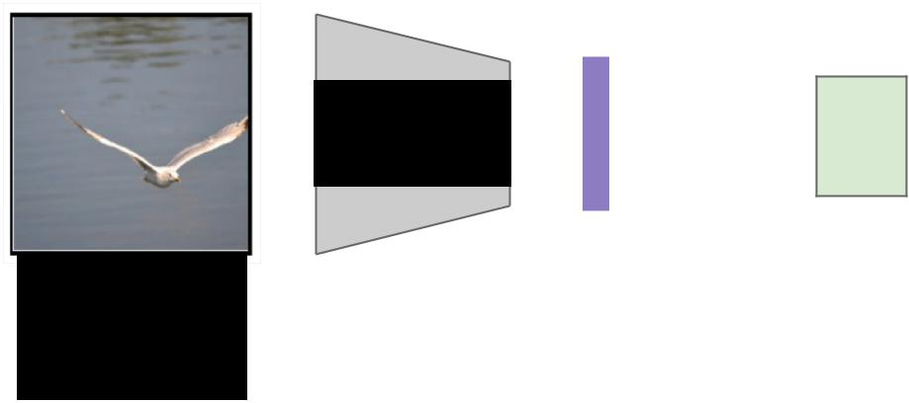

CNN h0

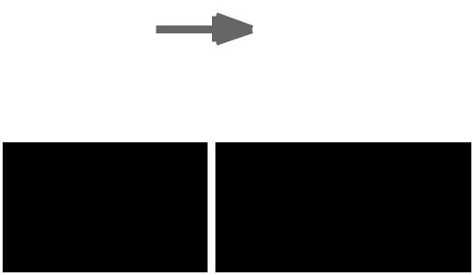

|  |  |  |
| --- | --- | --- |
| Image: | Features: | Hidden state: |
| H x W x 3 | D | H |



Fei-Fei Li & Andrej Karpathy & Justin Johnson Lecture 13 83 24 Feb 2016

Recall: RNN for Captioning

Distribution

over vocab



d1

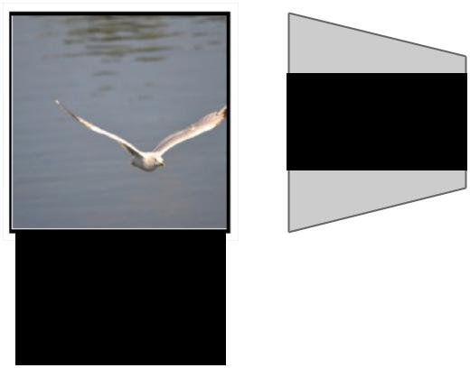

|  |  |  |  |  |  |  |  |  |  |  |  |  |
| --- | --- | --- | --- | --- | --- | --- | --- | --- | --- | --- | --- | --- |
| CNN |  |  |  |  |  |  |  |  |  |  |  |  |
|  |  |  |  |  |  |  |  |  |  |  |  |
|  |  |  |  |  |  |  |  |  |  |  |  |
|  |  |  |  |  | h0 |  |  |  | h1 | |  |
|  |  |  |  |  |  |  |  |
| Image: |  |  |  |  |  |  |  |  |  |  |  |  |
|  |  |  |  |  |  |  |  |  |  |  |  |
| Features: | | | | Hidden state: | | | |  |  |  |  |
|  |  |  |  |
|  |  |  |  |
|  |  |  |  |
| H x W x 3 | D | | | |  | H | | |  | y1 | |  |
|  |  |  |  |  |  |  |  |  |  |  |  |  |

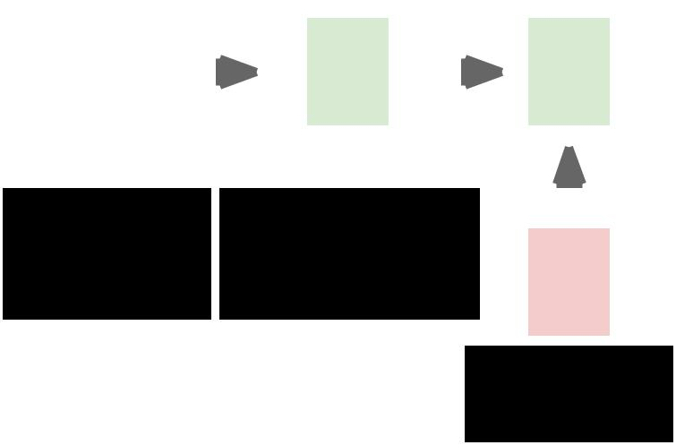

First

word



Fei-Fei Li & Andrej Karpathy & Justin Johnson Lecture 13 84 24 Feb 2016

Recall: RNN for Captioning

Distribution

over vocab



d1 d2



|  |  |  |  |  |  |  |  |  |  |  |  |  |  |  |  |  |  |  |
| --- | --- | --- | --- | --- | --- | --- | --- | --- | --- | --- | --- | --- | --- | --- | --- | --- | --- | --- |
| CNN |  |  |  |  |  |  |  |  |  |  |  |  |  |  |  |  |  |  |
|  |  |  |  |  |  |  |  |  |  |  |  |  |  |  |  |  |  |
|  |  |  |  |  |  |  |  |  |  |  |  |  |  |  |  |  |  |
|  |  |  |  |  | h0 |  |  |  | h1 | |  |  |  | h2 | |  |  |
|  |  |  |  |  |  |  |  |  |
| Image: |  |  |  |  |  |  |  |  |  |  |  |  |  |  |  |  |  |  |
|  |  |  |  |  |  |  |  |  |  |  |  |  |  |  |  |  |  |
| Features: | | | | Hidden state: | | | |  |  |  |  |  |  |  |  |  |  |
|  |  |  |  |  |  |  |  |  |  |
|  |  |  |  |  |  |  |  |  |  |
|  |  |  |  |  |  |  |  |  |  |
| H x W x 3 | D | | | |  | H | | |  | y1 | |  |  |  | y2 | |  |  |
|  |  |  |  |  |  |  |  |  |  |  |  |  |  |  |  |  |  |  |
|  |  |  |  |  |  |  |  |  |  | First | |  |  | Second | | | |  |
|  |  |  |  |  |  |  |  |  |  | word | |  |  |  | word | | |  |

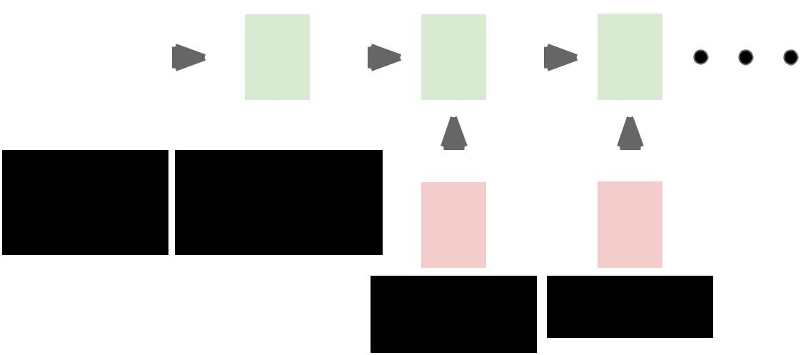

Fei-Fei Li & Andrej Karpathy & Justin Johnson Lecture 13 85 24 Feb 2016

Recall: RNN for Captioning

Distribution

over vocab



d1 d2



|  |  |  |  |  |  |  |  |  |  |  |  |  |  |  |  |  |  |  |
| --- | --- | --- | --- | --- | --- | --- | --- | --- | --- | --- | --- | --- | --- | --- | --- | --- | --- | --- |
| CNN |  |  |  |  |  |  |  |  |  |  |  |  |  |  |  |  |  |  |
|  |  |  |  |  |  |  |  |  |  |  |  |  |  |  |  |  |  |
|  |  |  |  |  |  |  |  |  |  |  |  |  |  |  |  |  |  |
|  |  |  |  |  | h0 |  |  |  | h1 | |  |  |  | h2 | |  |  |
|  |  |  |  |  |  |  |  |  |
| Image: |  |  |  |  |  |  |  |  |  |  |  |  |  |  |  |  |  |  |
|  |  |  |  |  |  |  |  |  |  |  |  |  |  |  |  |  |  |
| Features: | | | | Hidden state: | | | |  |  |  |  |  |  |  |  |  |  |
|  |  |  |  |  |  |  |  |  |  |
|  |  |  |  |  |  |  |  |  |  |
|  |  |  |  |  |  |  |  |  |  |
| H x W x 3 | D | | | |  | H | | |  | y1 | |  |  |  | y2 | |  |  |
|  |  |  |  |  |  |  |  |  |  |  |  |  |  |  |  |  |  |  |
|  |  |  |  |  |  |  |  |  |  | First | |  |  | Second | | | |  |
|  |  |  |  |  |  |  |  |  |  | word | |  |  |  | word | | |  |

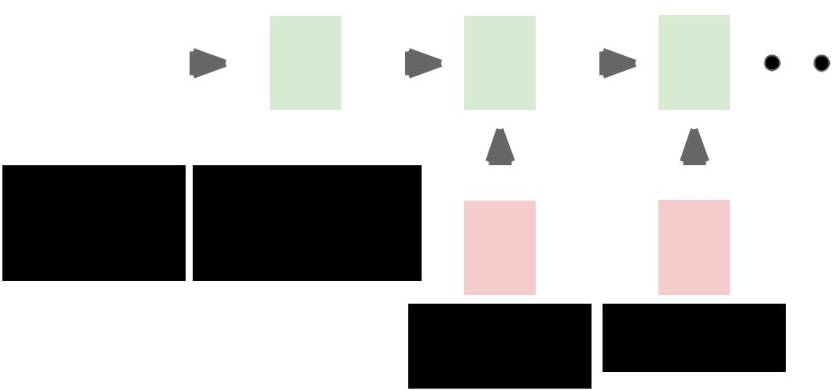

RNN only looks at whole image, once



Fei-Fei Li & Andrej Karpathy & Justin Johnson Lecture 13 86 24 Feb 2016

Recall: RNN for Captioning

Distribution

over vocab



d1 d2



|  |  |  |  |  |  |  |  |  |  |  |  |  |  |  |  |  |  |  |
| --- | --- | --- | --- | --- | --- | --- | --- | --- | --- | --- | --- | --- | --- | --- | --- | --- | --- | --- |
| CNN |  |  |  |  |  |  |  |  |  |  |  |  |  |  |  |  |  |  |
|  |  |  |  |  |  |  |  |  |  |  |  |  |  |  |  |  |  |
|  |  |  |  |  |  |  |  |  |  |  |  |  |  |  |  |  |  |
|  |  |  |  |  | h0 |  |  |  | h1 | |  |  |  | h2 | |  |  |
|  |  |  |  |  |  |  |  |  |
| Image: |  |  |  |  |  |  |  |  |  |  |  |  |  |  |  |  |  |  |
|  |  |  |  |  |  |  |  |  |  |  |  |  |  |  |  |  |  |
| Features: | | | | Hidden state: | | | |  |  |  |  |  |  |  |  |  |  |
|  |  |  |  |  |  |  |  |  |  |
|  |  |  |  |  |  |  |  |  |  |
|  |  |  |  |  |  |  |  |  |  |
| H x W x 3 | D | | | |  | H | | |  | y1 | |  |  |  | y2 | |  |  |
|  |  |  |  |  |  |  |  |  |  |  |  |  |  |  |  |  |  |  |
|  |  |  |  |  |  |  |  |  |  | First | |  |  | Second | | | |  |
|  |  |  |  |  |  |  |  |  |  | word | |  |  |  | word | | |  |



RNN only looks at whole image, once



What if the RNN looks at different parts of the image at each timestep?

Fei-Fei Li & Andrej Karpathy & Justin Johnson Lecture 13 87 24 Feb 2016

Soft Attention for Captioning

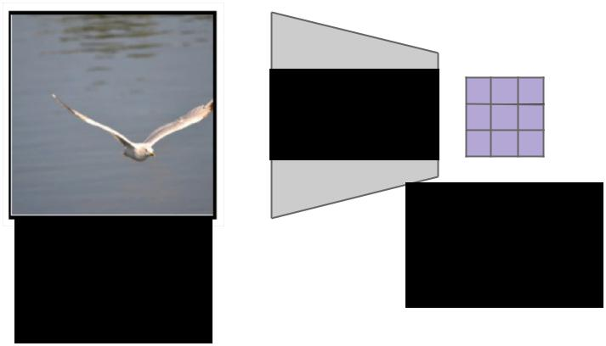

CNN

Features:

Image: L x D

H x W x 3



Xu et al, “Show, Attend and Tell: Neural

Image Caption Generation with Visual

Attention”, ICML 2015



Fei-Fei Li & Andrej Karpathy & Justin Johnson Lecture 13 88 24 Feb 2016

Soft Attention for Captioning

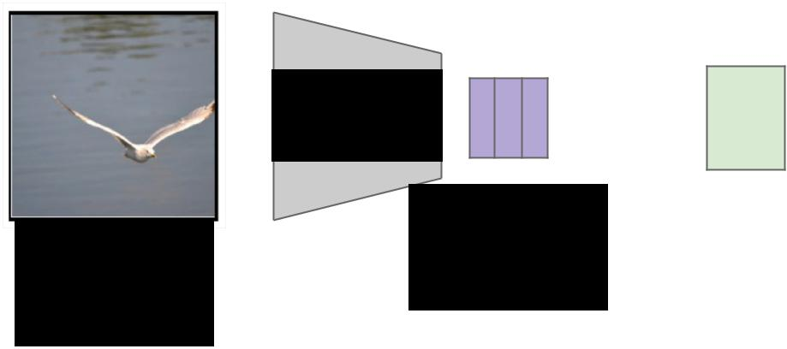

CNN 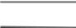 h0



Features:

Image: L x D

H x W x 3



Xu et al, “Show, Attend and Tell: Neural

Image Caption Generation with Visual

Attention”, ICML 2015



Fei-Fei Li & Andrej Karpathy & Justin Johnson Lecture 13 89 24 Feb 2016

Soft Attention for Captioning

L locations



a1

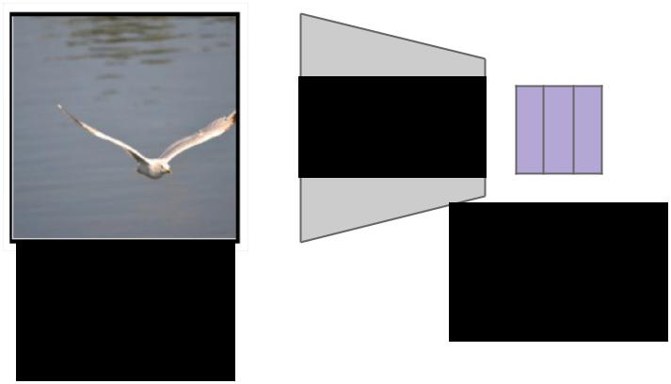

CNN  h0



Features:

Image: L x D

H x W x 3



Xu et al, “Show, Attend and Tell: Neural

Image Caption Generation with Visual

Attention”, ICML 2015



Fei-Fei Li & Andrej Karpathy & Justin Johnson Lecture 13 90 24 Feb 2016

Soft Attention for Captioning

L locations

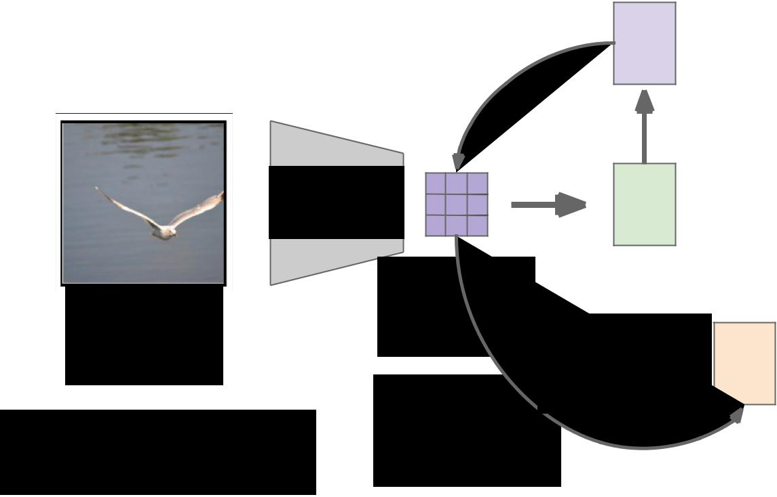

CNN

Image:

H x W x 3

Xu et al, “Show, Attend and Tell: Neural Image Caption Generation with Visual Attention”, ICML 2015

a1



h0



Features:

L x D

Weighted

z1

features: D

Weighted

combination

of features



Fei-Fei Li & Andrej Karpathy & Justin Johnson Lecture 13 91 24 Feb 2016

Soft Attention for Captioning

L locations

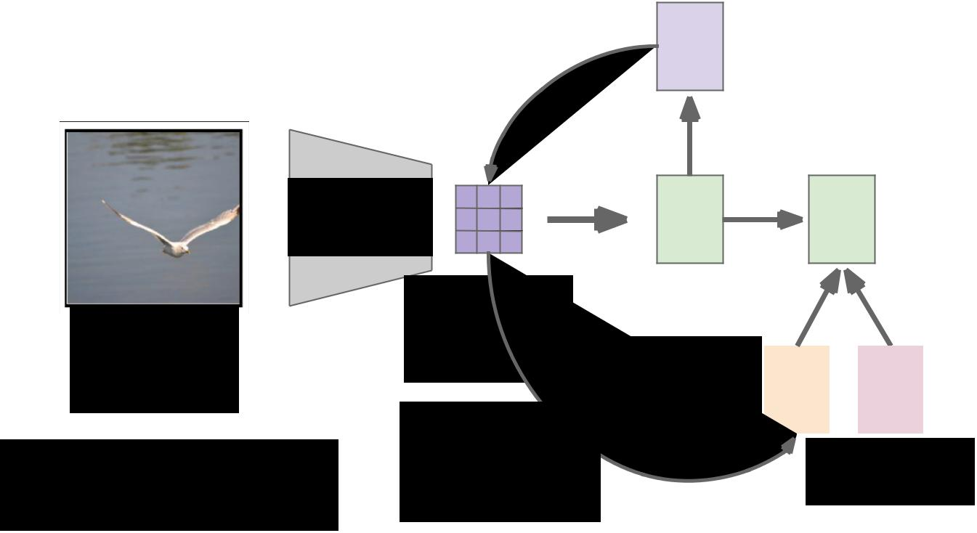

CNN

Image:

H x W x 3

Xu et al, “Show, Attend and Tell: Neural Image Caption Generation with Visual Attention”, ICML 2015

a1



|  |  |
| --- | --- |
| h0 | h1 |



|  |  |  |  |  |  |  |
| --- | --- | --- | --- | --- | --- | --- |
| Features: |  |  |  |  |  |  |
| L x D |  |  |  |  |  |  |
|  |  |  |  |  |  |
| Weighted | z1 |  |  | y1 |  |  |
| features: D |  |  |  |  |
|  |  |  |  |  |  |
| Weighted |  |  |  |  |  |  |
|  |  |  |  |  |  |
| combination |  | First word | | | |  |
| of features |  |  |  |  |  |  |



Fei-Fei Li & Andrej Karpathy & Justin Johnson Lecture 13 92 24 Feb 2016

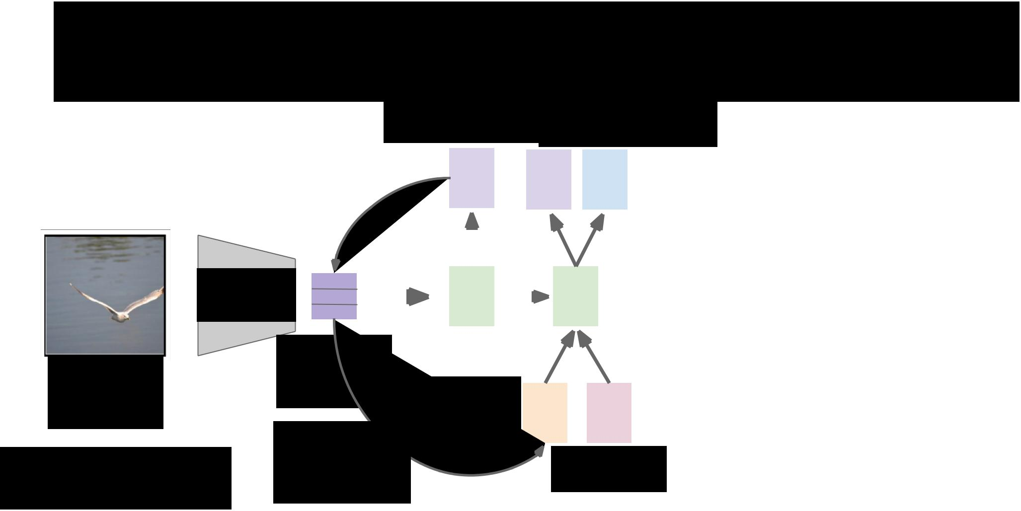Soft Attention for Captioning

|  |  |  |  |  |  |  |  |
| --- | --- | --- | --- | --- | --- | --- | --- |
| L locations | | |  | Distribution | | |  |
|  | over vocab | | |  |
|  |  |  |  |  |  |  |  |
|  | a1 |  | a2 |  | d1 |  |  |
|  |  |  |  |  |  |  |  |



|  |  |  |  |  |  |  |  |  |  |  |  |  |  |  |  |  |  |  |  |
| --- | --- | --- | --- | --- | --- | --- | --- | --- | --- | --- | --- | --- | --- | --- | --- | --- | --- | --- | --- |
| CNN |  |  |  |  |  |  |  |  |  |  |  |  |  |  |  |  |  |  |  |
|  |  |  |  |  |  |  | h0 | |  |  |  |  | h1 | | |  |  |  |
|  |  |  |  |  |  |  |  |  |  |  |  | |  |
|  |  |  |  |  |  |  |  |  |  |  |  |
|  |  |  |  |  |  |  |  |  |  |  |  | |  |
|  |  |  |  |  |  |  |  |  |  |  |  |
|  |  |  |  |  |  |  |  |  |  |  |  |  |  |  |  |  |  |  |  |
|  |  |  |  |  |  |  |  |  |  |  |  |  |  |  |  |  |  |  |  |
| Image: | Features: | | | | | | | | | |  |  |  |  |  |  |  |  |  |
| L x D | | | | | | | | | |  |  |  |  |  |  |  |  |  |
|  |  |  |  |  |  |  |  |  |
| H x W x 3 |  |  |  |  |  |  | Weighted | | | |  | z1 | |  |  |  | y1 |  |  |
|  |  |  |  |  |  | features: D | | | | |  |  |  |  |  |  |
|  |  |  |  |  |  |  |  |  |  |  |  |  |  |  |
|  | Weighted | | | | | | | | | |  |  |  |  |  |  |  |  |  |
|  |  |  |  |  |  |  |  |  |  |
| Xu et al, “Show, Attend and Tell: Neural | combination | | | | | | | | | |  |  |  | First word | | | | |  |
| Image Caption Generation with Visual |  |  |  |  |
| of features | | | | | | | | | |  |  |  |  |  |  |  |  |  |
| Attention”, ICML 2015 |  |  |  |  |  |  |  |  |  |



Fei-Fei Li & Andrej Karpathy & Justin Johnson Lecture 13 93 24 Feb 2016

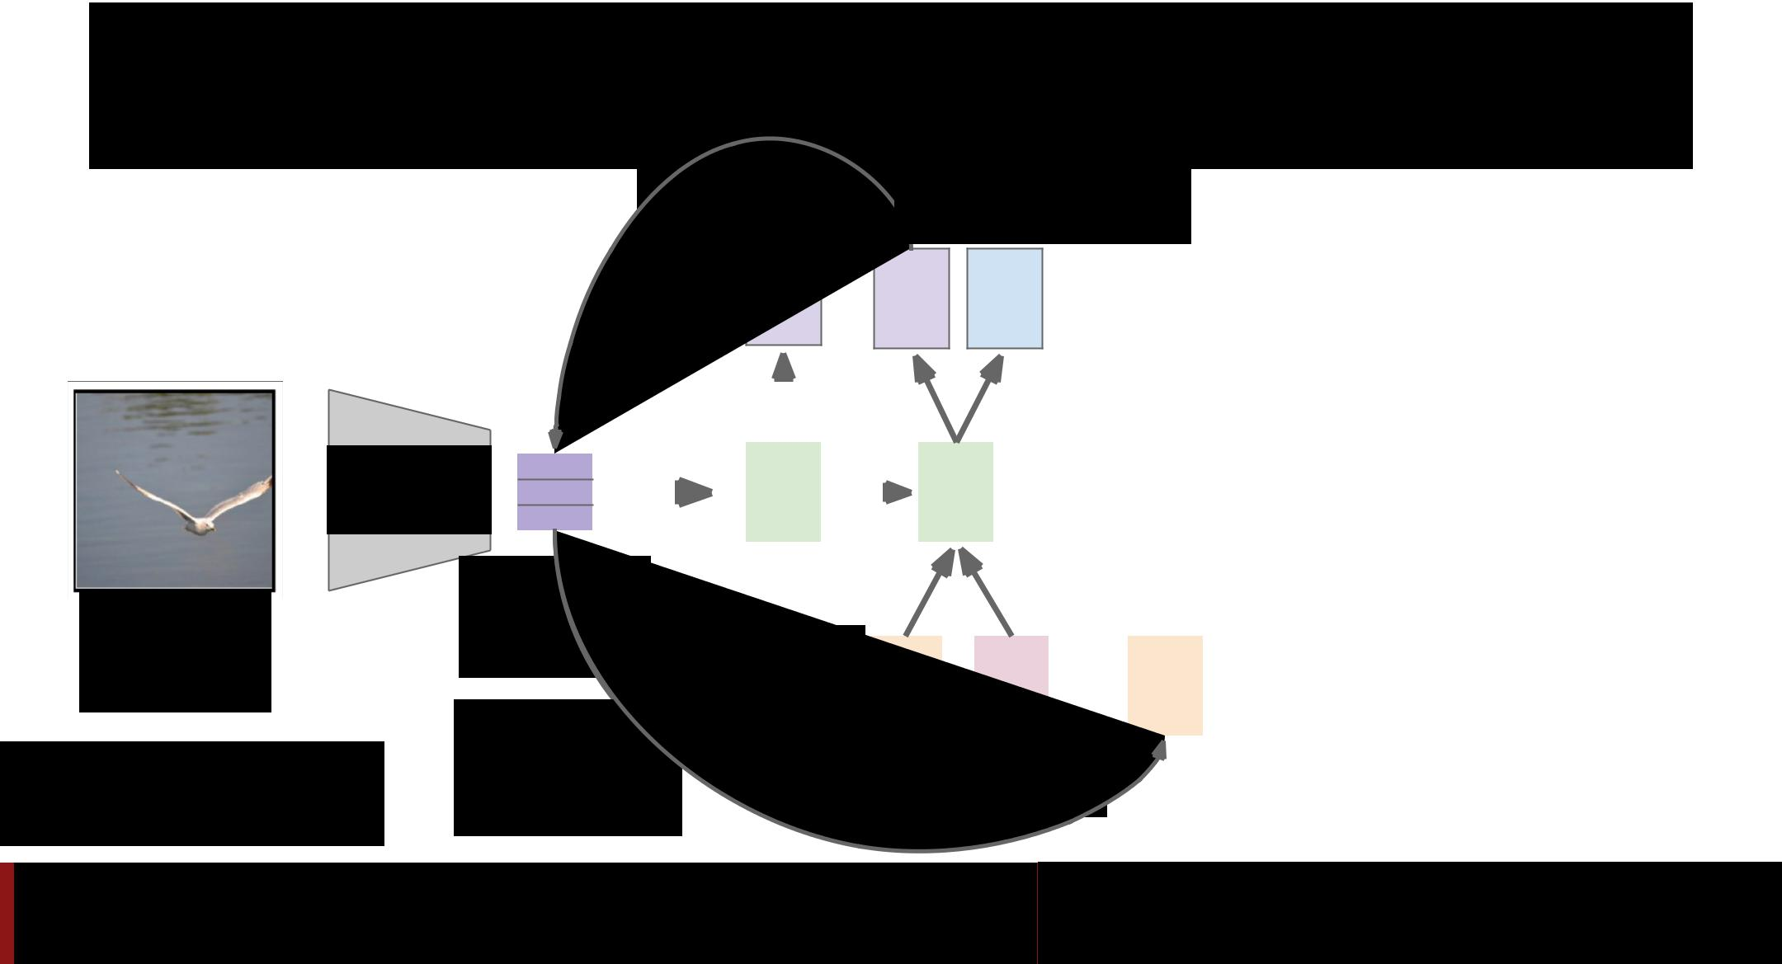Soft Attention for Captioning

|  |  |  |  |
| --- | --- | --- | --- |
| L locations |  | Distribution |  |
|  | over vocab |  |
| a1 | a2 | d1 |  |



|  |  |  |  |  |  |  |  |  |  |  |  |  |  |  |  |  |  |  |  |  |
| --- | --- | --- | --- | --- | --- | --- | --- | --- | --- | --- | --- | --- | --- | --- | --- | --- | --- | --- | --- | --- |
| CNN |  |  |  |  |  |  |  |  |  |  |  |  |  |  |  |  |  |  |  |  |
|  |  |  |  |  |  |  | h0 | |  |  |  |  | h1 | | |  |  |  |  |
|  |  |  |  |  |  |  |  |  |  |  |  | |  |  |
|  |  |  |  |  |  |  |  |  |  |  |  |  |
|  |  |  |  |  |  |  |  |  |  |  |  | |  |  |
|  |  |  |  |  |  |  |  |  |  |  |  |  |
|  |  |  |  |  |  |  |  |  |  |  |  |  |  |  |  |  |  |  |  |  |
|  |  |  |  |  |  |  |  |  |  |  |  |  |  |  |  |  |  |  |  |  |
| Image: | Features: | | | | | | | | | |  |  |  |  |  |  |  |  |  |  |
| L x D | | | | | | | | | |  |  |  |  |  |  |  |  |  |  |
|  |  |  |  |  |  |  |  |  |  |
| H x W x 3 |  |  |  |  |  |  | Weighted | | | |  | z1 | |  |  |  | y1 |  | z2 |  |
|  |  |  |  |  |  | features: D | | | | |  |  |  |  |  |  |
|  |  |  |  |  |  |  |  |  |  |  |  |  |  |  |  |
|  | Weighted | | | | | | | | | |  |  |  |  |  |  |  |  |  |  |
|  |  |  |  |  |  |  |  |  |  |  |
| Xu et al, “Show, Attend and Tell: Neural | combination | | | | | | | | | |  |  |  | First word | | | | |  |  |
| Image Caption Generation with Visual |  |  |  |  |  |
| of features | | | | | | | | | |  |  |  |  |  |  |  |  |  |  |
| Attention”, ICML 2015 |  |  |  |  |  |  |  |  |  |  |



Fei-Fei Li & Andrej Karpathy & Justin Johnson Lecture 13 94 24 Feb 2016

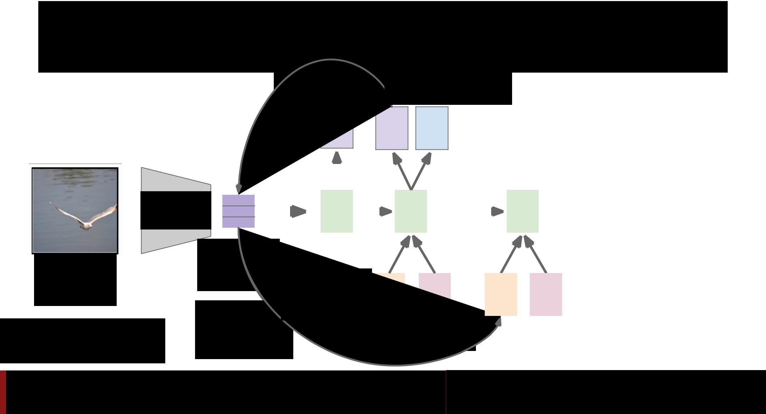Soft Attention for Captioning

|  |  |  |  |
| --- | --- | --- | --- |
| L locations |  | Distribution |  |
|  | over vocab |  |
| a1 | a2 | d1 |  |



|  |  |  |  |  |  |  |  |  |  |  |  |  |  |  |  |  |  |  |  |  |  |  |  |  |  |  |
| --- | --- | --- | --- | --- | --- | --- | --- | --- | --- | --- | --- | --- | --- | --- | --- | --- | --- | --- | --- | --- | --- | --- | --- | --- | --- | --- |
| CNN |  |  |  |  |  |  |  |  |  |  |  |  |  |  |  |  |  |  |  |  |  |  |  |  |  |  |
|  |  |  |  |  |  |  | h0 | |  |  |  |  | h1 | | |  |  |  |  |  | h2 | | |  |  |
|  |  |  |  |  |  |  |  |  |  |  |  | |  |  |  |  |  |
|  |  |  |  |  |  |  |  |  |  |  |  |  |  |
|  |  |  |  |  |  |  |  |  |  |  |  | |  |  |  |  |
|  |  |  |  |  |  |  |  |  |  |  |  |  |  |  |  |  |  |  |  |  |  |  |  |  |  |  |
|  |  |  |  |  |  |  |  |  |  |  |  |  |  |  |  |  |  |  |  |  |  |  |  |  |  |  |
| Image: | Features: | | | | | | | | | |  |  |  |  |  |  |  |  |  |  |  |  |  |  |  |  |
| L x D | | | | | | | | | |  |  |  |  |  |  |  |  |  |  |  |  |  |  |  |  |
|  |  |  |  |  |  |  |  |  |  |  |  |  |  |  |  |
| H x W x 3 |  |  |  |  |  |  | Weighted | | | |  | z1 | |  |  |  | y1 |  |  | z2 | |  |  |  | y2 |  |
|  |  |  |  |  |  | features: D | | | | |  |  |  |  |  |  |  |  |  |  |
|  |  |  |  |  |  |  |  |  |  |  |  |  |  |  |  |  |  |  |  |  |  |
|  | Weighted | | | | | | | | | |  |  |  |  |  |  |  |  |  |  |  |  |  |  |  |  |
|  |  |  |  |  |  |  |  |  |  |  |  |  |  |  |  |  |
| Xu et al, “Show, Attend and Tell: Neural | combination | | | | | | | | | |  |  |  | First word | | | | | |  |  |  |  |  |  |  |
| Image Caption Generation with Visual |  |  |  |  |  |  |  |  |  |  |
| of features | | | | | | | | | |  |  |  |  |  |  |  |  |  |  |  |  |  |  |  |  |
| Attention”, ICML 2015 |  |  |  |  |  |  |  |  |  |  |  |  |  |  |  |  |



Fei-Fei Li & Andrej Karpathy & Justin Johnson Lecture 13 95 24 Feb 2016

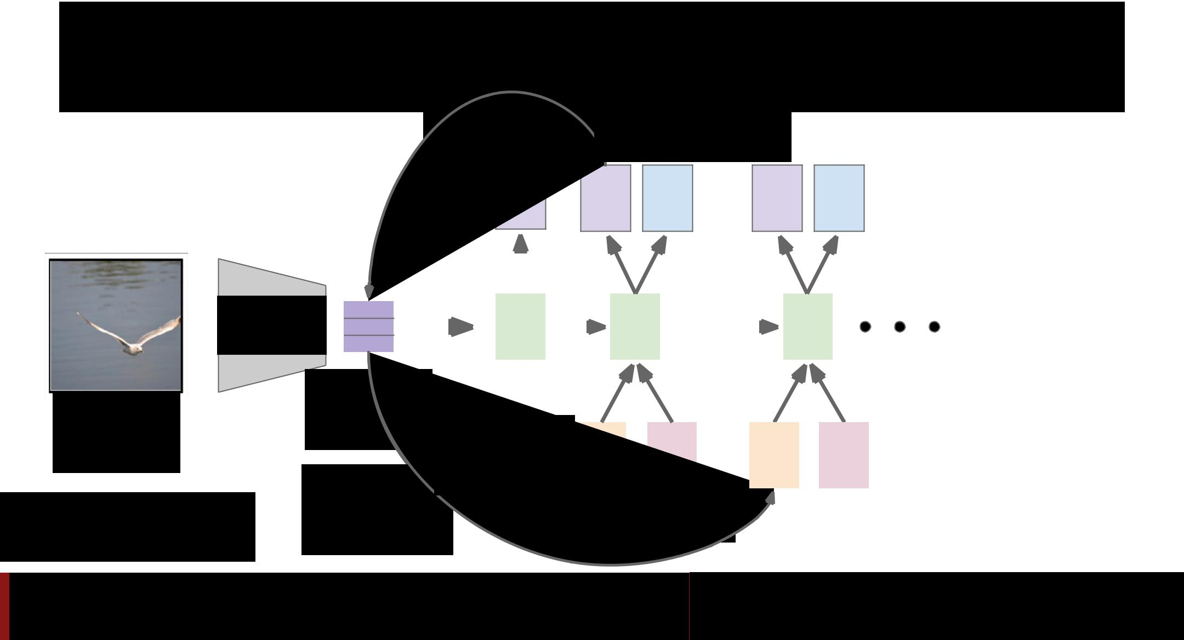Soft Attention for Captioning

|  |  |  |  |  |  |
| --- | --- | --- | --- | --- | --- |
| L locations |  | Distribution |  |  |  |
|  | over vocab |  |  |  |
| a1 | a2 | d1 | a3 | d2 |  |



|  |  |  |  |  |  |  |  |  |  |  |  |  |  |  |  |  |  |  |  |  |  |  |  |  |  |  |
| --- | --- | --- | --- | --- | --- | --- | --- | --- | --- | --- | --- | --- | --- | --- | --- | --- | --- | --- | --- | --- | --- | --- | --- | --- | --- | --- |
| CNN |  |  |  |  |  |  |  |  |  |  |  |  |  |  |  |  |  |  |  |  |  |  |  |  |  |  |
|  |  |  |  |  |  |  | h0 | |  |  |  |  | h1 | | |  |  |  |  |  | h2 | | |  |  |
|  |  |  |  |  |  |  |  |  |  |  |  | |  |  |  |  |  |
|  |  |  |  |  |  |  |  |  |  |  |  |  |  |
|  |  |  |  |  |  |  |  |  |  |  |  | |  |  |  |  |
|  |  |  |  |  |  |  |  |  |  |  |  |  |  |  |  |  |  |  |  |  |  |  |  |  |  |  |
|  |  |  |  |  |  |  |  |  |  |  |  |  |  |  |  |  |  |  |  |  |  |  |  |  |  |  |
| Image: | Features: | | | | | | | | | |  |  |  |  |  |  |  |  |  |  |  |  |  |  |  |  |
| L x D | | | | | | | | | |  |  |  |  |  |  |  |  |  |  |  |  |  |  |  |  |
|  |  |  |  |  |  |  |  |  |  |  |  |  |  |  |  |
| H x W x 3 |  |  |  |  |  |  | Weighted | | | |  | z1 | |  |  |  | y1 |  |  | z2 | |  |  |  | y2 |  |
|  |  |  |  |  |  | features: D | | | | |  |  |  |  |  |  |  |  |  |  |
|  |  |  |  |  |  |  |  |  |  |  |  |  |  |  |  |  |  |  |  |  |  |
|  | Weighted | | | | | | | | | |  |  |  |  |  |  |  |  |  |  |  |  |  |  |  |  |
|  |  |  |  |  |  |  |  |  |  |  |  |  |  |  |  |  |
| Xu et al, “Show, Attend and Tell: Neural | combination | | | | | | | | | |  |  |  | First word | | | | | |  |  |  |  |  |  |  |
| Image Caption Generation with Visual |  |  |  |  |  |  |  |  |  |  |
| of features | | | | | | | | | |  |  |  |  |  |  |  |  |  |  |  |  |  |  |  |  |
| Attention”, ICML 2015 |  |  |  |  |  |  |  |  |  |  |  |  |  |  |  |  |



Fei-Fei Li & Andrej Karpathy & Justin Johnson Lecture 13 96 24 Feb 2016

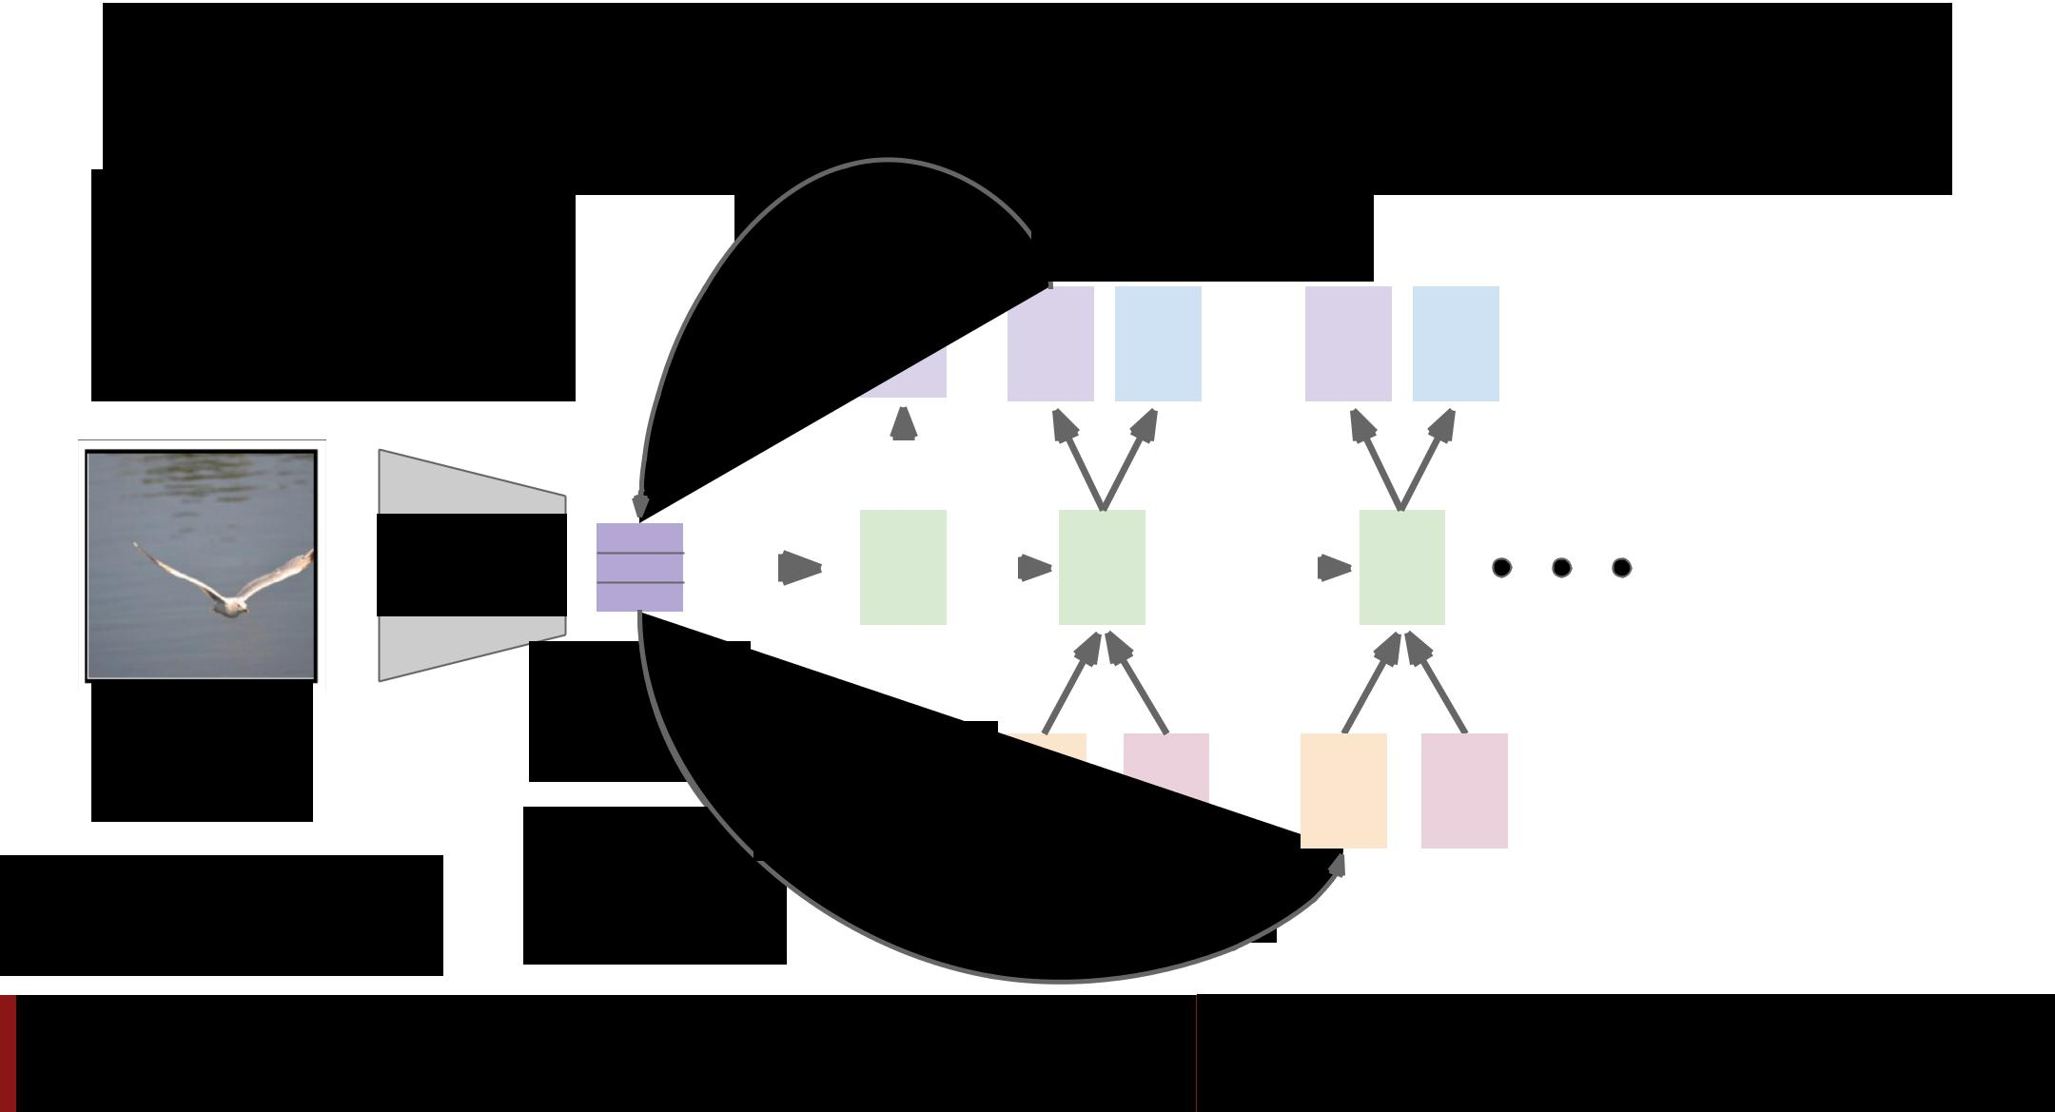Soft Attention for Captioning

|  |  |  |  |  |  |  |  |  |  |  |  |
| --- | --- | --- | --- | --- | --- | --- | --- | --- | --- | --- | --- |
| Guess which framework | L locations | | |  | Distribution | | |  |  |  |  |
| was used to implement? |  | over vocab | | |  |  |  |  |
|  |  | a1 |  | a2 |  | d1 |  | a3 |  | d2 |  |
|  |  |  |  |  |  |  |  |  |  |  |  |



|  |  |  |  |  |  |  |  |  |  |  |  |  |  |  |  |  |  |  |  |  |  |  |  |  |  |  |
| --- | --- | --- | --- | --- | --- | --- | --- | --- | --- | --- | --- | --- | --- | --- | --- | --- | --- | --- | --- | --- | --- | --- | --- | --- | --- | --- |
| CNN |  |  |  |  |  |  |  |  |  |  |  |  |  |  |  |  |  |  |  |  |  |  |  |  |  |  |
|  |  |  |  |  |  |  | h0 | |  |  |  |  | h1 | | |  |  |  |  |  | h2 | | |  |  |
|  |  |  |  |  |  |  |  |  |  |  |  | |  |  |  |  |  |
|  |  |  |  |  |  |  |  |  |  |  |  |  |  |
|  |  |  |  |  |  |  |  |  |  |  |  | |  |  |  |  |
|  |  |  |  |  |  |  |  |  |  |  |  |  |  |  |  |  |  |  |  |  |  |  |  |  |  |  |
|  |  |  |  |  |  |  |  |  |  |  |  |  |  |  |  |  |  |  |  |  |  |  |  |  |  |  |
| Image: | Features: | | | | | | | | | |  |  |  |  |  |  |  |  |  |  |  |  |  |  |  |  |
| L x D | | | | | | | | | |  |  |  |  |  |  |  |  |  |  |  |  |  |  |  |  |
|  |  |  |  |  |  |  |  |  |  |  |  |  |  |  |  |
| H x W x 3 |  |  |  |  |  |  | Weighted | | | |  | z1 | |  |  |  | y1 |  |  | z2 | |  |  |  | y2 |  |
|  |  |  |  |  |  | features: D | | | | |  |  |  |  |  |  |  |  |  |  |
|  |  |  |  |  |  |  |  |  |  |  |  |  |  |  |  |  |  |  |  |  |  |
|  | Weighted | | | | | | | | | |  |  |  |  |  |  |  |  |  |  |  |  |  |  |  |  |
|  |  |  |  |  |  |  |  |  |  |  |  |  |  |  |  |  |
| Xu et al, “Show, Attend and Tell: Neural | combination | | | | | | | | | |  |  |  | First word | | | | | |  |  |  |  |  |  |  |
| Image Caption Generation with Visual |  |  |  |  |  |  |  |  |  |  |
| of features | | | | | | | | | |  |  |  |  |  |  |  |  |  |  |  |  |  |  |  |  |
| Attention”, ICML 2015 |  |  |  |  |  |  |  |  |  |  |  |  |  |  |  |  |



Fei-Fei Li & Andrej Karpathy & Justin Johnson Lecture 13 97 24 Feb 2016

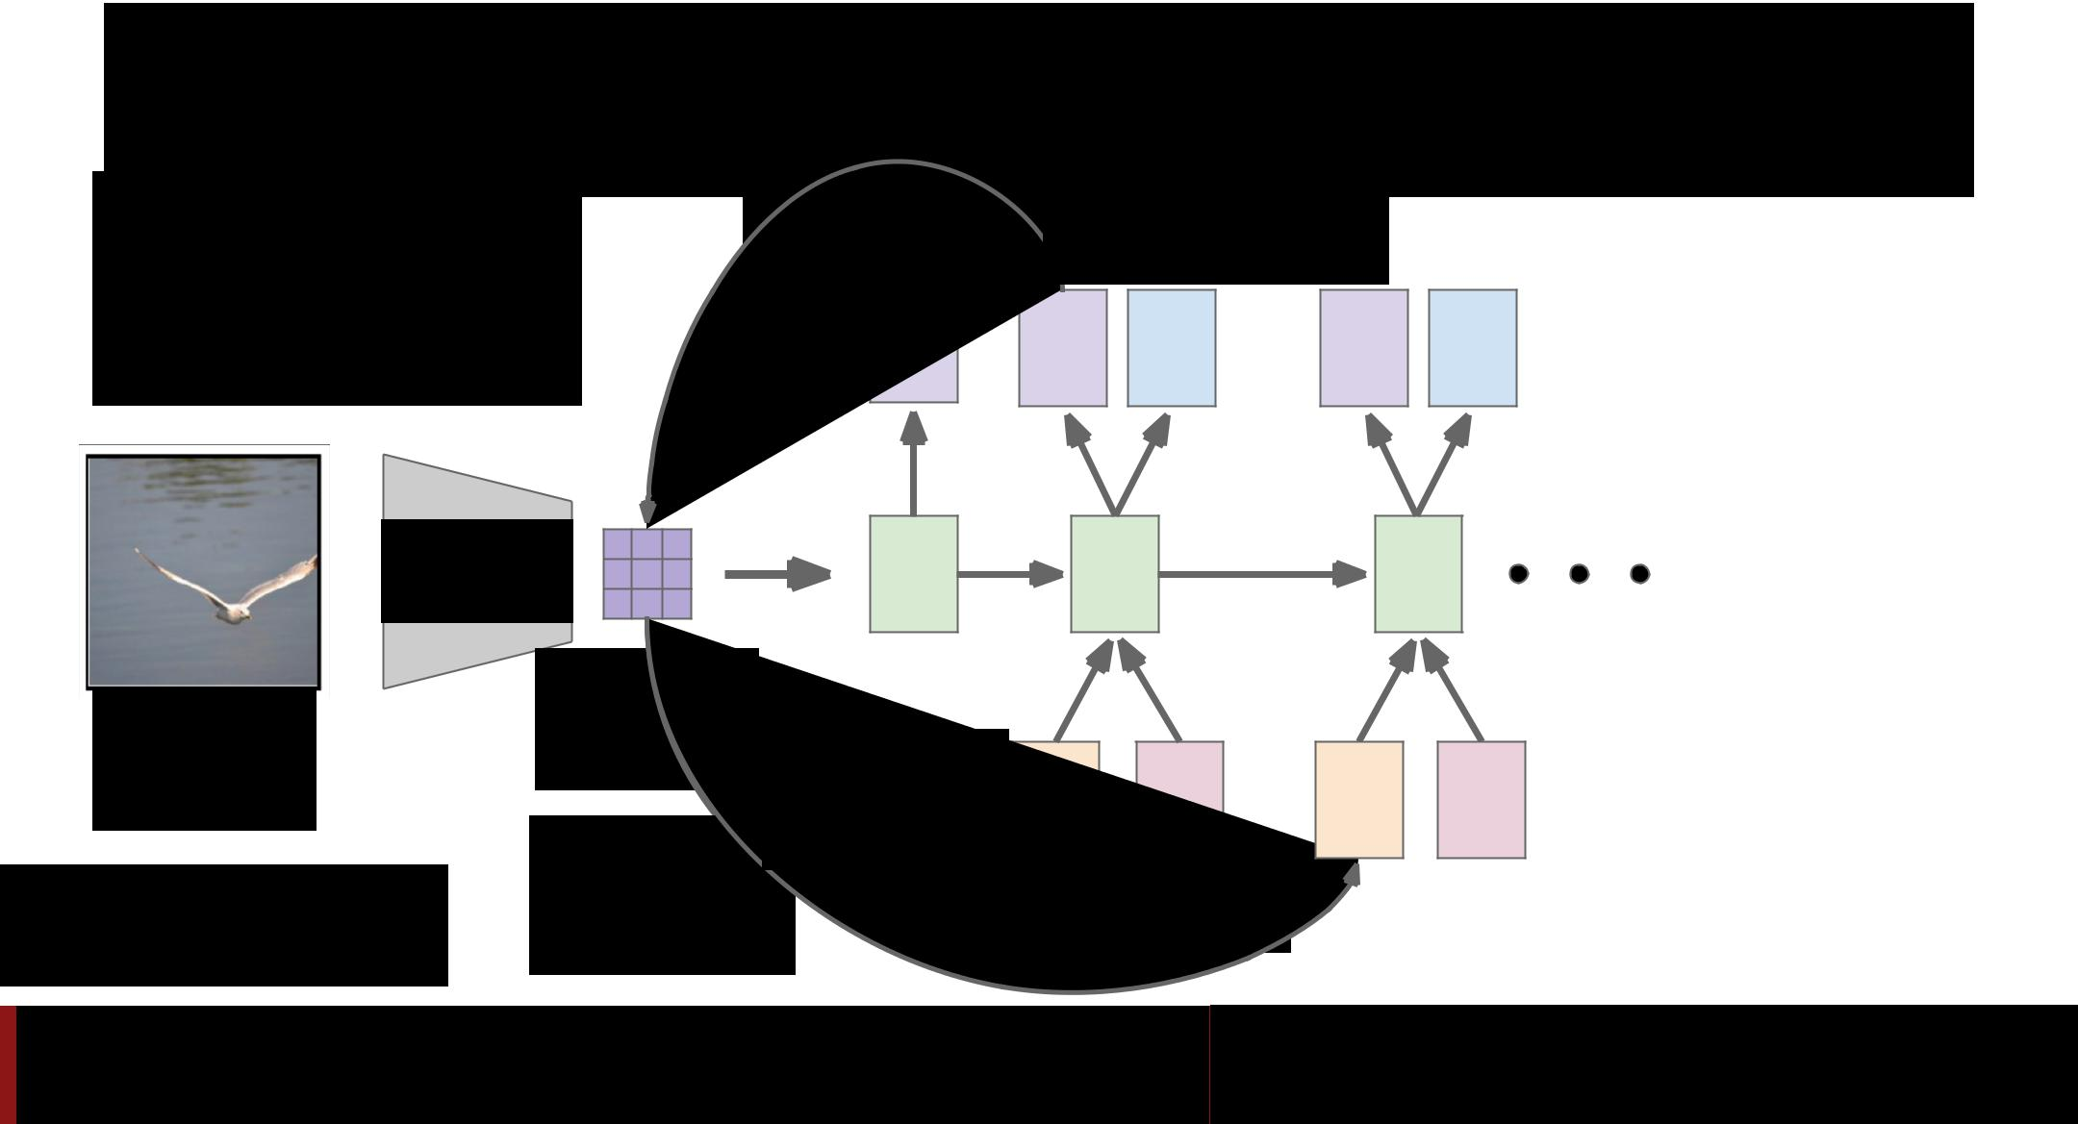Soft Attention for Captioning

Guess which framework was used to implement?

Crazy RNN = **Theano**

CNN

Image:

H x W x 3

Xu et al, “Show, Attend and Tell: Neural Image Caption Generation with Visual Attention”, ICML 2015

|  |  |  |  |  |  |
| --- | --- | --- | --- | --- | --- |
| L locations |  | Distribution |  |  |  |
|  | over vocab |  |  |  |
| a1 | a2 | d1 | a3 | d2 |  |



|  |  |  |
| --- | --- | --- |
| h0 | h1 | h2 |



|  |  |  |  |  |  |
| --- | --- | --- | --- | --- | --- |
| Features: |  |  |  |  |  |
| L x D |  |  |  |  |  |
| Weighted | z1 | y1 | z2 | y2 |  |
| features: D |  |
|  |  |  |  |  |
| Weighted |  |  |  |  |  |
| combination |  | First word |  |  |  |
| of features |  |  |  |  |  |

Fei-Fei Li & Andrej Karpathy & Justin Johnson Lecture 13 98 24 Feb 2016

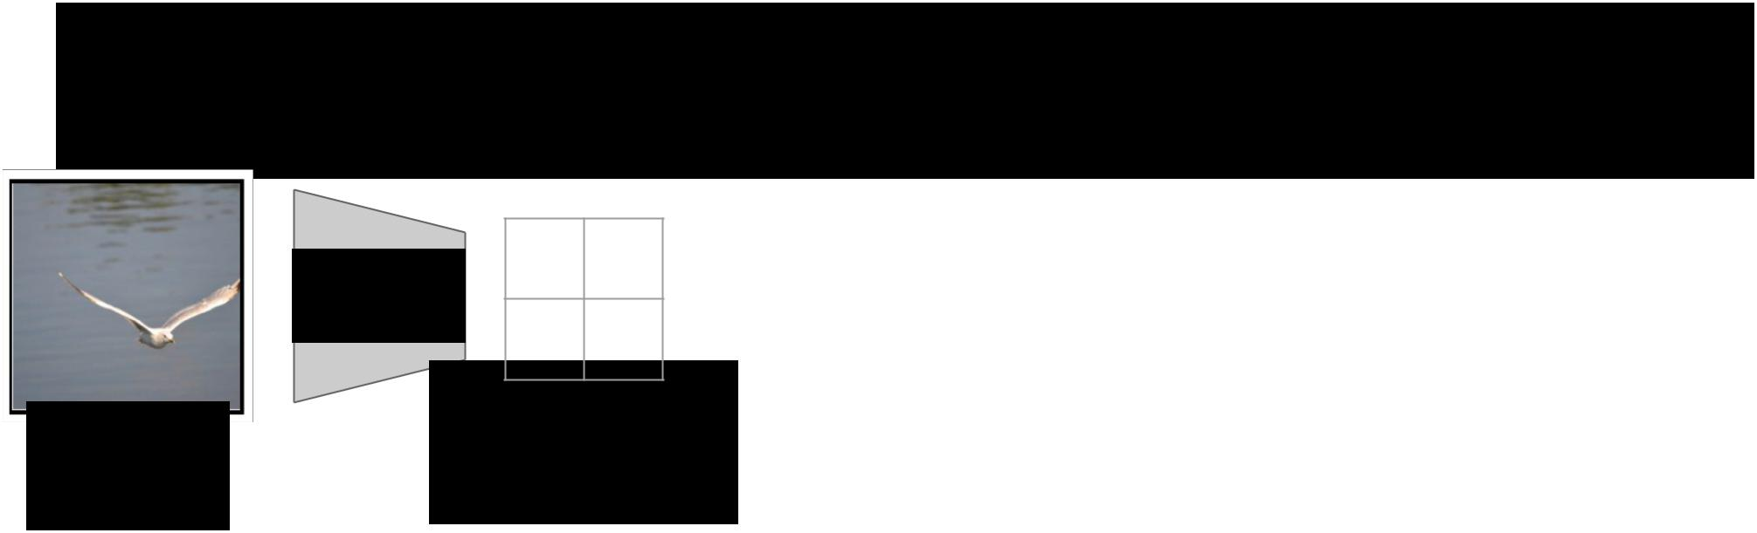Soft vs Hard Attention

Image:

H x W x 3

From

RNN:

a b

CNN

c d

Grid of features

(Each D-

dimensional)

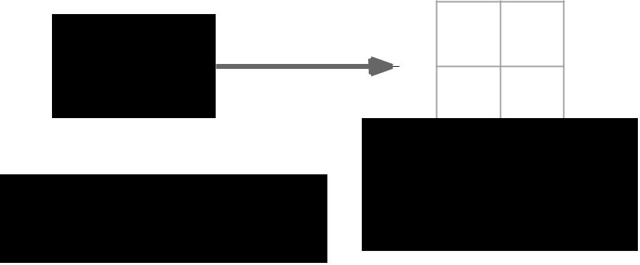

pa pb

pc pd

|  |  |  |
| --- | --- | --- |
|  | Distribution over |  |
| Xu et al, “Show, Attend and Tell: Neural | grid locations |  |
| Image Caption Generation with Visual | pa + pb + pc + pc = 1 |  |
|  |  |
| Attention”, ICML 2015 |  |  |



Fei-Fei Li & Andrej Karpathy & Justin Johnson Lecture 13 99 24 Feb 2016

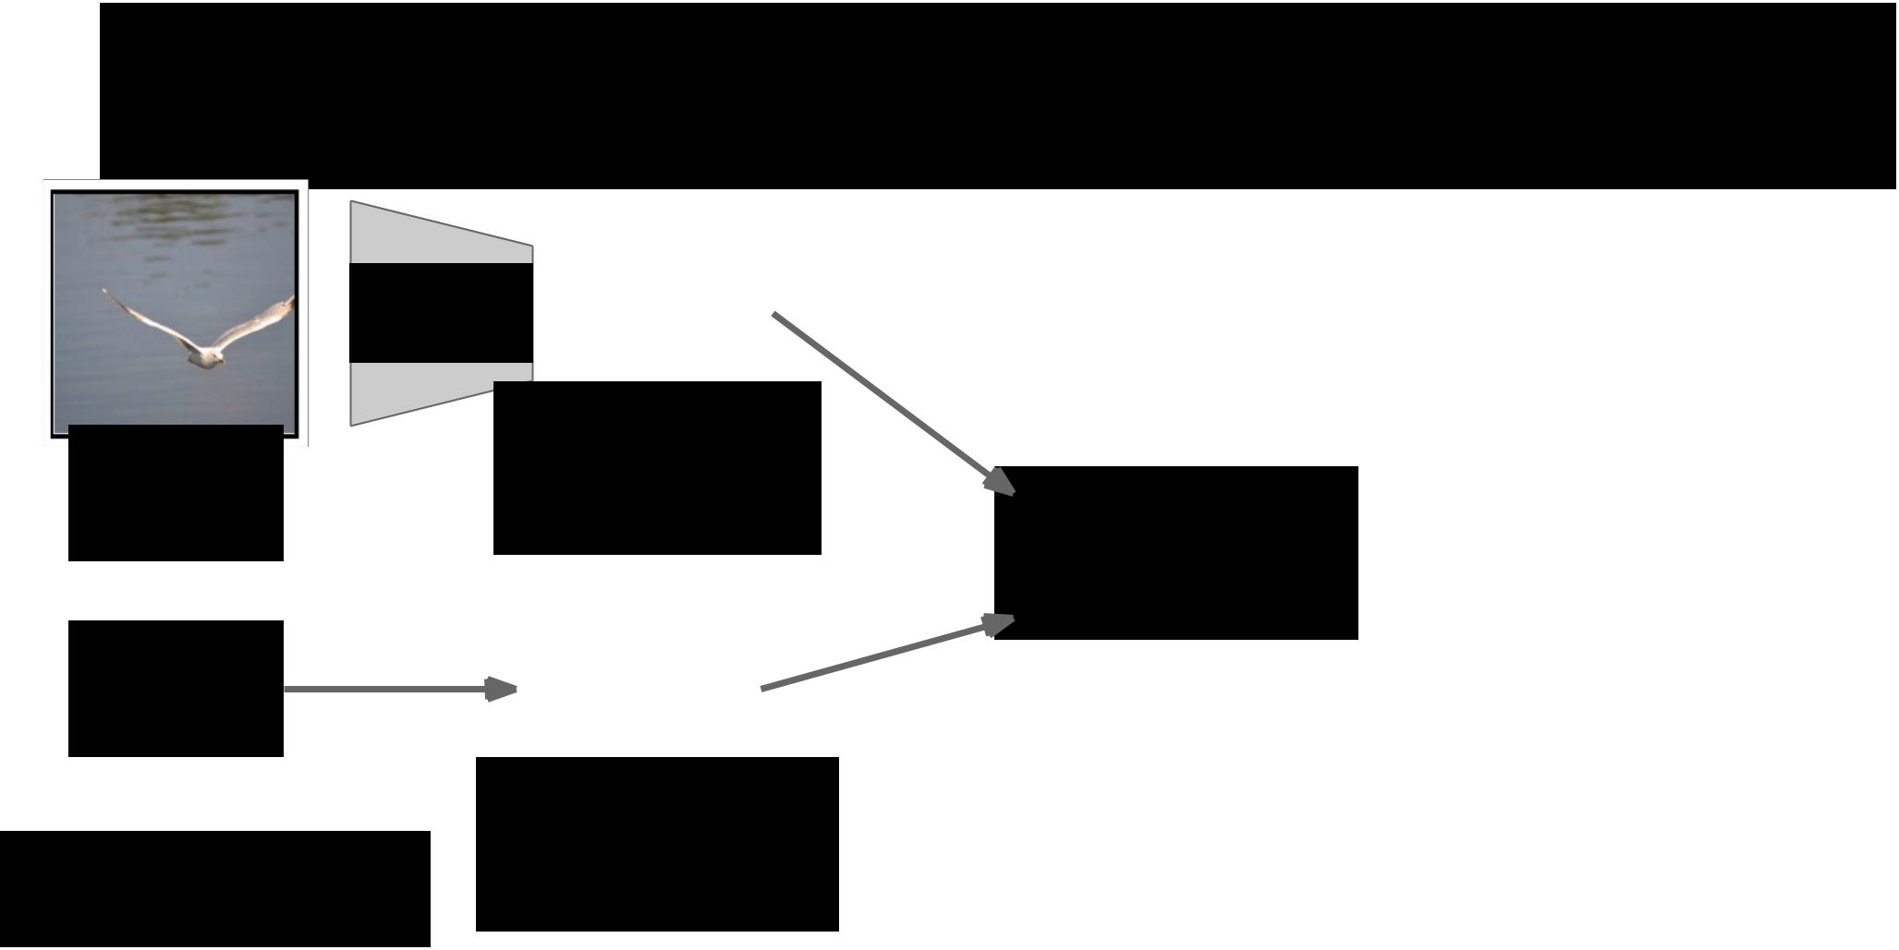Soft vs Hard Attention

|  |  |  |  |  |  |  |  |
| --- | --- | --- | --- | --- | --- | --- | --- |
|  | CNN |  |  | a | b |  |  |
|  |  |  |  |  |  |  |
|  |  | c | d |  |  |
|  |  |  |  |  |  |
|  |  |  |  |  |  |  |  |
| Image: | | Grid of features | | | | |  |
|  |  | (Each D- | | |  |
| H x W x 3 | |  | dimensional) | | | |  |
|  |  |  |  |  |  | |  |
| From | |  |  | pa | pb |  |  |
| RNN: |  |  |  | pc | pd |  |  |
|  |  |  |  |  |  |
|  |  |  |  |  |  |  |  |
|  |  | Distribution over | | | | |  |
| Xu et al, “Show, Attend and Tell: Neural | |  | grid locations | | | |  |

|  |  |  |
| --- | --- | --- |
| Image Caption Generation with Visual | pa + pb + pc + pc = 1 |  |
|  |  |
| Attention”, ICML 2015 |  |  |

Context vector z

(D-dimensional)



Fei-Fei Li & Andrej Karpathy & Justin Johnson Lecture 13 100 24 Feb 2016

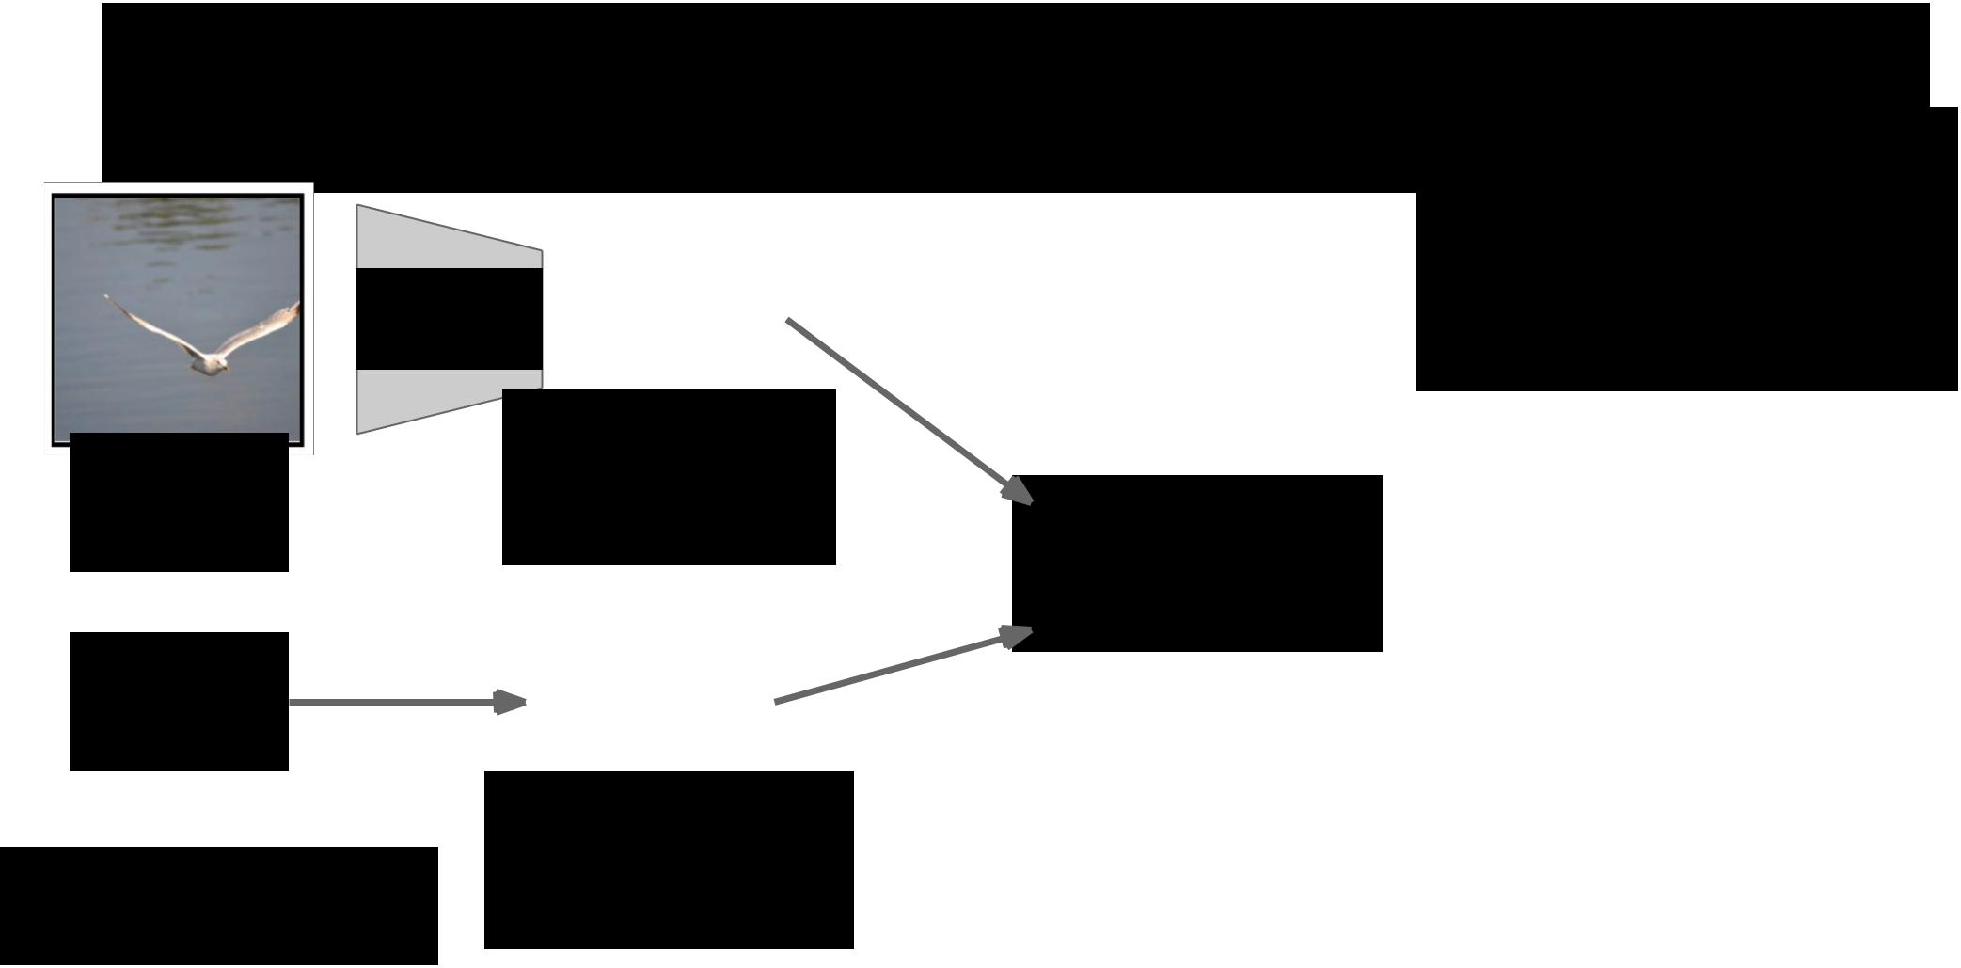Soft vs Hard Attention

**Soft attention:**

|  |  |  |  |  |  |  |  |
| --- | --- | --- | --- | --- | --- | --- | --- |
|  | CNN |  |  | a | b |  |  |
|  |  |  |  |  |  |  |
|  |  | c | d |  |  |
|  |  |  |  |  |  |
|  |  |  |  |  |  |  |  |
| Image: | | Grid of features | | | | |  |
|  |  | (Each D- | | |  |
| H x W x 3 | |  | dimensional) | | | |  |
|  |  |  |  |  |  | |  |
| From | |  |  | pa | pb |  |  |
| RNN: |  |  |  | pc | pd |  |  |
|  |  |  |  |  |  |
|  |  |  |  |  |  |  |  |
|  |  | Distribution over | | | | |  |
| Xu et al, “Show, Attend and Tell: Neural | |  | grid locations | | | |  |

|  |  |  |
| --- | --- | --- |
| Image Caption Generation with Visual | pa + pb + pc + pc = 1 |  |
|  |  |
| Attention”, ICML 2015 |  |  |

Context vector z

(D-dimensional)



Summarize ALL locations

z = paa+ pbb + pcc + pdd

Derivative dz/dp is nice!

Train with gradient descent

Fei-Fei Li & Andrej Karpathy & Justin Johnson Lecture 13 101 24 Feb 2016

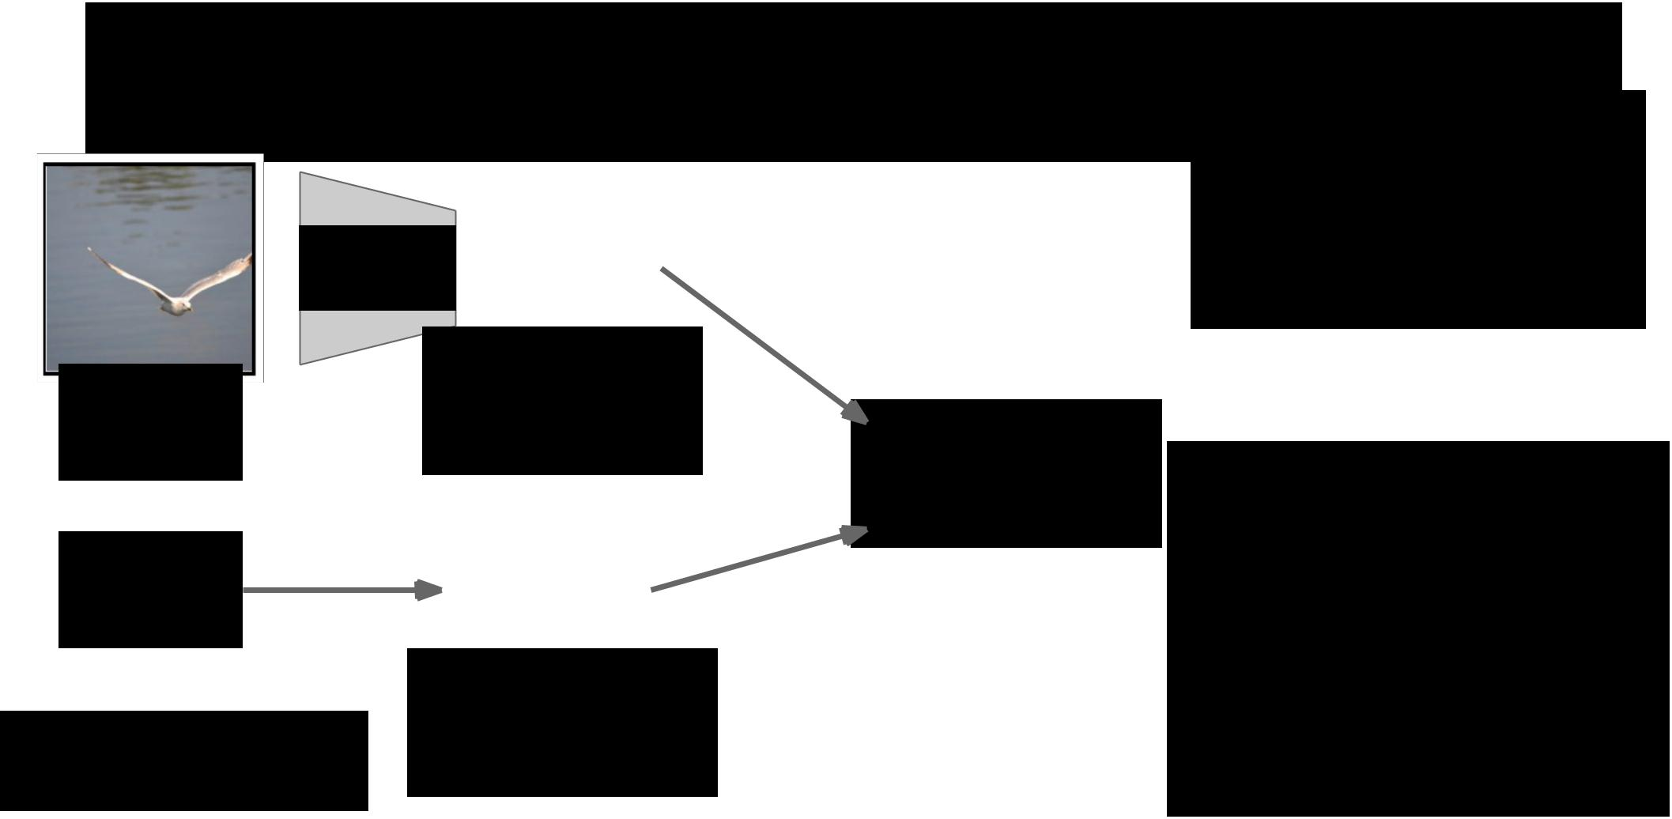Soft vs Hard Attention

**Soft attention:**

|  |  |  |  |  |  |  |  |
| --- | --- | --- | --- | --- | --- | --- | --- |
|  | CNN |  |  | a | b |  |  |
|  |  |  |  |  |  |  |
|  |  | c | d |  |  |
|  |  |  |  |  |  |
|  |  |  |  |  |  |  |  |
| Image: | | Grid of features | | | | |  |
|  |  | (Each D- | | |  |
| H x W x 3 | |  | dimensional) | | | |  |
|  |  |  |  |  |  | |  |
| From | |  |  | pa | pb |  |  |
| RNN: |  |  |  | pc | pd |  |  |
|  |  |  |  |  |  |
|  |  |  |  |  |  |  |  |
|  |  | Distribution over | | | | |  |
| Xu et al, “Show, Attend and Tell: Neural | |  | grid locations | | | |  |

|  |  |  |
| --- | --- | --- |
| Image Caption Generation with Visual | pa + pb + pc + pc = 1 |  |
|  |  |
| Attention”, ICML 2015 |  |  |

Context vector z

(D-dimensional)



Summarize ALL locations

z = paa+ pbb + pcc + pdd

Derivative dz/dp is nice!

Train with gradient descent

**Hard attention**:

Sample ONE location

according to p, z = that vector

With argmax, dz/dp is zero

almost everywhere …

Can’t use gradient descent; need reinforcement learning

Fei-Fei Li & Andrej Karpathy & Justin Johnson Lecture 13 102 24 Feb 2016

Soft Attention for Captioning

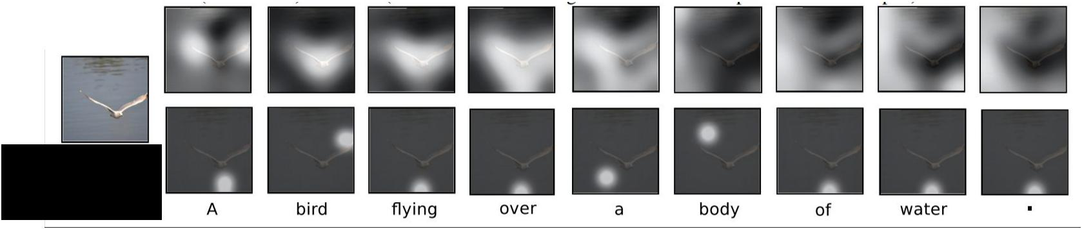

Soft attention

Hard attention



Xu et al, “Show, Attend and Tell: Neural

Image Caption Generation with Visual

Attention”, ICML 2015



Fei-Fei Li & Andrej Karpathy & Justin Johnson Lecture 13 103 24 Feb 2016

Soft Attention for Captioning

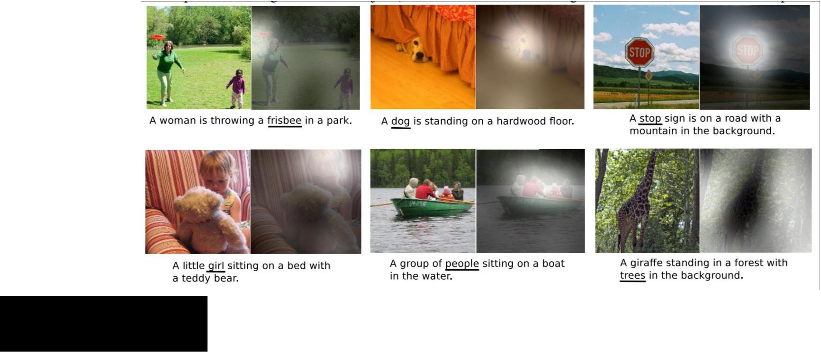

Xu et al, “Show, Attend and Tell: Neural

Image Caption Generation with Visual

Attention”, ICML 2015



Fei-Fei Li & Andrej Karpathy & Justin Johnson Lecture 13 104 24 Feb 2016

|  |  |  |  |  |  |  |  |  |  |  |  |  |  |  |  |  |  |  |  |  |  |  |  |  |  |
| --- | --- | --- | --- | --- | --- | --- | --- | --- | --- | --- | --- | --- | --- | --- | --- | --- | --- | --- | --- | --- | --- | --- | --- | --- | --- |
| Soft Attention for Captioning | | | | | | | | | | | | | | | | | | Attention constrained to | | | | | | |  |
| fixed grid! We’ll come | | | | | | |  |
| back to this …. | | | | | | |  |
|  |  |  |  |  |  |  |  |  |  |  |  |  |  |  |  |  |  |  |  |  |  |  |  |  |  |
|  |  |  |  |  |  |  |  |  |  |  |  |  |  |  |  |  |  |  |  |  |  |  |  |  |  |
|  |  |  |  |  |  |  |  |  |  |  |  |  |  |  |  |  |  |  |  |  |  |  |  |  |  |
|  |  |  |  |  |  |  |  |  |  |  |  |  |  |  |  |  |  |  |  |  |  |  |  |  |  |
|  |  |  |  |  |  |  |  |  |  |  |  |  |  |  |  |  |  |  |  |  |  |  |  |  |  |
|  |  |  |  |  |  |  |  |  |  |  |  |  |  |  |  |  |  |  |  |  |  |  |  |  |  |
|  |  |  |  |  |  |  |  |  |  |  |  |  |  |  |  |  |  |  |  |  |  |  |  |  |  |
|  |  |  |  |  |  |  |  |  |  |  |  |  |  |  |  |  |  |  |  |  |  |  |  |  |  |
|  |  |  |  |  |  |  |  |  |  |  |  |  |  |  |  |  |  |  |  |  |  |  |  |  |  |
|  |  |  |  |  |  |  |  |  |  |  |  |  |  |  |  |  |  |  |  |  |  |  |  |  |  |
|  |  |  |  |  |  |  |  |  |  |  |  |  |  |  |  |  |  |  |  |  |  |  |  |  |  |
|  |  |  |  |  |  |  |  |  |  |  |  |  |  |  |  |  |  |  |  |  |  |  |  |  |  |
|  |  |  |  |  |  |  |  |  |  |  |  |  |  |  |  |  |  |  |  |  |  |  |  |  |  |
|  |  |  |  |  |  |  |  |  |  |  |  |  |  |  |  |  |  |  |  |  |  |  |  |  |  |
|  |  |  |  |  |  |  |  |  |  |  |  |  |  |  |  |  |  |  |  |  |  |  |  |  |  |
|  |  |  |  |  |  |  |  |  |  |  |  |  |  |  |  |  |  |  |  |  |  |  |  |  |  |
|  |  |  |  |  |  |  |  |  |  |  |  |  |  |  |  |  |  |  |  |  |  |  |  |  |  |



Xu et al, “Show, Attend and Tell: Neural

Image Caption Generation with Visual

Attention”, ICML 2015



Fei-Fei Li & Andrej Karpathy & Justin Johnson Lecture 13 105 24 Feb 2016

Soft Attention for Translation

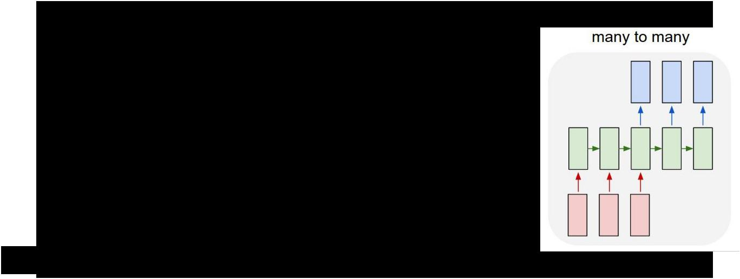

“Mi gato es el mejor” -> “My cat is the best”

Bahdanau et al, “Neural Machine Translation by

Jointly Learning to Align and Translate”, ICLR 2015



Fei-Fei Li & Andrej Karpathy & Justin Johnson Lecture 13 106 24 Feb 2016

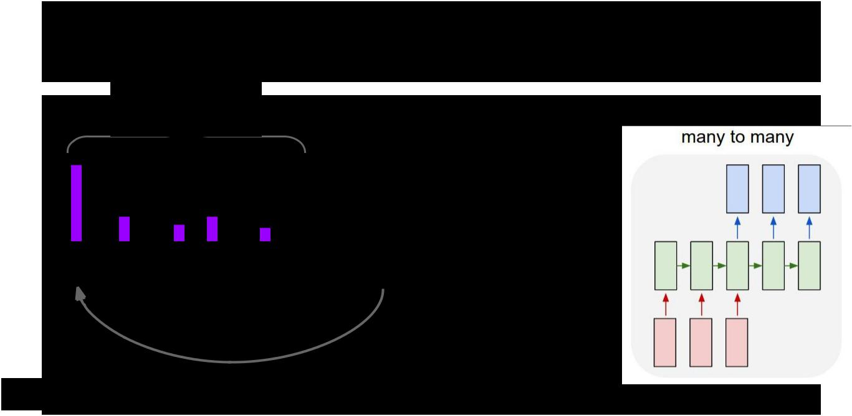Soft Attention for Translation

Distribution over

input words



“Mi gato es el mejor” -> “My cat is the best”

Bahdanau et al, “Neural Machine Translation by

Jointly Learning to Align and Translate”, ICLR 2015



Fei-Fei Li & Andrej Karpathy & Justin Johnson Lecture 13 107 24 Feb 2016

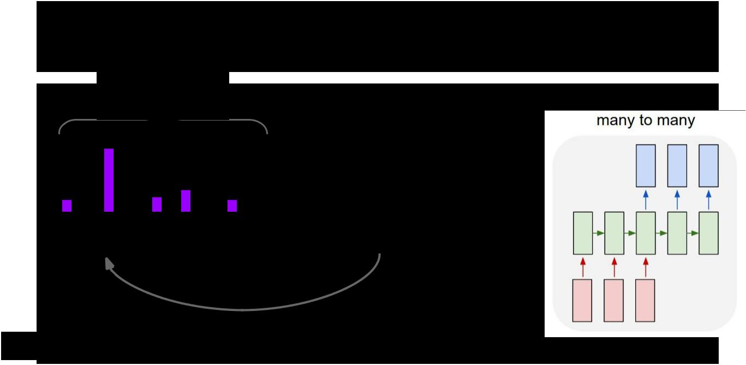Soft Attention for Translation

Distribution over

input words



“Mi gato es el mejor” -> “My cat is the best”

Bahdanau et al, “Neural Machine Translation by

Jointly Learning to Align and Translate”, ICLR 2015



Fei-Fei Li & Andrej Karpathy & Justin Johnson Lecture 13 108 24 Feb 2016

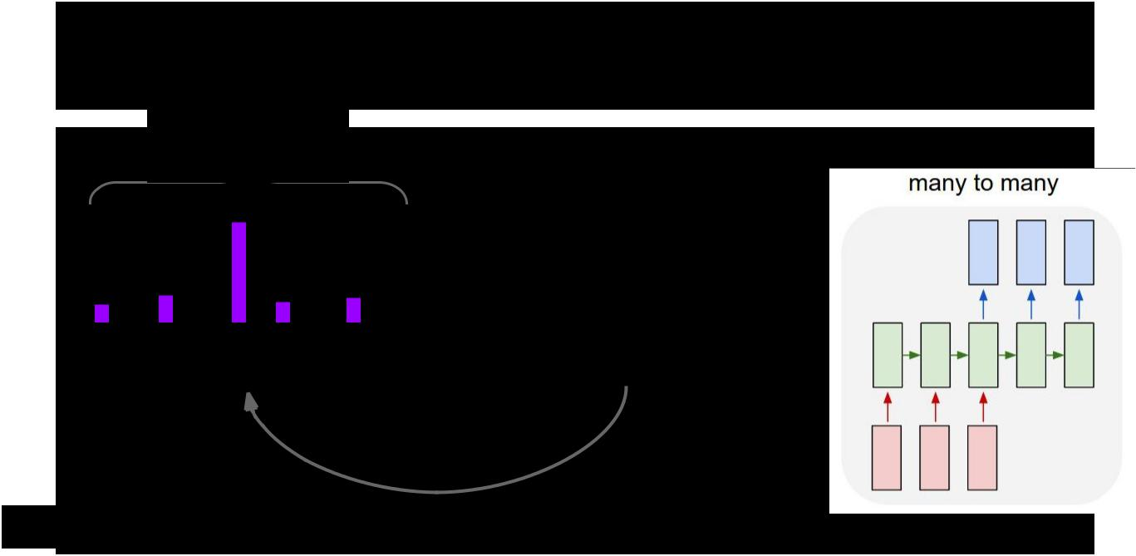Soft Attention for Translation

Distribution over

input words



“Mi gato es el mejor” -> “My cat is the best”

Bahdanau et al, “Neural Machine Translation by

Jointly Learning to Align and Translate”, ICLR 2015



Fei-Fei Li & Andrej Karpathy & Justin Johnson Lecture 13 109 24 Feb 2016

Soft Attention for Everything!

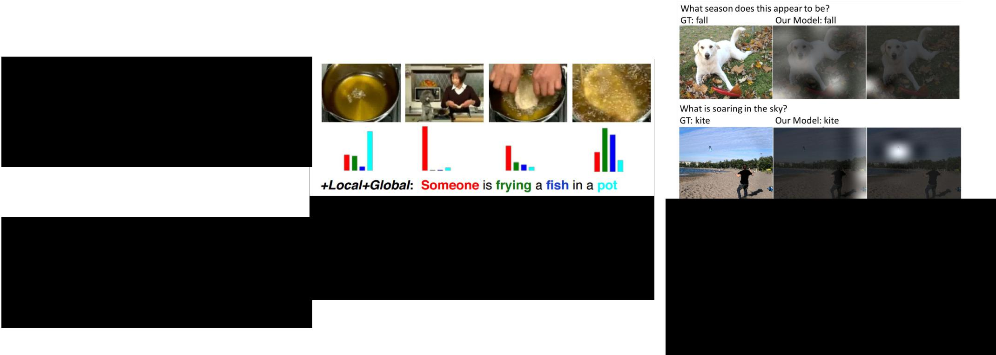

**Machine Translation, attention over input:**

- Luong et al, “Effective Approaches to Attention-based Neural Machine Translation,” EMNLP 2015

**Speech recognition, attention over input sounds:**

* Chan et al, “Listen, Attend, and Spell”, arXiv 2015
* Chorowski et al, “Attention-based models for Speech Recognition”, NIPS 2015

**Video captioning,**

**attention over input frames:**

* Yao et al, “Describing Videos by Exploiting Temporal Structure”, ICCV 2015



**Image, question to answer, attention over image:**

* Xu and Saenko, “Ask, Attend and Answer: Exploring Question-Guided Spatial Attention for Visual Question Answering”, arXiv 2015
* Zhu et al, “Visual7W: Grounded Question Answering in Images”, arXiv 2015

Fei-Fei Li & Andrej Karpathy & Justin Johnson Lecture 13 110 24 Feb 2016

Attending to arbitrary regions?

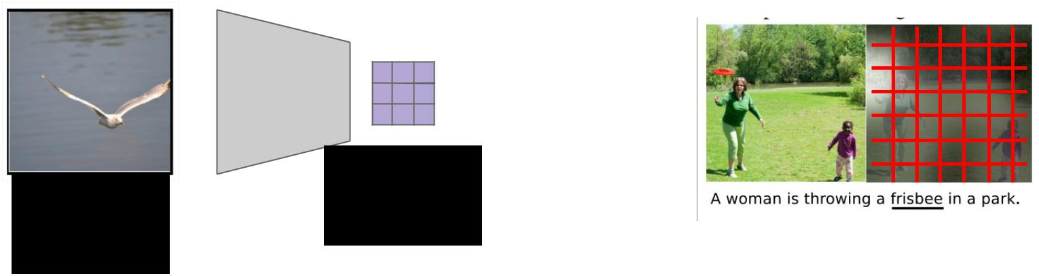

Features:



Image: L x D

H x W x 3



Attention mechanism from Show, Attend, and Tell only lets us softly attend to fixed grid positions … can we do better?



Fei-Fei Li & Andrej Karpathy & Justin Johnson Lecture 13 111 24 Feb 2016

Attending to Arbitrary Regions



* Read text, generate handwriting using an RNN
* Attend to arbitrary regions of the **output** by predicting params of a mixture model

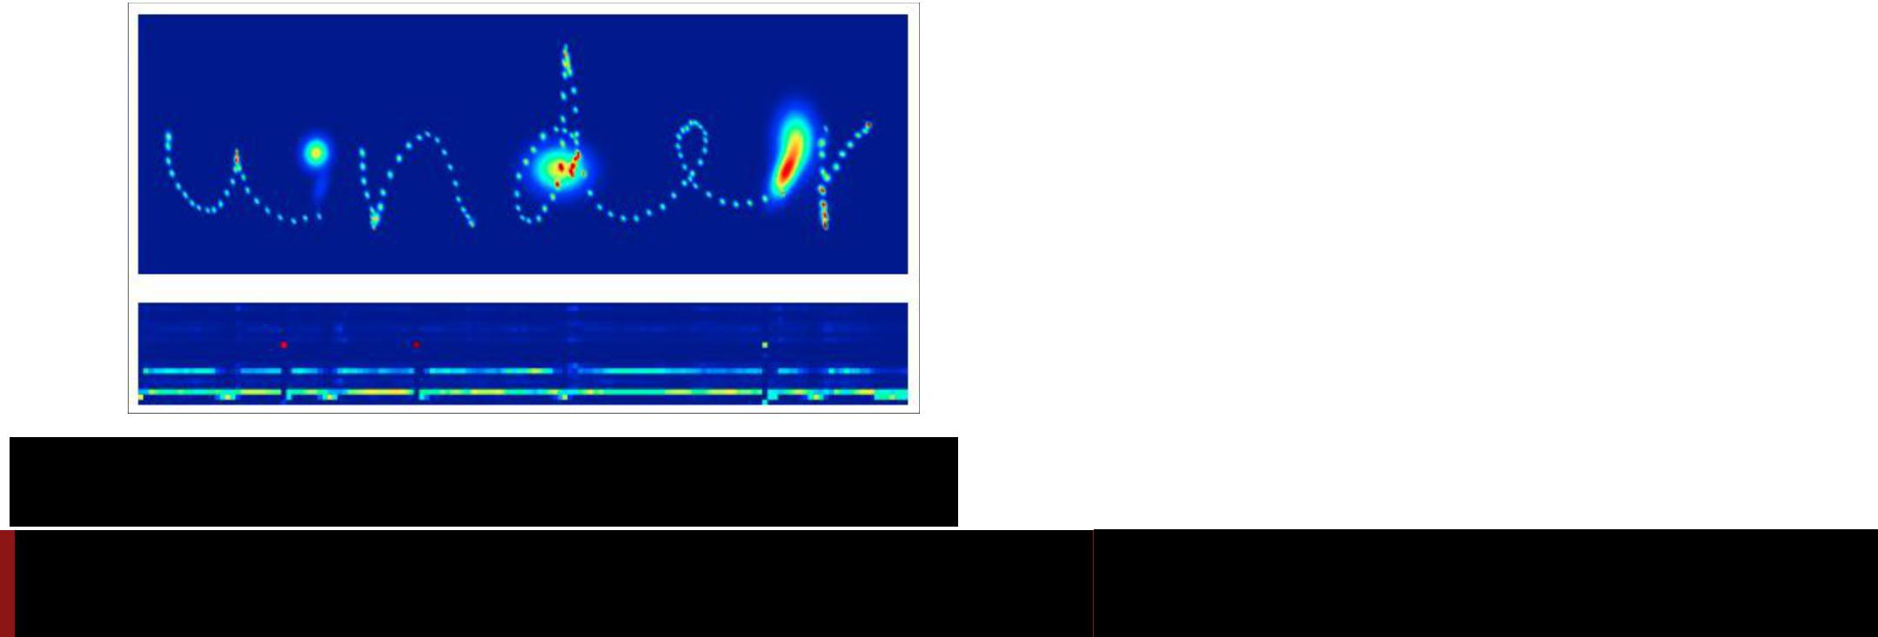

Graves, “Generating Sequences with Recurrent Neural Networks”, arXiv 2013

Fei-Fei Li & Andrej Karpathy & Justin Johnson Lecture 13 112 24 Feb 2016

Attending to Arbitrary Regions



* Read text, generate handwriting using an RNN
* Attend to arbitrary regions of the **output** by predicting params of a mixture model



Which are real and which are generated?

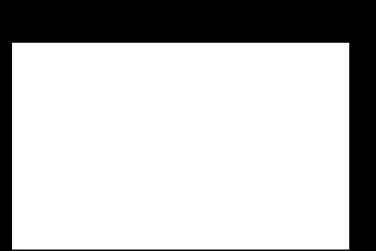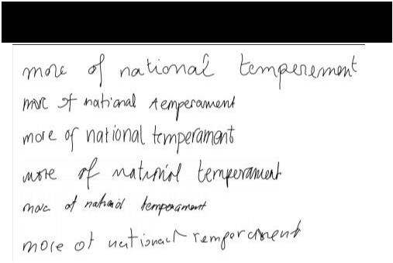

Graves, “Generating Sequences with Recurrent Neural Networks”, arXiv 2013

Fei-Fei Li & Andrej Karpathy & Justin Johnson Lecture 13 113 24 Feb 2016

Attending to Arbitrary Regions

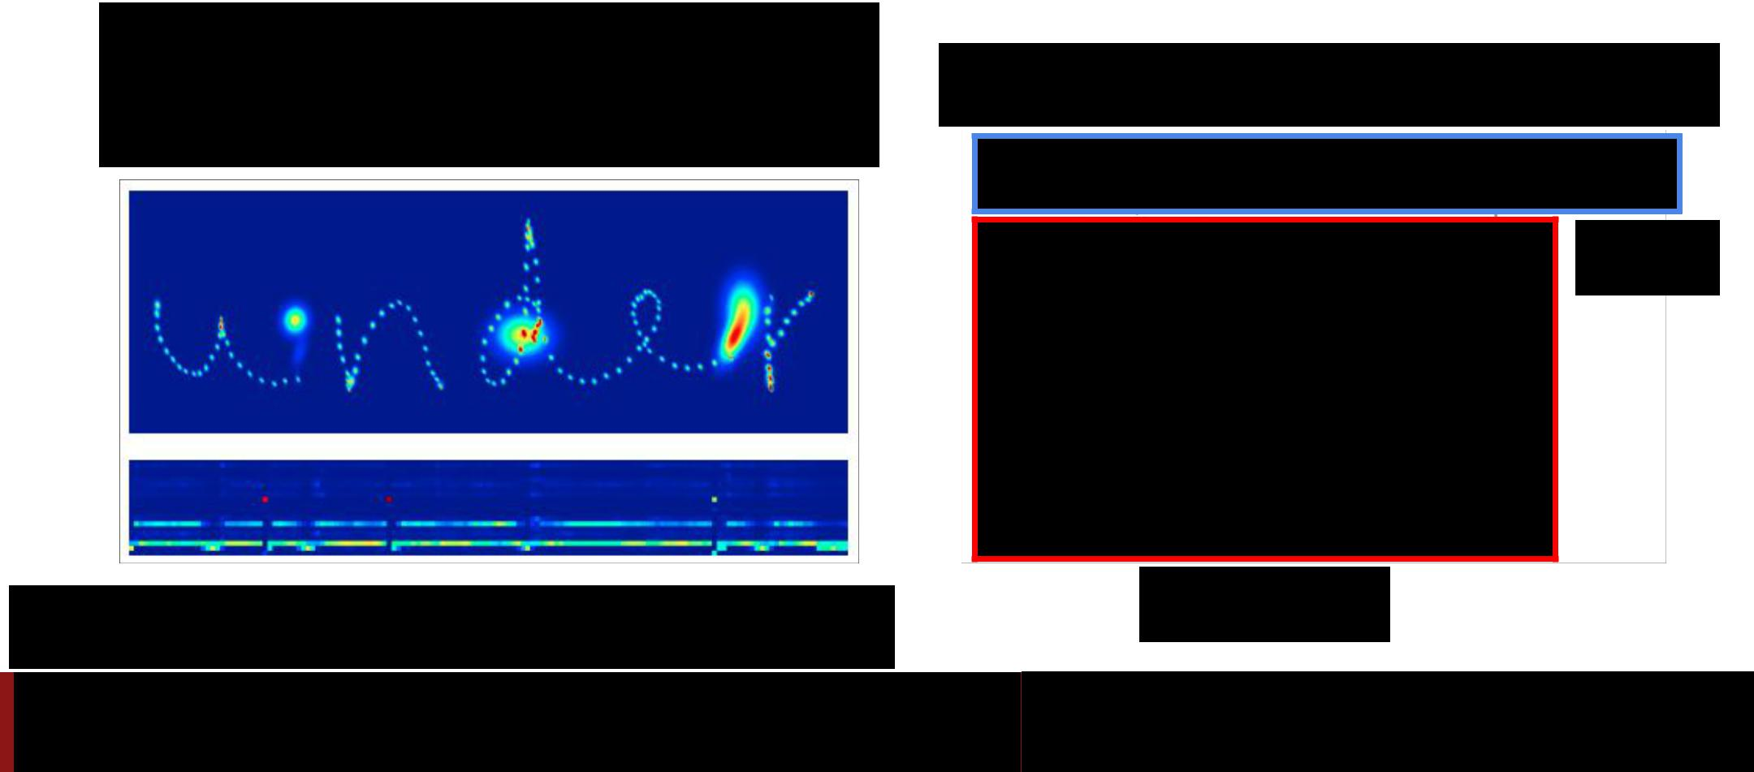

* Read text, generate handwriting using an RNN
* Attend to arbitrary regions of the **output** by predicting params of a mixture model

Which are real and which are generated?

**REAL**

Graves, “Generating Sequences with Recurrent Neural Networks”, arXiv 2013

**GENERATED**

Fei-Fei Li & Andrej Karpathy & Justin Johnson Lecture 13 114 24 Feb 2016

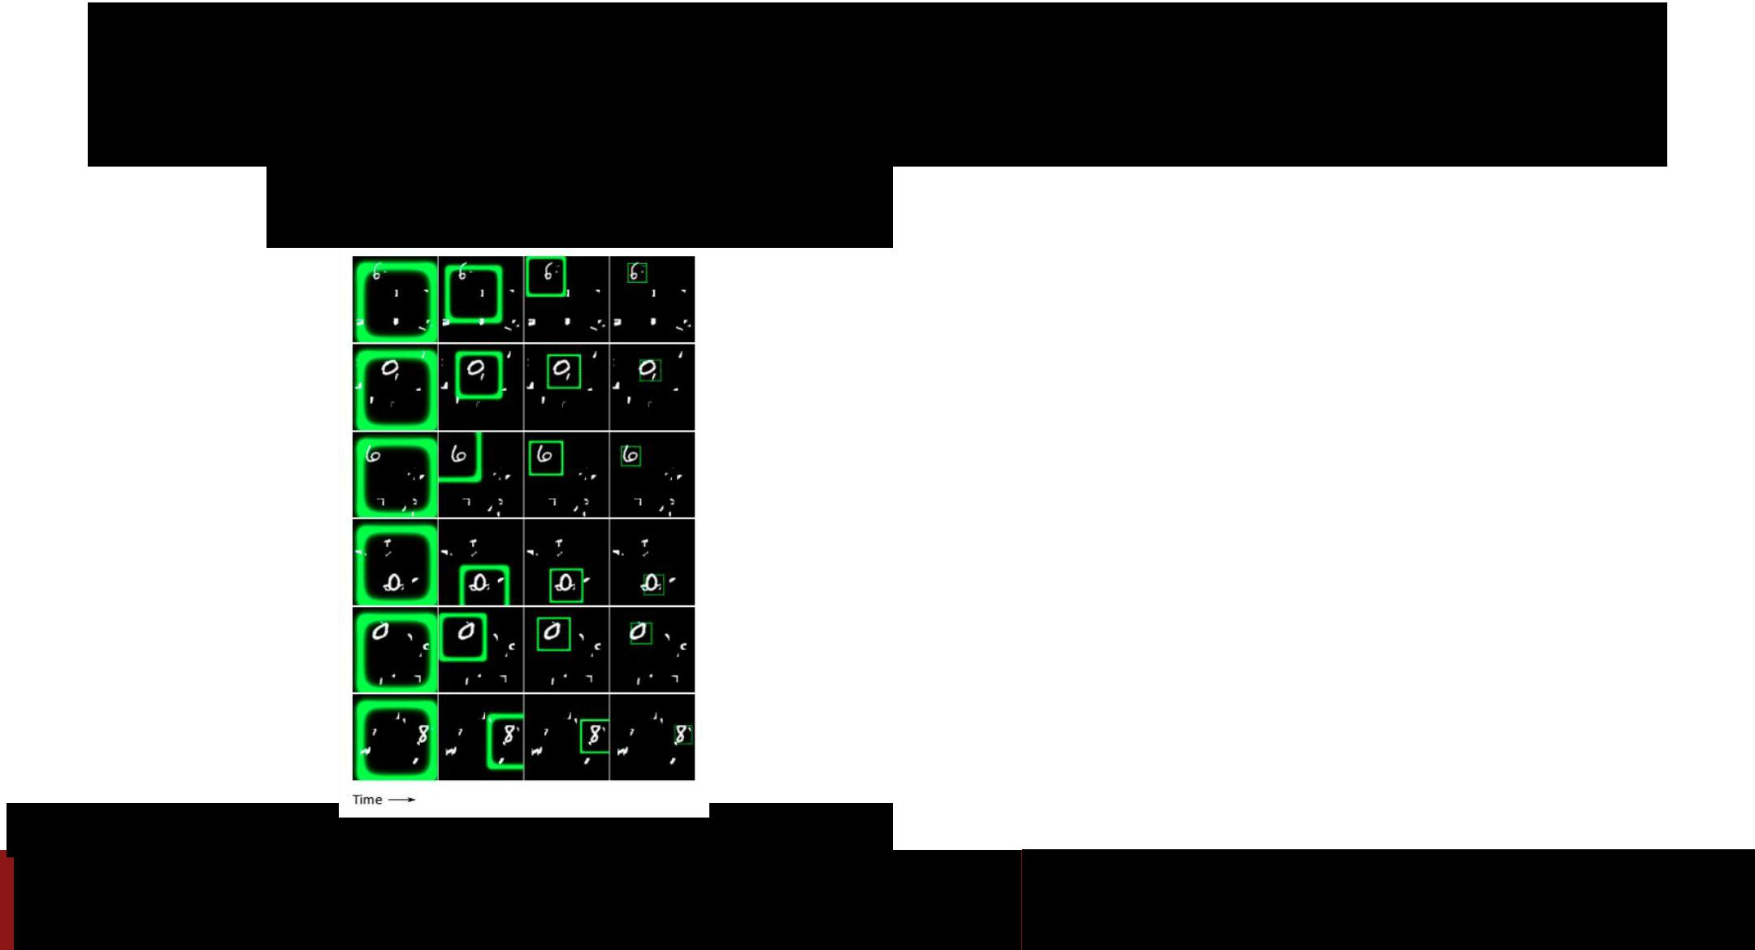Attending to Arbitrary Regions: DRAW

**Classify** images by attending to

arbitrary regions of the *input*

Gregor et al, “DRAW: A Recurrent Neural Network For Image Generation”, ICML 2015

Fei-Fei Li & Andrej Karpathy & Justin Johnson Lecture 13 115 24 Feb 2016

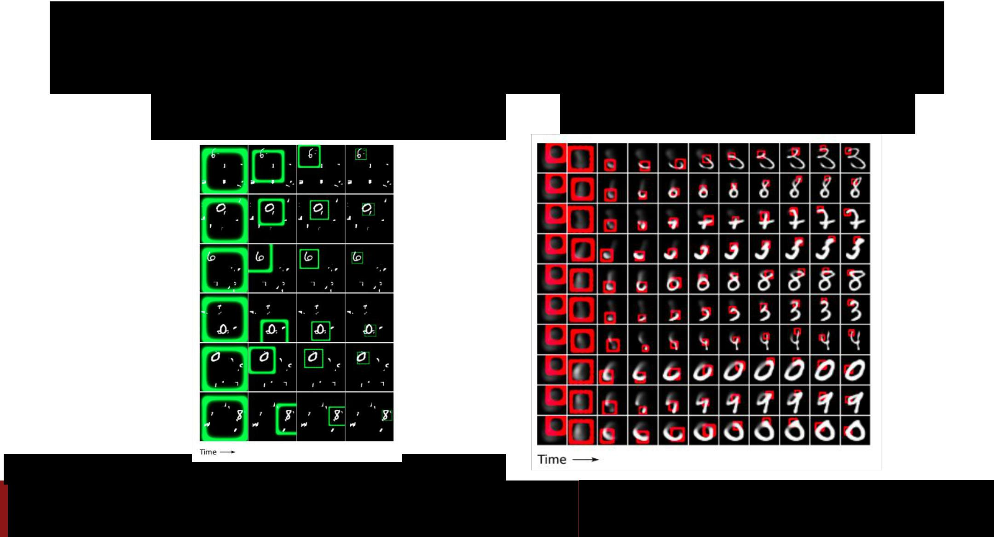Attending to Arbitrary Regions: DRAW

**Classify** images by attending to

arbitrary regions of the *input*

**Generate** images by attending toarbitrary regions of the *output*

Gregor et al, “DRAW: A Recurrent Neural Network For Image Generation”, ICML 2015

Fei-Fei Li & Andrej Karpathy & Justin Johnson Lecture 13 116 24 Feb 2016

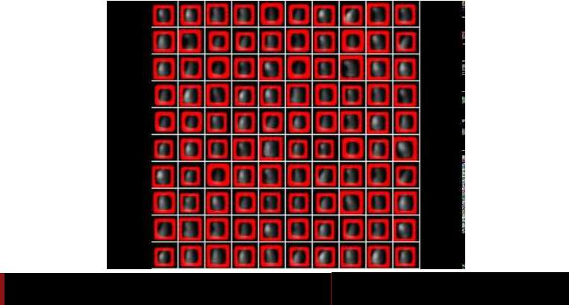

Fei-Fei Li & Andrej Karpathy & Justin Johnson Lecture 13 117 24 Feb 2016

Attending to Arbitrary Regions:

Spatial Transformer Networks



Attention mechanism similar to DRAW, but easier to explain



Jaderberg et al, “Spatial Transformer Networks”, NIPS 2015



Fei-Fei Li & Andrej Karpathy & Justin Johnson Lecture 13 118 24 Feb 2016

Spatial Transformer Networks

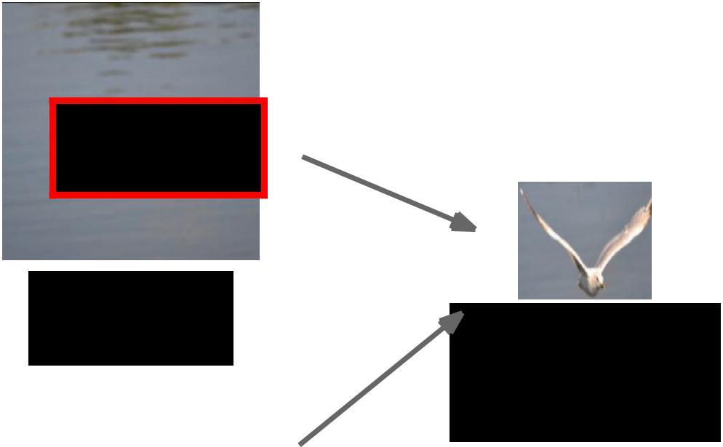

Input image:

H x W x 3 Cropped and

rescaled image:

X x Y x 3



Box Coordinates:

(xc, yc, w, h)



Jaderberg et al, “Spatial Transformer Networks”, NIPS 2015



Fei-Fei Li & Andrej Karpathy & Justin Johnson Lecture 13 119 24 Feb 2016

Spatial Transformer Networks



Can we make this

function differentiable?

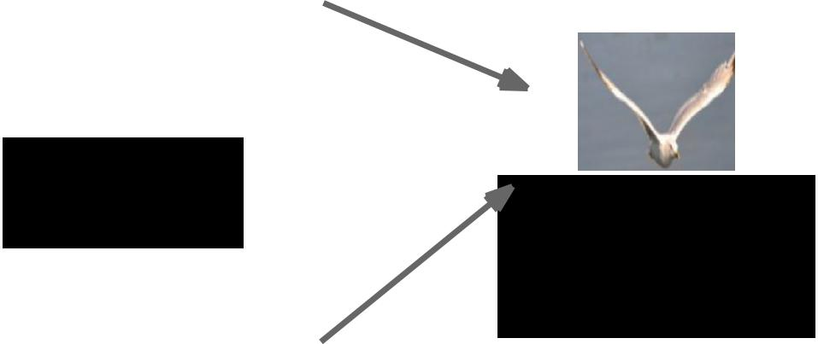

Input image:

H x W x 3 Cropped and

rescaled image:

X x Y x 3



Box Coordinates:

(xc, yc, w, h)



Jaderberg et al, “Spatial Transformer Networks”, NIPS 2015



Fei-Fei Li & Andrej Karpathy & Justin Johnson Lecture 13 120 24 Feb 2016

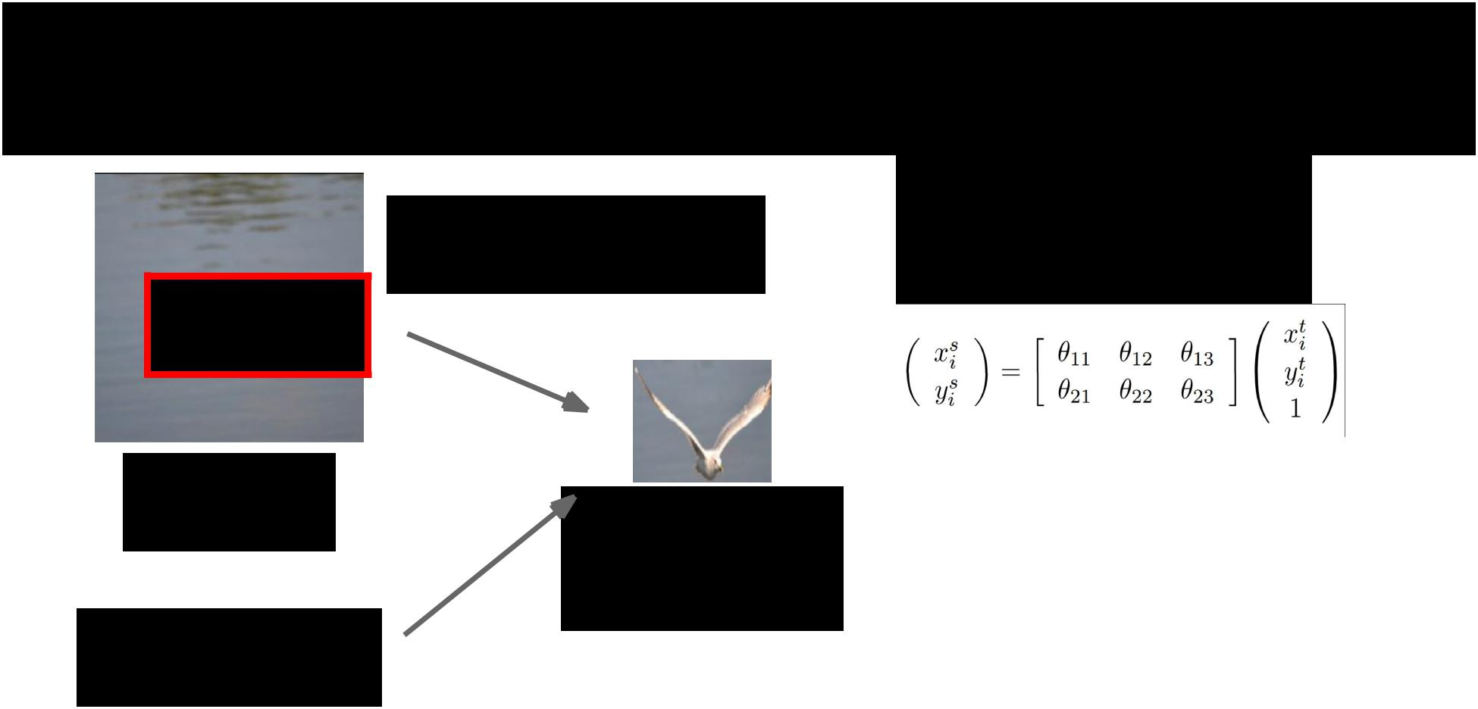Spatial Transformer Networks

Can we make this

function differentiable?

Input image:

H x W x 3 Cropped and rescaled image:

X x Y x 3

Box Coordinates:

(xc, yc, w, h)



**Idea**: Function mapping*pixel coordinates* (xt, yt) ofoutput to *pixel coordinates* (xs, ys) of input

Jaderberg et al, “Spatial Transformer Networks”, NIPS 2015



Fei-Fei Li & Andrej Karpathy & Justin Johnson Lecture 13 121 24 Feb 2016

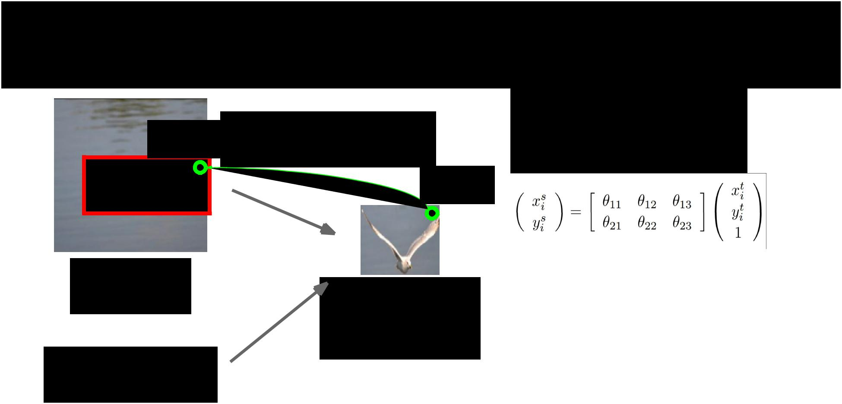Spatial Transformer Networks

|  |  |
| --- | --- |
| (xs, ys) | Can we make this |
|  | function differentiable? |
|  | (xt, yt) |

Input image:

H x W x 3 Cropped and rescaled image:

X x Y x 3

Box Coordinates:

(xc, yc, w, h)



**Idea**: Function mapping*pixel coordinates* (xt, yt) ofoutput to *pixel coordinates* (xs, ys) of input

Jaderberg et al, “Spatial Transformer Networks”, NIPS 2015



Fei-Fei Li & Andrej Karpathy & Justin Johnson Lecture 13 122 24 Feb 2016

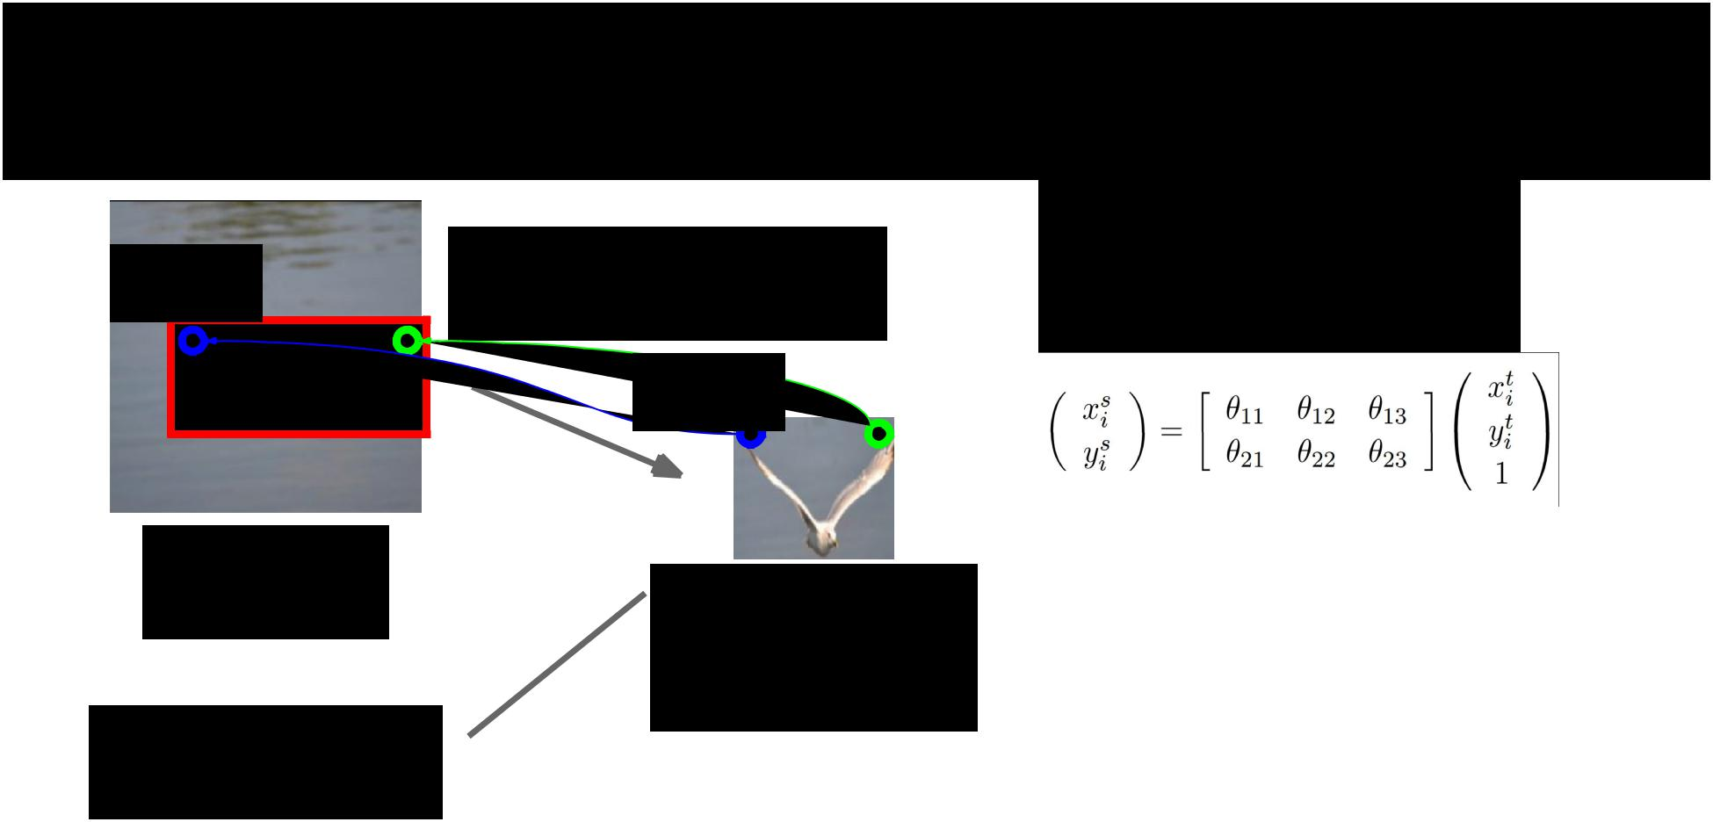Spatial Transformer Networks

(xs, ys)

Input image:

H x W x 3

Box Coordinates:

(xc, yc, w, h)



Can we make this

function differentiable?

(xt, yt)

Cropped and

rescaled image:

X x Y x 3

**Idea**: Function mapping*pixel coordinates* (xt, yt) ofoutput to *pixel coordinates* (xs, ys) of input

Jaderberg et al, “Spatial Transformer Networks”, NIPS 2015



Fei-Fei Li & Andrej Karpathy & Justin Johnson Lecture 13 123 24 Feb 2016

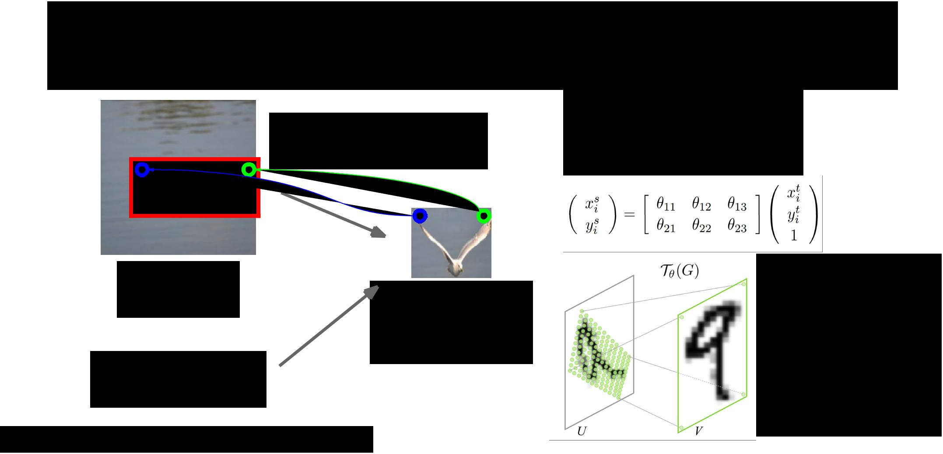Spatial Transformer Networks

Can we make this

function differentiable?

**Idea**: Function mapping

*pixel coordinates* (xt, yt) of

output to *pixel coordinates*

(xs, ys) of input

|  |  |  |  |
| --- | --- | --- | --- |
| Input image: |  | Repeat for all pixels |  |
| Cropped and | in *output* to get a |  |
| H x W x 3 |  |
|  | rescaled image: | **sampling grid** |  |
|  | X x Y x 3 |  |  |
| Box Coordinates: |  |  |  |
| (xc, yc, w, h) |  |  |  |
| Jaderberg et al, “Spatial Transformer Networks”, NIPS 2015 |  |  |  |



Fei-Fei Li & Andrej Karpathy & Justin Johnson Lecture 13 124 24 Feb 2016

Spatial Transformer Networks

Can we make this

function differentiable?

**Idea**: Function mapping

*pixel coordinates* (xt, yt) of

output to *pixel coordinates*

(xs, ys) of input

|  |  |  |  |
| --- | --- | --- | --- |
| Input image: |  | Repeat for all pixels |  |
| Cropped and | in *output* to get a |  |
| H x W x 3 |  |
|  | rescaled image: | **sampling grid** |  |
|  | X x Y x 3 |  |  |

Then use **bilinear**

Box Coordinates:

**interpolation** to

(xc, yc, w, h)

compute output

Jaderberg et al, “Spatial Transformer Networks”, NIPS 2015



Fei-Fei Li & Andrej Karpathy & Justin Johnson Lecture 13 125 24 Feb 2016

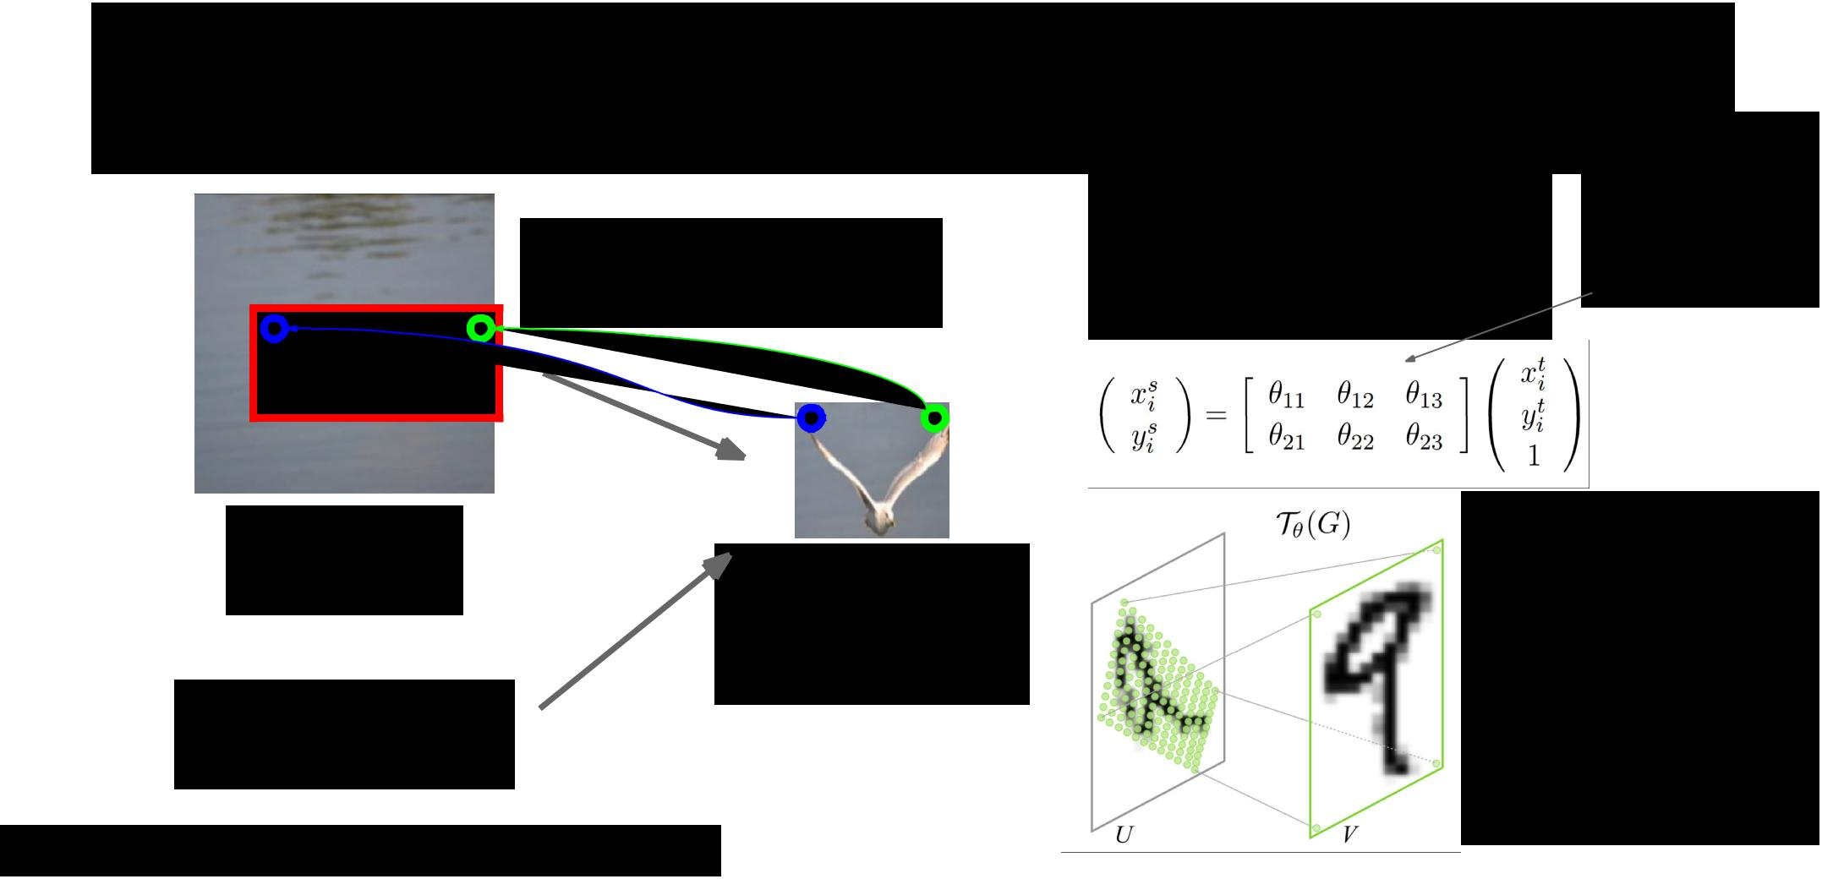Spatial Transformer Networks

Can we make this

function differentiable?

Input image:

H x W x 3 Cropped and rescaled image:

X x Y x 3

Box Coordinates:

(xc, yc, w, h)

|  |  |  |
| --- | --- | --- |
| **Idea**: Function mapping | Network |  |
| attends to |  |
| *pixel coordinates* (xt, yt) of |  |
| input by |  |
| output to *pixel coordinates* |  |
| predicting |  |
| (xs, ys) of input |  |
|  |  |

Repeat for all pixels in *output* to get a **sampling grid**

Then use **bilinear**

**interpolation** tocompute output

Jaderberg et al, “Spatial Transformer Networks”, NIPS 2015



Fei-Fei Li & Andrej Karpathy & Justin Johnson Lecture 13 126 24 Feb 2016

Spatial Transformer Networks

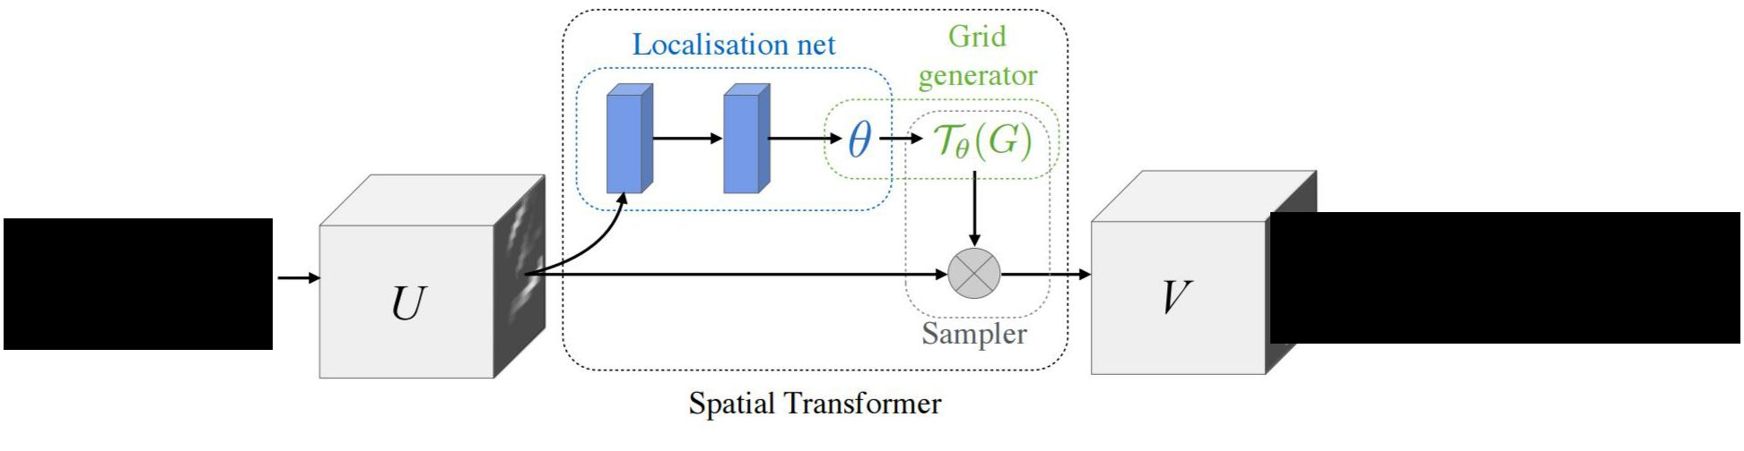

|  |  |
| --- | --- |
| **Input**: | **Output:** Region of |
| Full image | interest from input |



Fei-Fei Li & Andrej Karpathy & Justin Johnson Lecture 13 127 24 Feb 2016

Spatial Transformer Networks

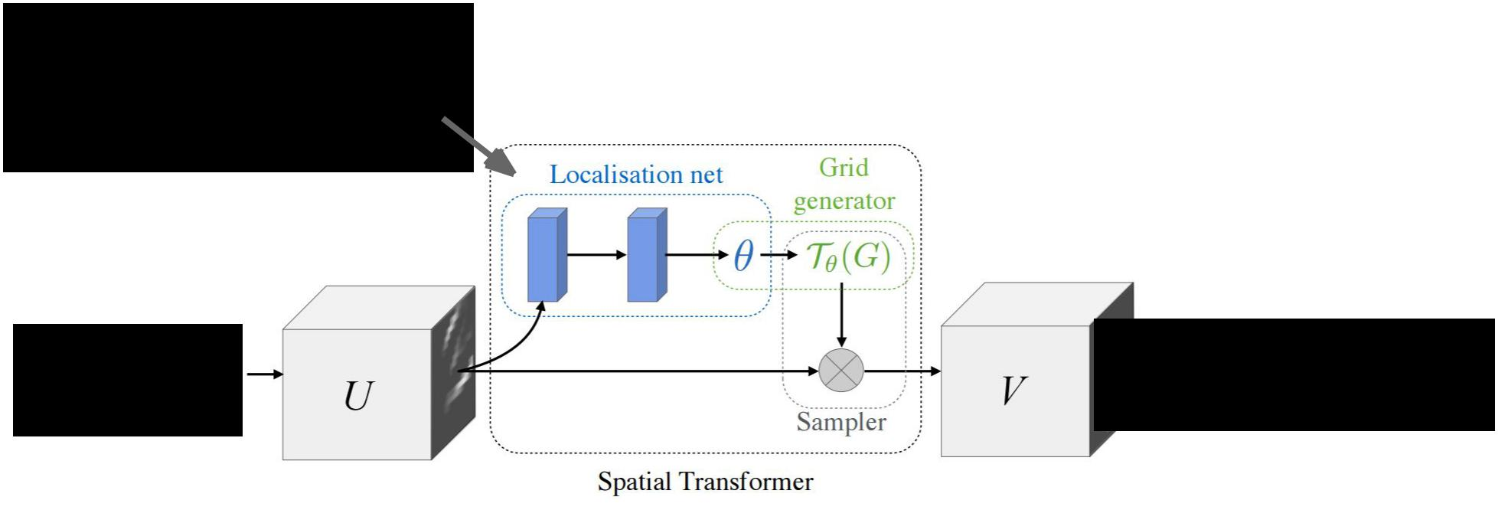

* small

**Localization network**

predicts transform

|  |  |
| --- | --- |
| **Input**: | **Output:** Region of |
| Full image | interest from input |



Fei-Fei Li & Andrej Karpathy & Justin Johnson Lecture 13 128 24 Feb 2016

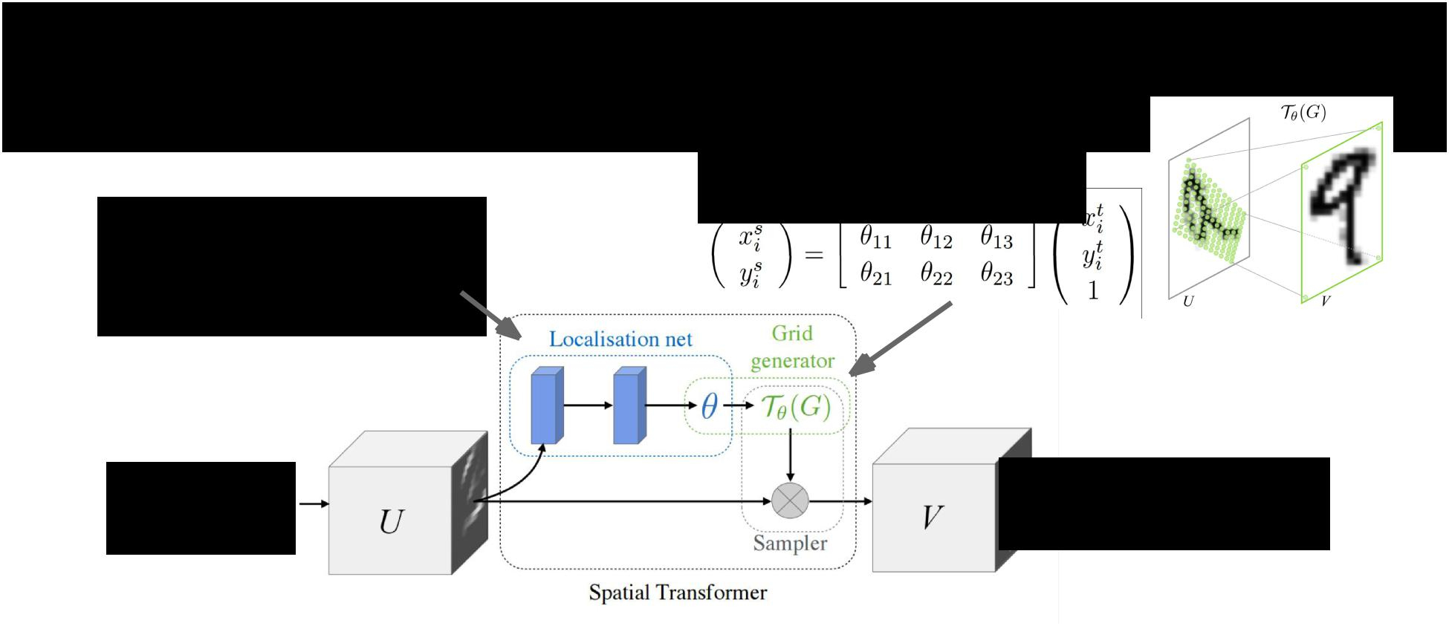Spatial Transformer Networks

**Grid generator** uses to

compute sampling grid

* small

**Localization network**

predicts transform

|  |  |
| --- | --- |
| **Input**: | **Output:** Region of |
| Full image | interest from input |



Fei-Fei Li & Andrej Karpathy & Justin Johnson Lecture 13 129 24 Feb 2016

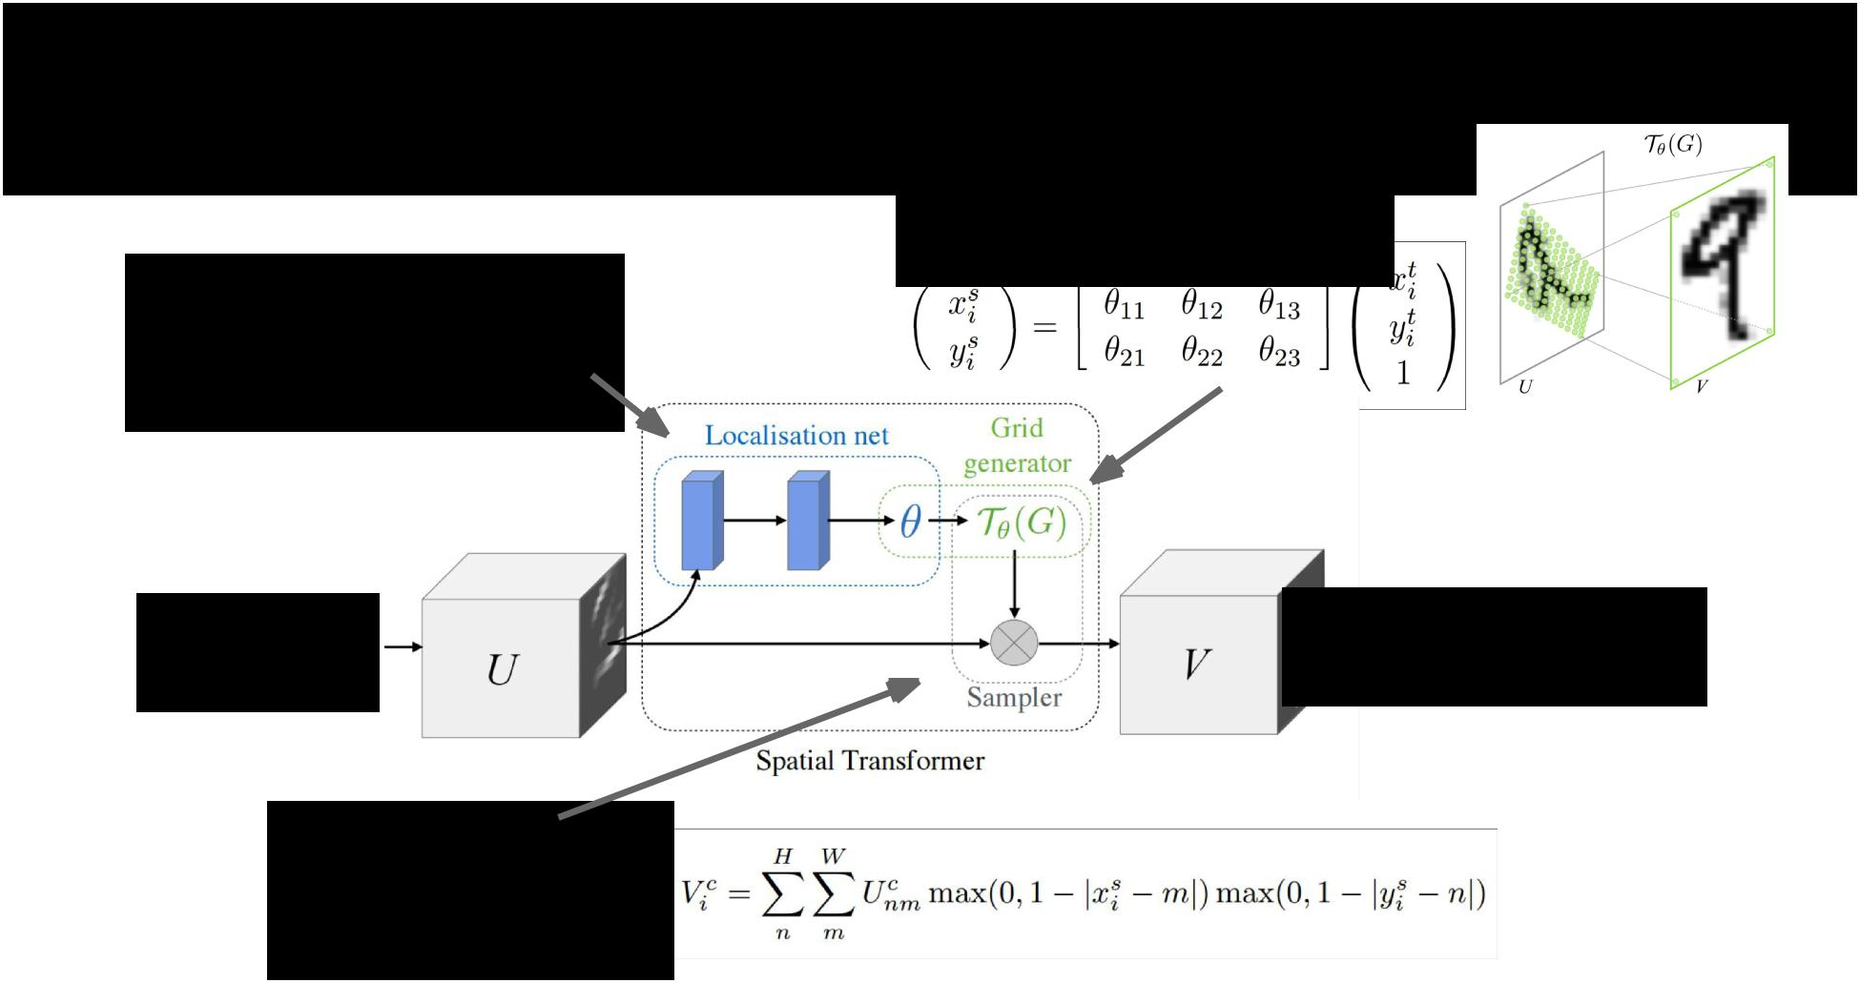Spatial Transformer Networks

**Grid generator** uses to

compute sampling grid

* small

**Localization network**

predicts transform

|  |  |
| --- | --- |
| **Input**: | **Output:** Region of |
| Full image | interest from input |

**Sampler** uses

bilinear interpolation

to produce output



Fei-Fei Li & Andrej Karpathy & Justin Johnson Lecture 13 130 24 Feb 2016

Spatial Transformer Networks

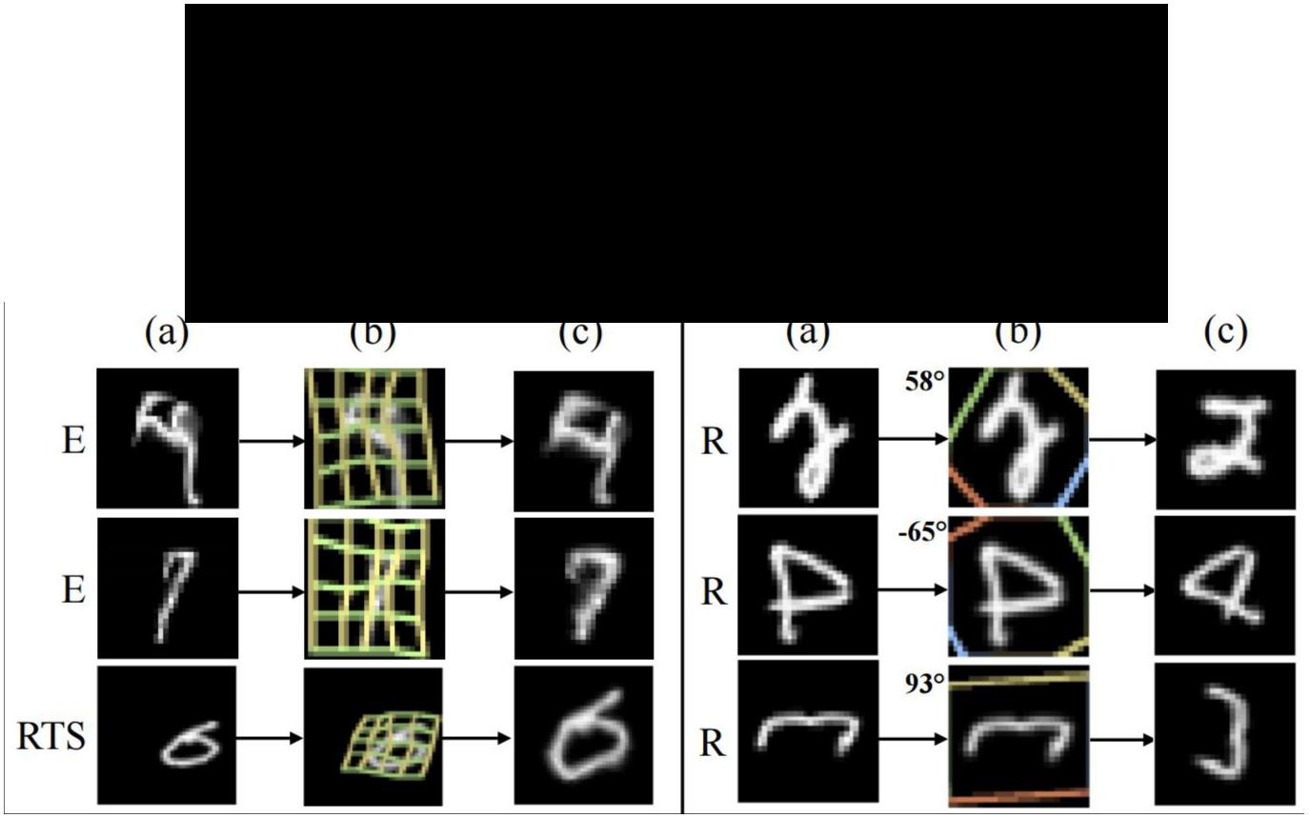

Insert spatial transformers into a

classification network and it learns

to attend and transform the input



Differentiable “attention /

transformation” module

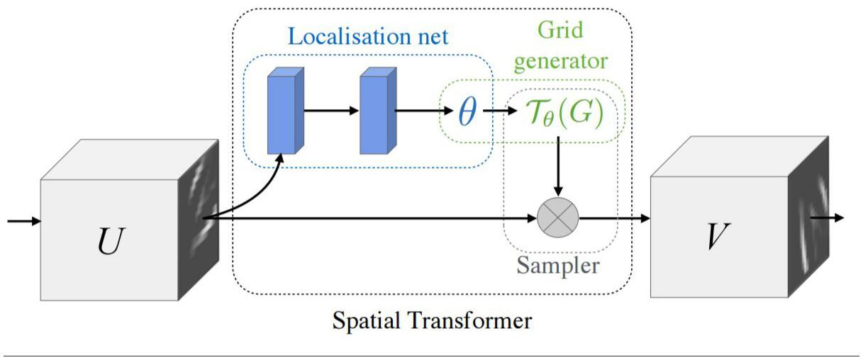

Fei-Fei Li & Andrej Karpathy & Justin Johnson Lecture 13 131 24 Feb 2016

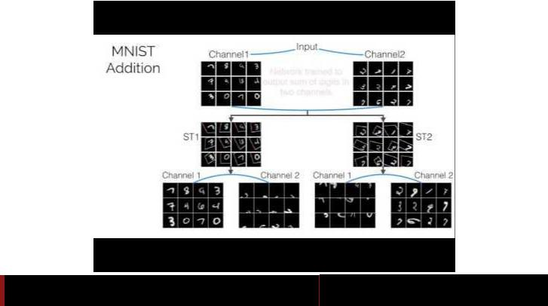

Fei-Fei Li & Andrej Karpathy & Justin Johnson Lecture 13 132 24 Feb 2016

Attention Recap



* Soft attention:
  + Easy to implement: produce distribution over input locations, reweight features and feed as input
  + Attend to arbitrary input locations using spatial transformer networks
* Hard attention:
  + Attend to a single input location
  + Can’t use gradient descent!
  + Need **reinforcement learning!**



Fei-Fei Li & Andrej Karpathy & Justin Johnson Lecture 13 133 24 Feb 2016